LABOR MOVEMENT PHOTOGRAPH SET

Photograph #1
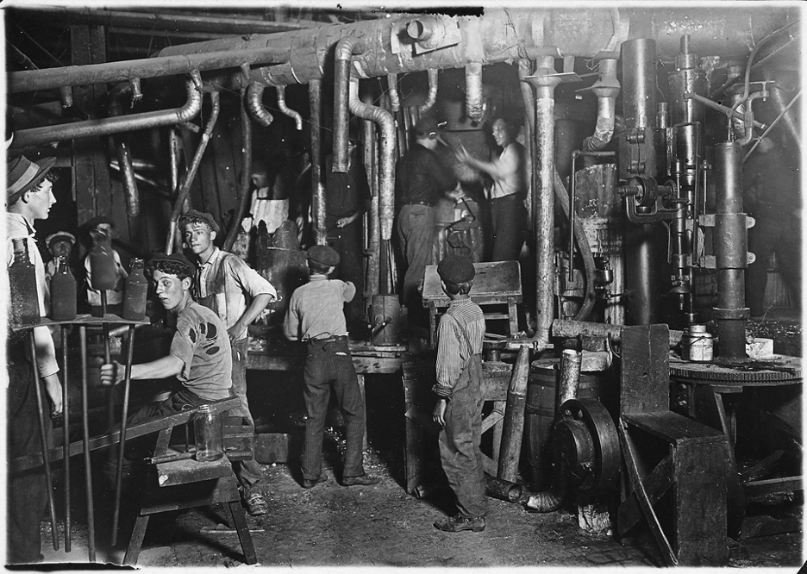
9 P.M. in an Indiana Glass Works. Indiana, 1908.

Hine, L. (1908). 9 P.M. in an Indiana Glass Works, Aug. 1908. Location: Indiana. Library of Congress Prints and Photographs Division Washington, D.C. 20540 USA. https://hdl.loc.gov/loc.pnp/nclc.01166

Photograph #2

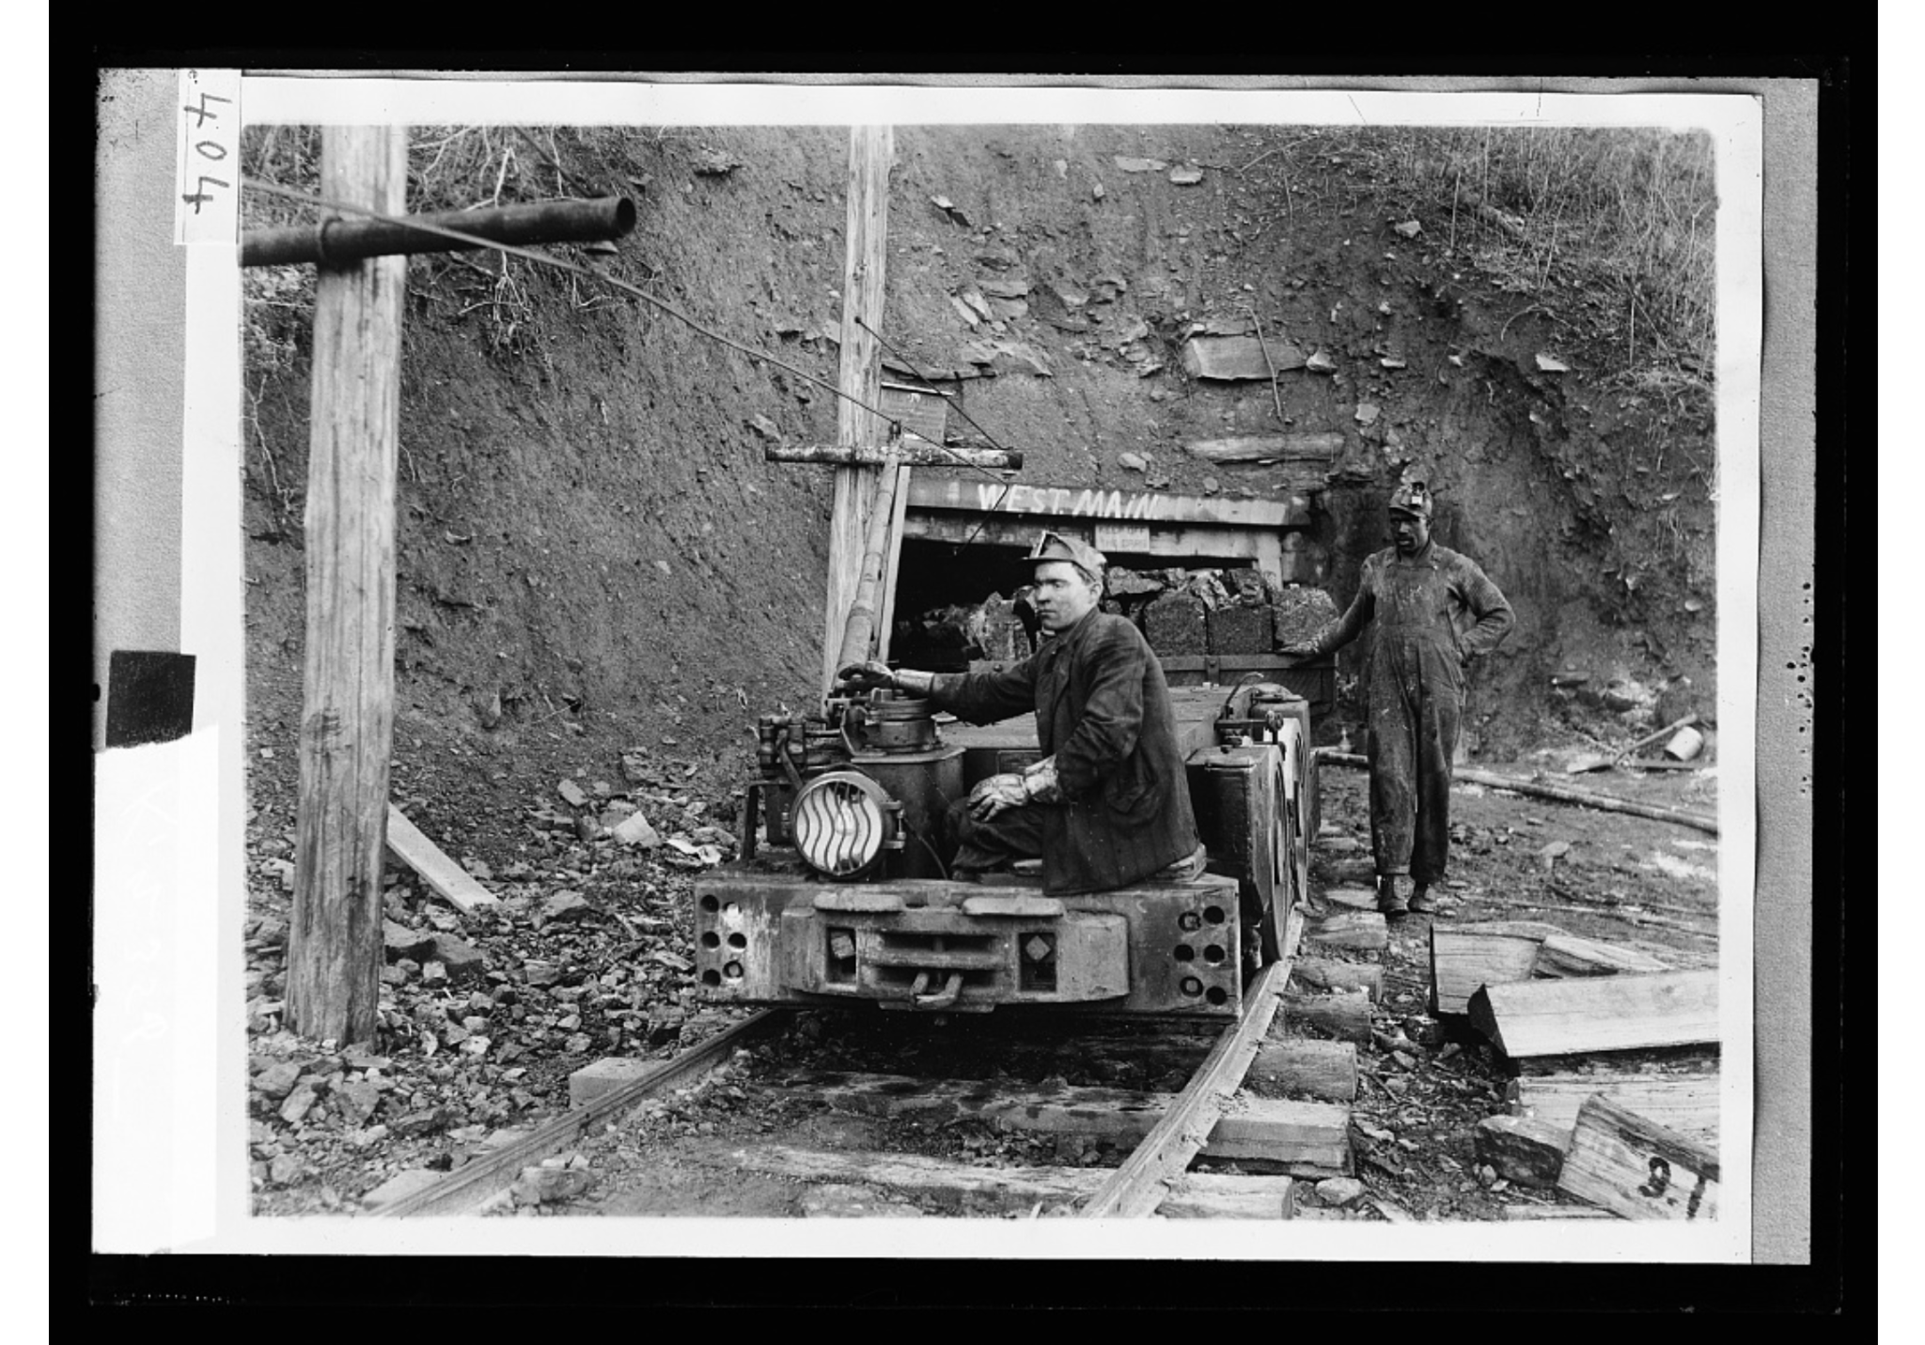
[Hauling coal], 1915-1925.

Detroit Publishing Co. (1915-1925). [Hauling coal]. Library of Congress Prints and Photographs Division Washington, D.C. 20540 USA. https://www.loc.gov/item/2016816922/

Photograph #3
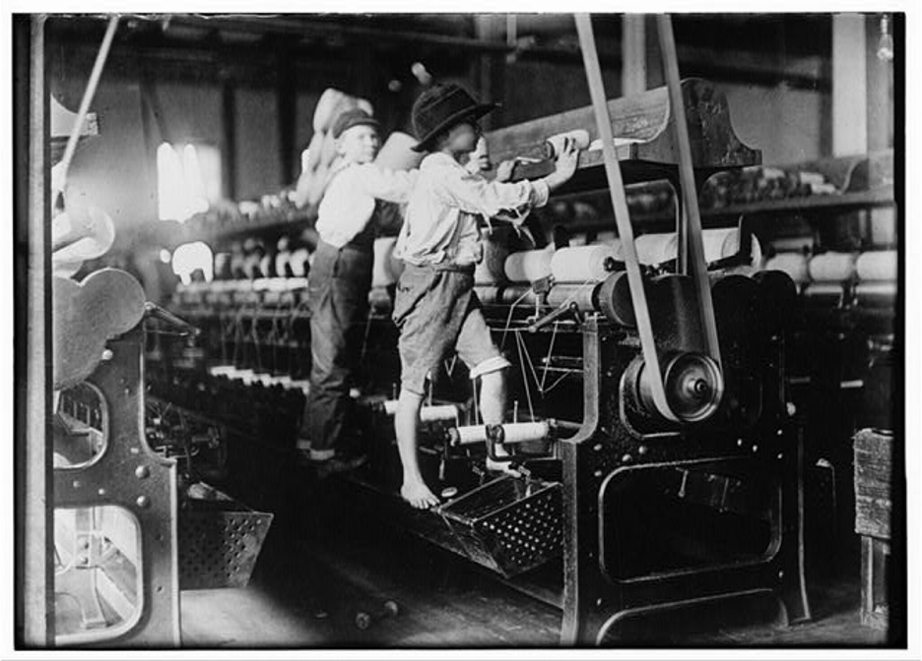
Many youngsters here. Some boys were so small they had to climb up on the spinning frame to mend the broken threads and put back the empty bobbins. Macon, Georgia.

Hine, L. (1909, January 19). 488 Macon, Ga. Lewis W. Hine 1-19-1909. Bibb Mill No. 1 Many youngsters here. Some boys were so small they had to climb up on the spinning frame to mend the broken threads and put back the empty bobbins. Location: Macon, Georgia.. Library of Congress Prints and Photographs Division Washington, D.C. 20540 USA. https://hdl.loc.gov/loc.pnp/nclc.05394

Photograph #4
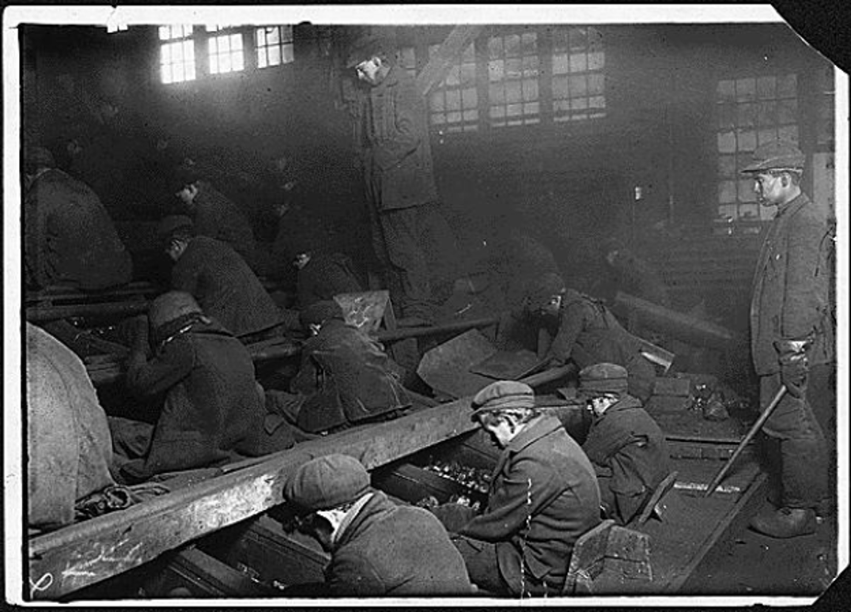
View of the Ewen Breaker of the Pa. Coal Co. The dust was so dense at times as to obscure the view. This dust penetrated the utmost recesses of the boys’ lungs. A kind of slave-driver sometimes stands over the boys, prodding or kicking them into obedience. Pittston, Pennsylvania, 1911.

Hine, L. (1912.). View of the Ewen Breaker of the Pa. Coal Co. The dust was so dense at times as to obscure the view. This dust penetrated the utmost recesses of the boy's lungs. A kind of slave-driver sometimes stands over the boys, prodding or kicking them into obedience. S. Pittston, Pa.. National Archives Catalog. https://catalog.archives.gov/id/523378
Photograph #5

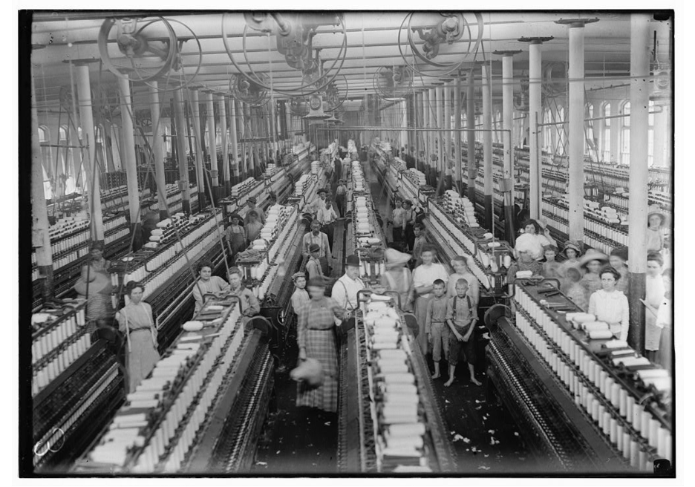
Interior of Magnolia (Miss.) Cotton Mills spinning room. See the little ones scattered through the mill. All work.

Hine, L. (1911, March). Interior of Magnolia (Miss.) Cotton Mills spinning room. See the little ones scattered through the mill. All work. Library of Congress Prints and Photographs Division Washington, D.C. 20540 USA. https://www.loc.gov/pictures/item/2018674824/

Photograph #6

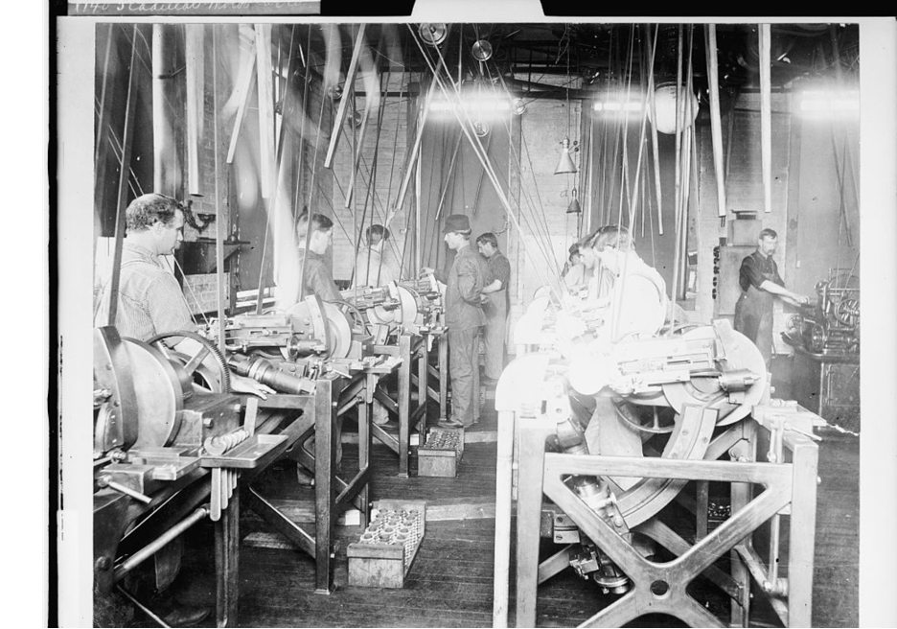
Men at the foundry and machine shop that produced automobile engines in 1903 and merged with Cadillac Motor Co. in 1905.

Detroit Publishing Co. (1903). [Factory workers assembling engines at Leland & Faulconer Manufacturing Co., Detroit, Mich.] Library of Congress Prints and Photographs Division Washington, D.C. 20540 USA. https://www.loc.gov/resource/det.4a26764/

