TO WHAT EXTENT DID THE GREAT DEPRESSION CAUSE WORLD WAR II?
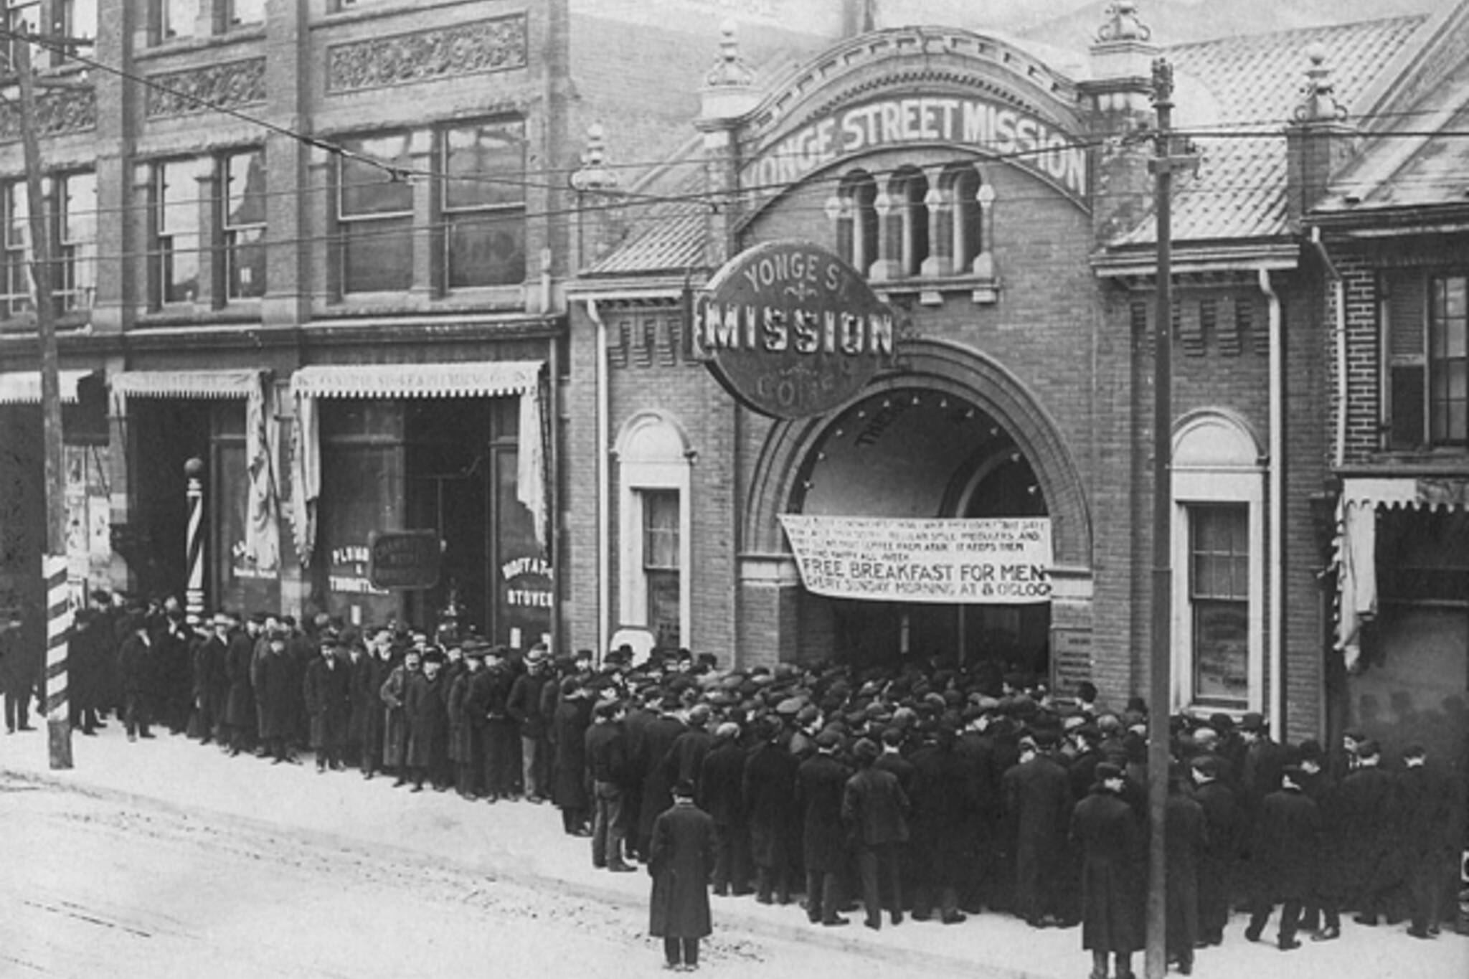
Figure 1: Barc, A. (2010, Oct 23). The Great Depression in Toronto. City. https://www.blogto.com/city/2010/10/nostalgia_tripping_the_great_depression_in_toronto
The Great Depression was a worldwide event that started in the United States in 1929 and lasted through 1939. Historians believe that the Great Depression certainly was one of the reasons that caused World War II.
In October 1929, the U. S. stock market crashed. Before the crash, people’s financial situations had been perhaps better than they ever had. It was easy to get credit, which meant that there was lots of spending on things that were luxury items. As people spent more, prices rose. Industry that had emerged to build things needed for World War I was still producing iron and steel. There was an increase in building cars because more people could afford them, and car manufacturers needed to hire workers. Farmers were producing more food than they could sell, so at one point, they threw away vegetables, eggs, milk, wheat, and rice instead of selling it cheaply. The U.S. economy could not maintain excessive spending. When the stock market crashed, the country slid into a huge economic crisis.
The crash meant that the value of major stocks dropped to their lowest levels ever. When this happened, companies were not able to stay open because they did not have money to pay salaries. When companies closed, people lost their jobs. Banks suddenly closed, and people lost any money they might have had in stocks or savings accounts. Millions of Americans lost all of their money. People suddenly stopped spending, which caused businesses that supplied goods and services to close. Just putting food on the table was a challenge for many Americans. Without an income, many families came to depend on soup kitchens and bread lines or vegetable gardens and hunting. There were food riots scattered across the country, and some large cities reported that some families died from starvation or diseases related to malnutrition. The entire country plunged into panic. Countries all over the world had similar experiences.
During the first five years of the Great Depression, the U.S. economy shrank more than 50 percent with 650 banks failing. By 1933, when the Depression reached its lowest point, around 15 million Americans were unemployed. At this time, economies all over the world were at a low, and these circumstances created a perfect condition for conflicts. World trade had collapsed. Democracies struggled to survive because people thought democracy and democratic leaders had failed citizens worldwide. People were hungry and homeless all over the world. Countries in Europe were struggling to recover from huge damages that happened to their countries during the war. Their citizens were angry and disappointed. Japan, who had been an ally in World War I, suffered equally. Most of their food and raw materials were imported from other countries. When trade collapsed, their main source of provisions disappeared. By the mid 1930’s, economic conditions began to improve slowly, but total recovery was not accomplished until the end of the decade. Ten years is a long time for people to suffer a harsh economic environment.
Near the end of the Great Depression in Europe, a large number of politicians took the opportunity to rise to power. In addition to people struggling in the U.S., people in Germany, France, Italy, Spain, the United Kingdom, and the Soviet Union were tired of being poor and hungry. They wanted change that would make their lives better. They were willing to follow and support leaders who promised to bring their countries to prosperity and greatness. Adolf Hitler in Germany, Joseph Stalin in the Soviet Union, Francisco Franco in Spain, and Benito Mussolini in Italy all promised a better life with a bright future.
Once they were in power, however, these men became dictators who ruled their countries by force. They did not keep their promises to make life better. In fact, they took total control over the way people lived and made decisions about how they could live their lives. Citizens lost their rights to freedom of speech and religion. People who disagreed with the dictators were sent to concentration camps or to forced labor camps. During this time of severe economic stress, these countries began to build their military strength and create plans to take control of neighboring countries. Leaders promoted military might, ethnic pride, and the importance of national prestige. They argued that these qualities would create full employment and create economic prosperity.
Between 1920 and 1930, the European authoritarian governments had adopted two different types of political systems: communism and fascism. The dictators argued that people were better off than before so that they could maintain their power.
Although the Depression was not the only reason World War II broke out, it definitely affected what happened in countries all over the world. When World War I ended, European nations who had been badly damaged by the war did what they could to live in peace. One major thing they all agreed on was that it was important to keep Germany happy and under control. This was called “appeasement.”
Unfortunately, the Treaty of Versailles, which was supposed make everyone happy, failed badly. Italy was unhappy because they had been damaged in the war, but they were not given money or territories to make up for what they had lost. France was unhappy because they wanted Germany punished harshly and felt that the punishment had not been severe enough. The new government of Soviet Union, which had pulled out of the war before it ended, had not even been invited to the Peace Conference. Spain had remained neutral throughout the war, and although the people of Spain were split in their support, Spain did not officially support either side.
The policies of appeasement that Germany was supposed to follow actually made Hitler bolder and gave him more time to build up a massive army. The German people who were insulted that Germany had to take responsibility for starting the war hated the situation they were living in. The country had huge fines they knew they could never pay. Lots of territory all over the world had been confiscated and divided up among other countries. The Great Depression had made everything worse.
In conclusion, it is evident that while the Great Depression was not the only reason World War II began, it greatly contributed to its start. The worldwide economic crises meant that economies and citizens everywhere were at their lowest points. Loss of jobs, loss of money, and hardships created by the war all made them vulnerable to people who were willing to lie to them to gain control. Multiple dictators seized the opportunities to rise to power and become leaders who would eventually control the lives of many citizens.
[Word Count: 1,096]
Source:
UK Essays. (2018). Did the great depression cause World War II. https://www.ukessays.com/essays/history/to-what-extent-did-the-great-depression-cause-world-war-ii.php?vref=1

