THE RISE OF MILITARISM AND DICTATORS
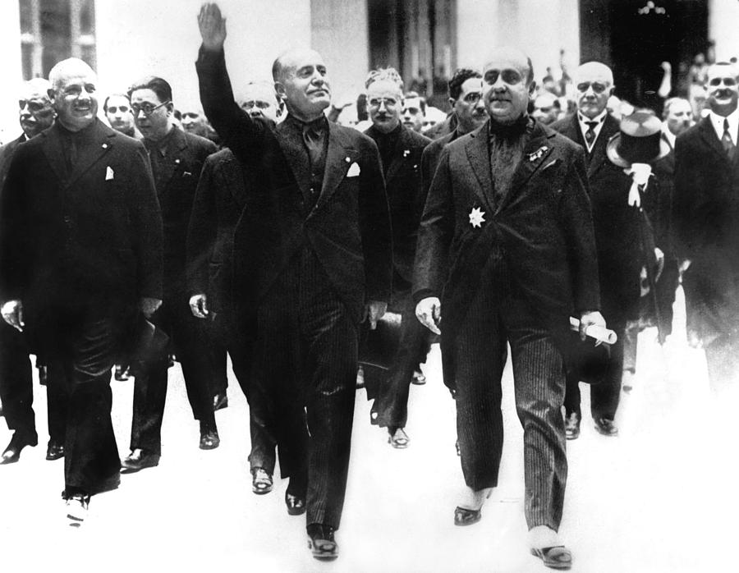
Figure 1: Everett. (2013, Jan 20). Benito Mussolini giving crowds Fascist salute, circa 1928. Fineartamerica. https://fineartamerica.com/featured/benito-mussolini-giving-crowds-fascist-everett.html
After the stock market crash of 1929, countries all over the world suffered economic hardships. The struggle lasted more than a decade. People look back on the 1930s as a time when poverty, hunger, and hardship were widespread in both America and the rest of the world. As it turned out, poverty and hardship were not nearly as dangerous as the decline of democracy all over Europe.
The 1930s were terrible for many countries, especially those who were trying to get back on their feet after World War I. Many countries thought the best solution to their problems was to revolt against their governments. They thought that kicking out the old government and putting in something new would make their lives better. As people protested everywhere because they were hungry and jobless, men eager for power stepped up and promised to make life better for them.
Military dictators promised to solve all of the problems people had. They promised to improve their economies so that no one went hungry or homeless. They promised to make sure that the world respected their country. They promised to restore law and order and to make sure everyone felt safe. They promised to remove disloyal and unacceptable people from their countries. Within just a few years after World War I ended, dictators took control of Germany, Italy, Japan, Spain, and the Soviet Union.

Germany
Adolf Hitler rose to power in Germany after World War I. He was very open about his hatred for Jewish people, in particular, but he also hated other ethnic minorities like Romani people (Gypsies), ethnic Poles, Soviets, people of color, disabled people, and homosexuals. In addition, he was also very unhappy with the Peace Conference that produced the Treaty of Versailles. He believed the punishment the Allied Powers gave Germany were too severe:
- Germany had to take total responsibility for starting World War I;
- Germany lost territory in Europe and across the world;
- Germany had to reduce its military to almost nothing;
- German leaders were tried as war criminals in international courts;
- Germany had to pay billions of dollars for war damages.

The German people who were struggling to rebuild their country after World War I and with the Great Depression agreed with him. He used their complaints to become popular. In 1933, he was named Chancellor of Germany. The very next year, he started calling himself "Führer," and Germany became a dictatorship under his control.
Hitler gained support gradually. After World War I ended in 1919, Germany was in a massive depression. Like other countries, Germany faced serious inflation right after the war ended. People were very unhappy to have to pay back huge amounts of money to the countries damaged by the war. German money decreased in value to the point of being worthless. At the same time, to stir up the anger of Germans against the Jewish population, the Nazi Party gained support by blaming the country’s financial troubles on Jewish people. The Nazi Party wanted the German people to be only “racially desirable.” They believed the Germans, Aryans, were a pure race, and Jews, Romani, Polish and Slavic people “polluted” the population. Only pure Aryans could be a member of the Nazi Party. If the member was married, his partner also had to be “pure.” Party members could not be related to non-Aryans by either blood or marriage.
In 1939, Hitler’s forces invaded Poland by surprise at 4:00 a.m. in the morning. Over the next year, after his initial attack on this border country, Hitler’s forces invaded a number of countries in Europe, including Denmark, Norway, Belgium, the Netherlands, Luxembourg, Yugoslavia, France, and the Soviet Union.
Repeating some of the steps it used in World War I, Germany invited Japan and Italy to join a war time alliance known as the Axis Powers.

Italy
Italy followed a path similar to Germany. Fascism was a political belief that became popular in the 1920s with the rise of the National Fascist Party. Benito Mussolini came to power during this decade. In 1922, he planned to march on Rome and force the Italian King to dismiss the government and make him dictator. King Vittorio Emanuele II did not resist and surrendered control to Mussolini, whom he named Prime Minister. Mussolini dismissed Parliament and proclaimed himself dictator. He was the dictator of Italy from 1925-1945. During this time, Mussolini expanded Italian territory by waging war against what he called “inferior Africans.” To colonize Libya in Northern Africa, he authorized an “ethnic cleansing” that resulted in mass killings, concentration camps, and forced starvation of thousands. He forcibly expelled 100,000 Bedouin Cyrenaicans from their settlements in Libya and gave their lands to Italian settlers.
In the 1930s, Italy invaded Ethiopia and Albania and joined the Axis Powers in the 1940s.
Japan
Japan, the third Axis Power, was taken over by its military leaders in the 1920s. Japan’s economy during and after the 1920s was in bad shape. Industrialization helped Japan recover from the Depression earlier than other countries. In the 1930s, Japan invade China, Korea, and Manchuria. In the 1940s, Japan invaded Vietnam, Laos, and Cambodia. For this, the U.S. stopped importing oil to Japan, which caused tension between the two countries. On December 7, 1941, Japan attacked Pearl Harbor, the U.S. naval base in Hawaii, which forced the United States’ to declare war and join the Allied Powers who were already fighting Hitler in Europe. The military leader Hideki Tojo was known for extreme violence during his term of office. The official leader of Japan was Emperor Hirohito. Although General Tojo was the Prime Minister during most of World War II, his decisions were made with the full approval of the Emperor.
The Soviet Union
Joseph Stalin became dictator of USSR, or Union of Soviet Socialist Republics, after the Russian revolution. He was one of the primary people who managed the rise of Communism. He became the General Secretary of the Communist Party in 1922 and remained in power until his death in 1952. The communist takeover controlled most of society. By the 1930s, the USSR had developed a five-year plan to industrialize the country while still maintaining elements of a dictatorship. He supported the secret street police who had the freedom to arrest, torture, and kill anyone who disagreed with Stalin’s politics. The police conducted a program that started at some point in 1936 and ended at some point around 1938 called the Great Purge. In the Purge, Stalin had 30,000 members of the Soviet Army executed. He also signed a decree that made families guilty for any crime committed by a husband or father. Wives, parents, and children as young as twelve could be executed. An estimated 750,000 people in the Soviet Union were tortured and killed. More than a million where sent to forced labor camps called Gulags. Many of these people died of starvation, disease, or were tortured in the camps because they disagreed with Stalin. In late 1939, Stalin and Hitler signed the non-aggression pact that promised the two countries would not to attack or use military force against each other for the next ten years. By the 1940s, the USSR had invaded a handful of eastern European countries, including Latvia, Lithuania, and Romania.
Spain
Francisco Franco took control of Spain in 1936 by leading a military coup against the democratic government. Franco’s dictatorship included forced labor, concentration camps and executions of between 30,000-50,000 deaths. In addition to these executions, Franco is said to have carried on a “cleansing” of society called the White Terror. Supporters of Franco supposedly killed between 100,000-200,000 people. The Terror included rape and public execution. People who were believed to be enemies of Franco were targeted. Those targeted included anyone who disagreed with him or who supported the government he overturned, liberals, Protestants, atheists, intellectuals, homosexuals, Jews, and certain ethnic groups who lived in Spain. Although Spain remained neutral in World War II, Franco supported the Axis Powers because Germany and Italy had supported him in his coup to overturn the previous government. Franco remained in power for thirty-six years until his death in 1975.

[Word Count: 1,208]

Sources:
Budanovic, N. (2016, Sept 10). Stalin’s great purge: Over a million detained, more than half a million killed. War History Online. https://www.warhistoryonline.com/world-war-ii/10-facts-stalins-great-purge.html
Mussolini, B. (1932). The doctrine of fascism. The New York Times. https://www.billdownscbs.com/2016/12/1932-benito-mussolini-declares-fascism.html
Lumen. (n.d.). The rise of fascism. https://courses.lumenlearning.com/boundless-worldhistory/chapter/the-rise-of-fascism/

Inflation: The price of goods increase, but the purchasing power of a country’s money decreases.
Fascism: A fascist government is controlled by one authoritarian figure. This person uses fear to control citizens. He (or she) emphasizes nationalism, which is the belief that one country is superior to all others.

