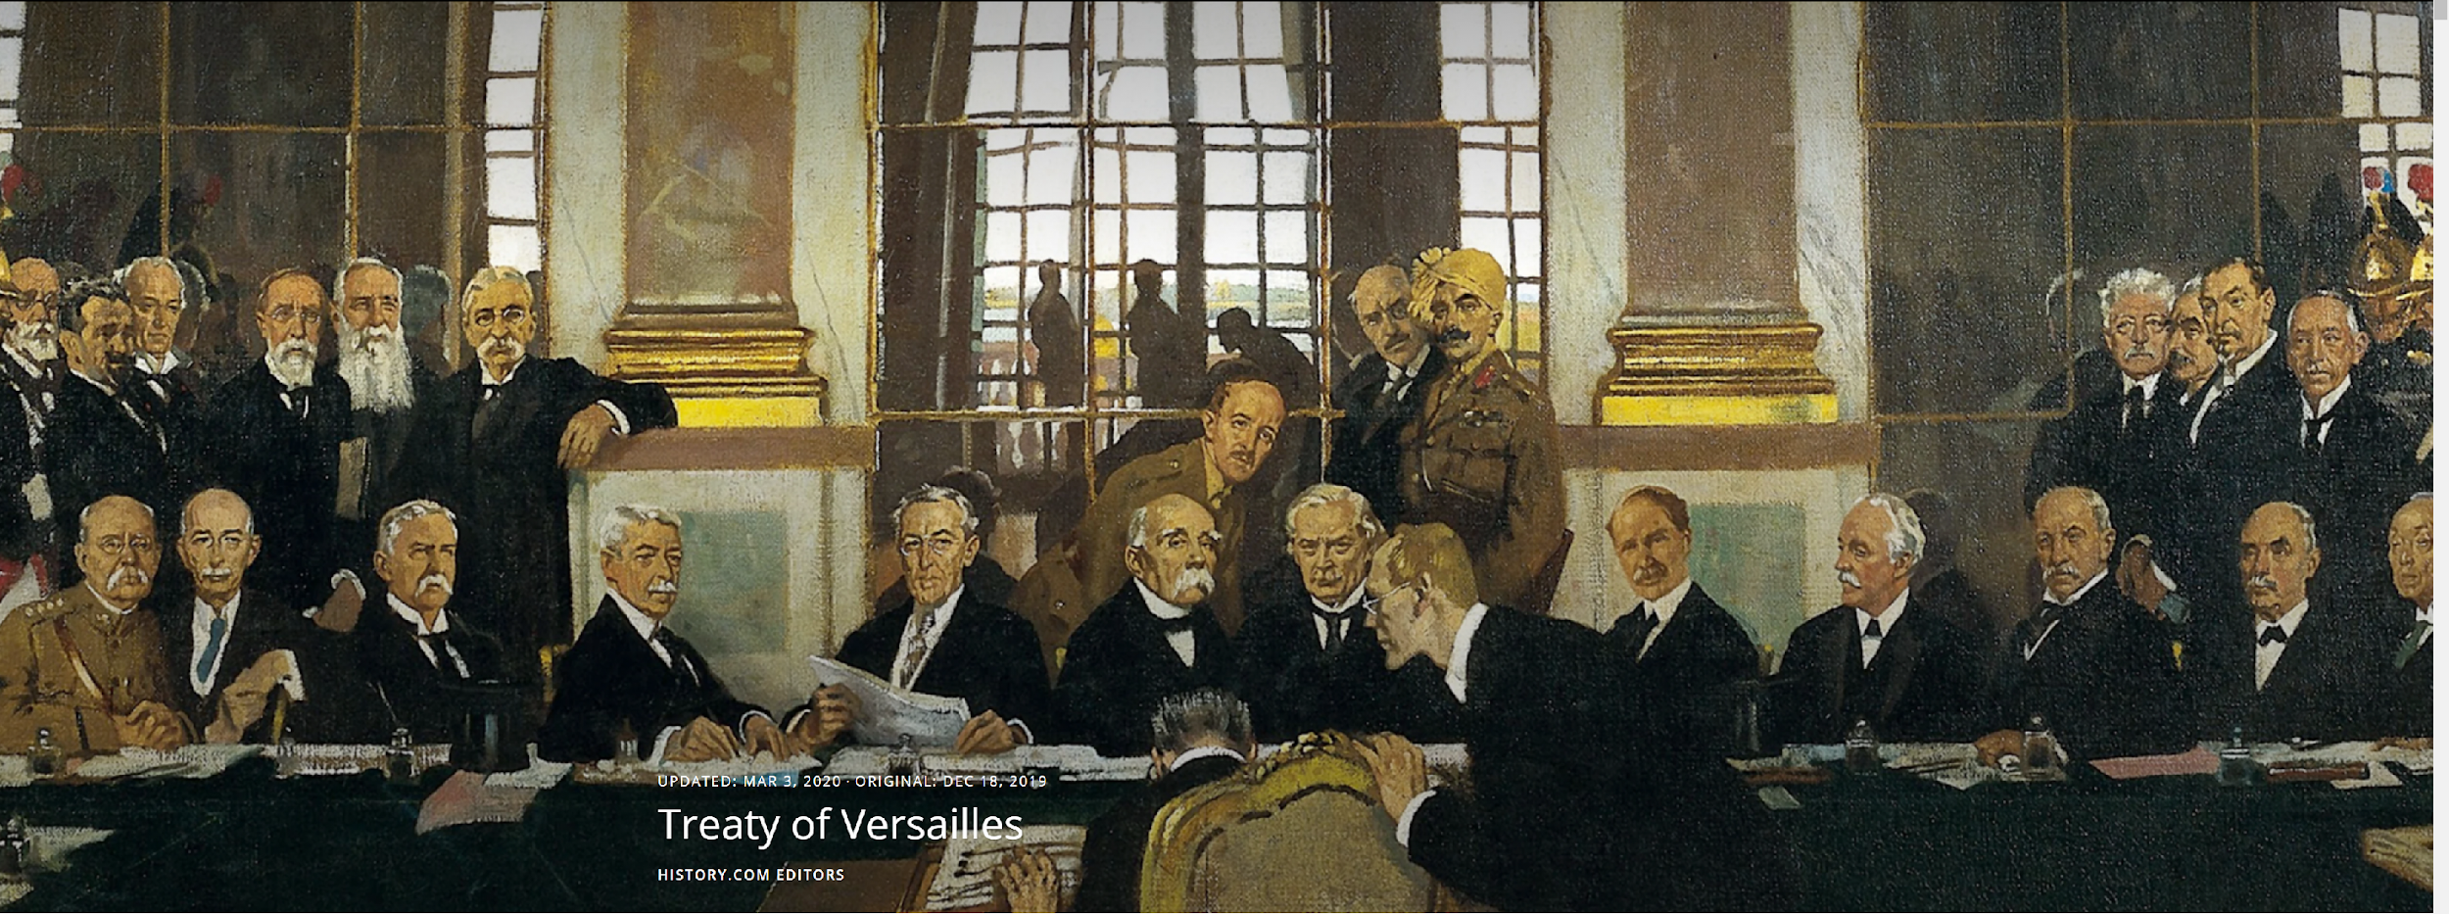

TREATY OF VERSAILLES
Introduction
Signed in June 1919 at the Paris Peace Conference, the Treaty of Versailles was an agreement among the countries who had fought in World War I. The Treaty stated that since Germany was the country that started the war, the countries represented at this meeting could decide how to punish Germany. The Treaty stated that Germany could no longer have an army or a navy and would have to pay huge fines, called reparations, to the countries who had been damaged by the war. Some of their leaders were tried in international courts as war criminals. Although Germany was angered and embarrassed by the punishment, they had no choice but to do as ordered because the countries who won the war took control of Germany. This is called occupation, which was another thing Germany was not happy about.
The Fourteen Points
The 28th President of the United States, Woodrow Wilson, was in office for eight years from 1913-1921. When World War I broke out in 1914, President Wilson tried to arrange peace between the Allied (England and France) and the Central Powers (Germany and Italy). He finally requested that Congress declare war on Germany after German submarines sunk three American merchant ships in what was considered international waters.
After the Allied forces defeated Germany in 1918, Wilson wrote a speech called Fourteen Points. At the Paris Peace Conference in 1919, he proposed these points to be an outline for a treaty to end the war. Wilson’s Fourteen Points, listed below, were a vision of a world united by peace, not by war. However, the United Kingdom and France objected to many of the points in the proposal. The United States Congress refused to approve the Treaty as well. The Fourteen Points are listed below:
- Countries cannot make secret treaties with one another.
- All ships of all countries have the right to use the sea and seaports at all times.
- All nations must accept free trade.
- All countries must reduce their armies, navies, and air forces (disarmament).
- Colonies in other parts of the world that were governed by the countries involved in the war should not be punished for actions of their “mother country.” Claims made by those colonies make should be treated fairly.
- Foreign troops must leave Russia, and the new government there must be welcomed by other nations.
- All foreign troops must leave Belgium, and its independence must be restored.
- German troops must leave all French territories, and Alsace-Lorraine, part of Germany since 1871, must be returned to France.
- The borders of Italy should be expanded to include areas where Italian-speaking citizens live.
- The countries of the Austria-Hungarian empire should be allowed to form individual nation states (their own countries).
- Foreign troops should leave the Balkan peninsula, and all states there should be restored. Serbia should have access to the sea.
- Turks in the Ottoman Empire should continue to rule themselves. Other nationalities in the Empire should be able to form their own states. The Dardanelles should be a free international waterway.
- An independent Poland should be created and given access to the sea.
- The League of Nations should be established to work towards resolving peace.

The Paris Peace Conference
The Paris Peace Conference, where Treaty of Versailles was written, lasted more than six months. The peace talks were controlled by five great powers. Leaders of the United Kingdom, Italy, France, and the United States dominated the peace talks. Each of these countries had different goals for the treaty. France wanted to make Germany weak militarily and limit its future economic power as a way of protecting itself from any future German aggression; however, France did approach Germany secretly in order to oppose England and the United States. Germany rejected the French offers. England wanted to rebuild Germany as a potential trade partner, but at the same time wanted to make sure France was safe from any future military attacks. Generally, the United Kingdom was satisfied with the outcome of the conference. Italy wanted to expand its territories and was not happy with the outcome of the talks. Japan was not interested in European affairs, but wanted to take control of former German colonies in the Far East and the Pacific Ocean. The Japanese delegation was unhappy with getting only half of the German colonies they wanted, so they walked out of the conference. U.S. President Wilson wanted to create a new, peaceful world. His Fourteen Points were intended to make sure Germany had no voice in what happened after the war. Although there were other Allies present, none of them had any voice in the final draft of the treaty.

The Terms of the Versailles Treaty
Talks between the leaders at the Paris Peace Conference were complicated. The United States, who had entered the war late, was not concerned about agreements that the United Kingdom, France, and Italy had made with each other during and after the war. The Allied Powers were more affected by the war than the United States or Japan because they were geographically closer to Germany. The United States and Japan were not actually damaged by the fights and bombings like the other countries near to Germany were. Russia, who had fought in the war until the end of 1917, did not participate because the Allies did not like its new leaders, called Bolsheviks, who took over the Russian government in 1917. They were not invited to the Peace Conference. Germany and countries who supported her were also not invited.

When the talks were over and the treaty written, Germany was given very harsh punishment. The country had to give up 10% of its territory and control of all its overseas colonies. All German money in international banks was taken. All ships used to bring in food and supplies were taken by the Allies. The army and the navy were cut to very small forces. She was not allowed to have an air force at all or to keep any of her submarines and war ships. German leaders were put on trial in international courts for war crimes. The worst thing Germany had to do was admit she was responsible for starting World War I. Because of this, Germans had to pay really huge fines to the countries who had been harmed the most.

Criticism of Versailles Treaty

The Germans hated everything about the Treaty. After the war, the German people struggled with starvation. German farmers could not grow crops because of the lack of materials and seeds and war damage to the soil itself. Food and supplies were not available because the British navy would not let supply ships in or out of Germany. The huge fines meant there was no money to help the people in Germany. The fines totaled about $33 billion. Government officials at that time resigned rather than sign the treaty.

France, who was also unhappy with the treaty, felt that the fines were not enough to make up for the damage Germany had done to their country. French leaders were afraid that Germany would be a continued threat to them in the future.

The United Kingdom was also not happy with the Treaty. Their leaders believed that the punishment against Germany was too severe, and Germany would rebel against it in the future. They were happy that the German navy was destroyed and with the German colonies they had been given.

Italy, who was unhappy with the Treaty because it hoped it would get a lot of land after the war, did not get the lands it wanted.

Japan was not happy with the Treaty. Like Italy, Japan wanted the German colonies in the Pacific Ocean. Some were given to them, but they also wanted the German colonies in China. They also felt they were not treated as equal parties – they believed they were being treated badly because they were Asian.

Even through President Wilson was very involved in writing the Treaty, the United States was not happy with it, so Congress refused to sign. Americans did not like the idea of the League of Nations and did not want to be responsible for taking care of a bunch of small European countries.

Many smaller nations were not included in the talks. They felt that the “Big Four” countries were making important decisions for everyone.

[Word Count: 1,428]

Source:
History.com Editors. (2020, Mar 3). Treaty of Versailles. History.com. https://www.history.com/topics/world-war-i/treaty-of-versailles-1

History.Com Editors. (2020, Mar 3). Treaty of Versailles. https://www.history.com/topics/world-war-i/treaty-of-versailles-1
Pronounced VER-SIGH. Versailles refers to the Palace of Versailles, located about 12 miles from Paris, France. The palace was built by King Louis XIV of France as a weekend hunting lodge. It took over fifty years to complete. At one time, it was considered the capital of France.
United Kingdom: England, Northern Ireland, Scotland, and Wales.

