Document analysis packet
Document A
Guiding question: What factors led to the Chinese Exclusion Act?
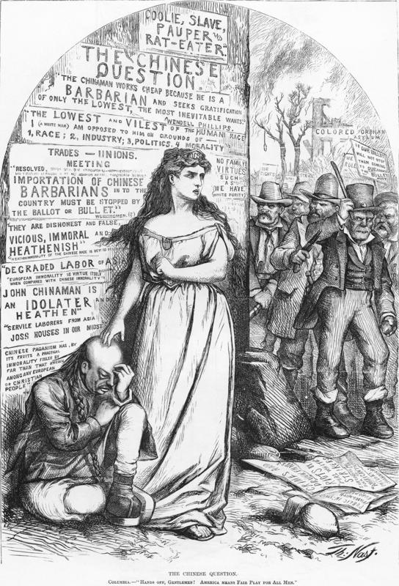
Nast, T. (n.d.). A figure of Justice protects the Chinese immigrant. SHEC: Resources for teachers. Social History for Every Classroom. https://shec.ashp.cuny.edu/items/show/637.

Document B
Guiding question: What factors led to the Chinese Exclusion Act?

The treatment of the Chinese in this country is all wrong and mean...
There is no reason for the prejudice against the Chinese. The cheap labor cry was always a falsehood. Their labor was never cheap and is not cheap now. It has always commanded the highest market price. But the trouble is that the Chinese are such excellent and faithful workers that bosses will have no others when they can get them. If you look at men working on the street, you will find an overseer for every four or five of them. That watching is not necessary for Chinese. They work as well when left to themselves as they do when someone is looking at them.
It was the jealousy of laboring men of other nationalities — especially the Irish—that raised all the outcry against the Chinese. No one would hire an Irishman, German, Englishman or Italian when he could get a Chinese, because our countrymen are so much more honest, industrious, steady, sober and painstaking. Chinese were persecuted, not for their vices, but for their virtues...
...There are few Chinamen in jails and none in the poor houses. There are no Chinese tramps or drunkards. Many Chinese here have become sincere Christians in spite of the persecution which they have to endure from their heathen countrymen. More than half the Chinese in this country would become citizens if allowed to do so, and [they] would be patriotic Americans. But how can they make this country their home as matters now are! They are not allowed to bring wives here from China, and if they marry American women there is a great outcry...
Under the circumstances, how can I call this my home, and how can anyone blame me if I take my money and go back to my village in China?

Chew, L. (n.d.). The Life of a Chinese Immigrant. Digital history. Retrieved September 28, 2021, from http://www.digitalhistory.uh.edu/disp_textbook.cfm?smtid=3&psid=40.
Document C
Guiding question: What factors led to the Chinese Exclusion Act?

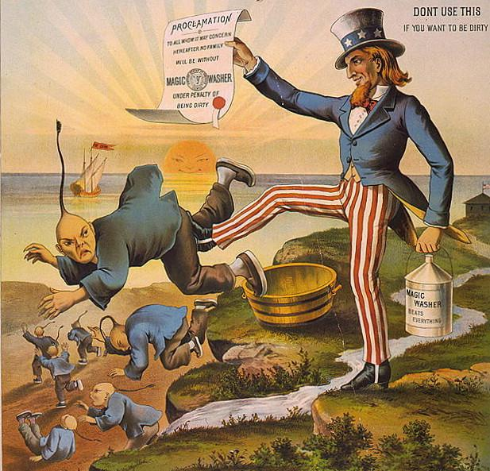
1886 Anti-Chinese political cartoon from The George Dee Magic Washing Machine Company depicting the Chinese Exclusion Act. The purpose of this racist cartoon was to promote the company’s new washing machine.

Strom, A. (2020, March 9). The Chinese Exclusion Act: Resources - RE-IMAGINING MIGRATION. Re. Retrieved September 24, 2021, from https://reimaginingmigration.org/the-chinese-exclusion-act-resources/.

Document D
Guiding question: What factors led to the Chinese Exclusion Act?

We have met here in San Francisco tonight to raise our voice to you in warning of a great danger that seems to us imminent, and threatens our almost utter destruction as a prosperous community...

The danger is, that while we have been sleeping in fancied security, believing that the tide of Chinese immigration to our State had been checked and was in a fair way to be entirely stopped, our opponents, the pro-China wealthy men of the land, have been wide-awake and have succeeded in reviving the importation of this Chinese slave-labor. So that now, hundreds and thousands of Chinese are every week flocking into our State...

Today, every avenue to labor, of every sort, is crowded with Chinese slave labor worse than it was eight years ago. The boot, shoe and cigar industries are almost entirely in their hands. In the manufacture of men’s overalls and women’s and children’s underwear they run over three thousand sewing machines night and day. They monopolize nearly all the farming done to supply the market with all sorts of vegetables. This state of things brings about a terrible competition between our own people, who must live as civilized Americans, and the Chinese, who live like degraded slaves. We should all understand that this state of things cannot be much longer endured... (p. 2).

Workingman’s Party. (1888, Aug 16). An address from the workingmen of San Francisco to their brothers throughout the Pacific coast. [Digital image]. https://oac.cdlib.org/ark:/13030/hb7199n8g9/?order=1&brand=oac4.

