Wave Interference Activity

Group Members:
Objective: Working within a group, you will explore different visual models that illustrate how two waves combine so that both of them can occupy the same space.

Model One: Two different ways that waves can interfere with each other.

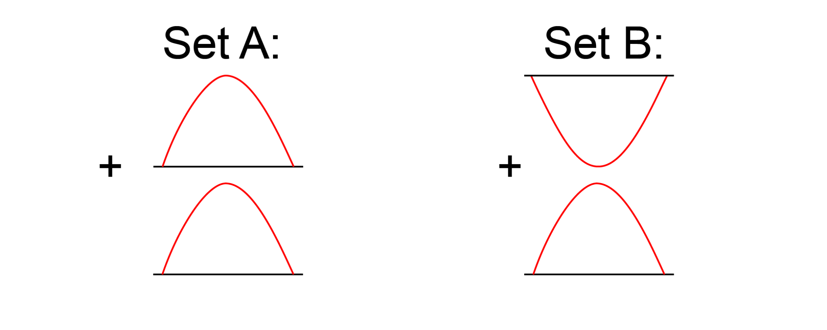

Concept Questions:
1) Predict how the waves in Set A combine and sketch the result:

2) Predict how the waves in Set B combine and sketch the result:

3) Set A represents constructive wave interference. In your own words, define constructive wave interference.

4) Set B represents destructive wave interference. In your own words, define destructive wave interference.

For the following, assume the two waves have the same frequency and velocity but are traveling in opposite directions.

5) Sketch a wave that will destructively interfere with the wave on the left.

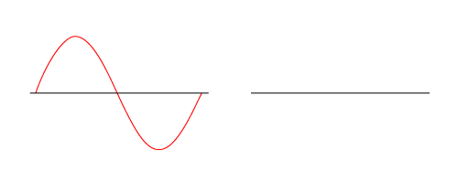
6) Sketch two waves that are different from the previous drawings that will destructively interfere when they meet.

7) Sketch two waves that will only partially experience destructive interference.

8) Sketch a wave that will constructively interfere with the following wave:

Model Two: Wave interference using a different way to draw area under peaks and troughs.

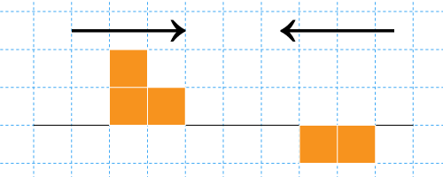

9) Two pulse waves are sent through a spring in opposite directions as shown above. On the graph below, sketch the result of the pulse waves at the instant they combine. Is this constructive or destructive interference?

10) Two pulse waves are sent through a spring in opposite directions as shown below. On the graph below, sketch the result of the pulse waves at the instant they combine. Is this constructive or destructive interference?

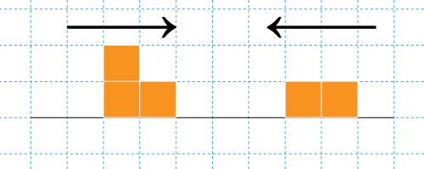

11) Sketch an original pulse wave pattern using blocks to represent peak and trough area, and show the result of the combined pulse waves.

