Waves Unit Vocabulary
Use styles to format the content in your document. To apply a style, go to the Home tab in your Word document and select the appropriate style from the Styles list.

Word | Definition | Examples
Oscillation | Consistently repeating vibration or motion.
Medium | A physical substance that carries the wave. The wave medium always returns to its original position after the wave passes through it. | Almost any kind of matter, air, water, or solids, such as steel or rock.
Transverse Waves | Bouncy waves; the medium vibrates up and down. | 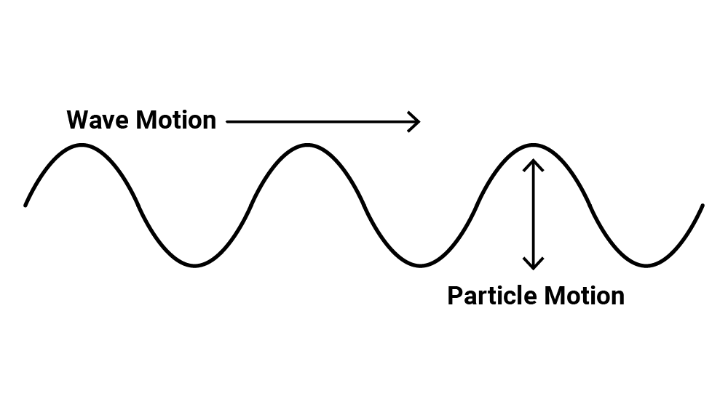
Longitudinal Waves | Stretchy waves; the medium expands (stretches) and compresses (squeezes). | 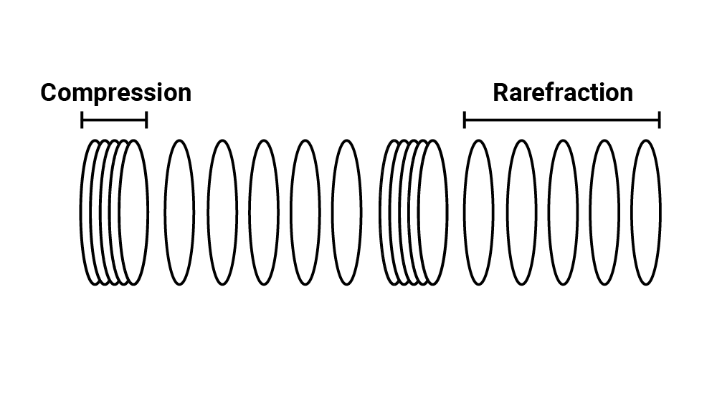
Wave Pulse | A short duration vibration that creates a single displacement traveling through the medium. | 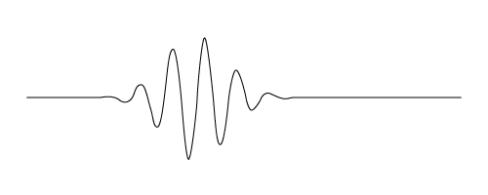
Driven Wave | A constant oscillation that creates a continuous displacement or vibration of the medium. | 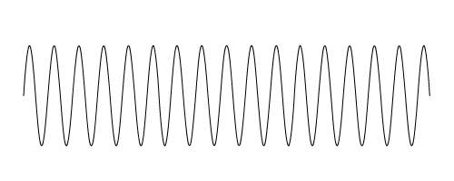
Velocity | Velocity is the speed that something travels.  If we know the speed something is traveling and the total time the object was moving, we can determine the distance it traveled. | Velocity = distance/time  Distance = velocity · time
Wavelength  λ  “lambda” | The horizontal distance between start and end points of one full wave cycle | 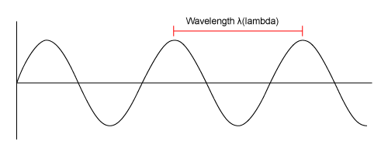
Amplitude  A | The vertical height of a wave, measured from the center line to the top of a peak or the bottom of a trough | 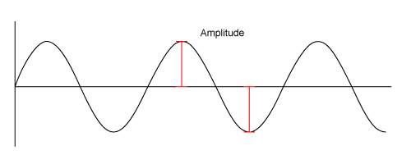
Frequency  f | The number of wavelengths that passes a fixed point in one second | 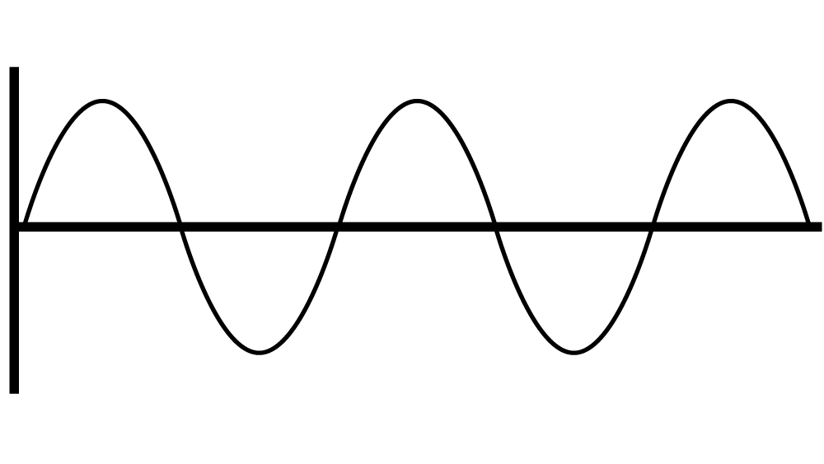
The wave equation | Velocity = Frequency · Wavelength  - Velocity is represented by a V  - Frequency is represented by f  - Wavelength is represented by λ, which is the Greek letter “lambda” | v = f λ
Triangle of Power  TITLE OF LESSON GOES HERE | Visual representation of equations to calculate velocity, frequency, and distance of wavelengths. | 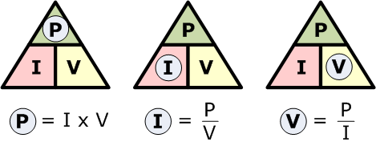
Inverse Relationship | For two interconnected quantities, as one gets bigger, the other gets proportionally smaller, and vice-versa. | f → λ λ→f
Interference | When two or more waves combine additively.
Constructive Interference | Waves combine peak + peak or trough + trough to produce a wave of larger amplitude. | 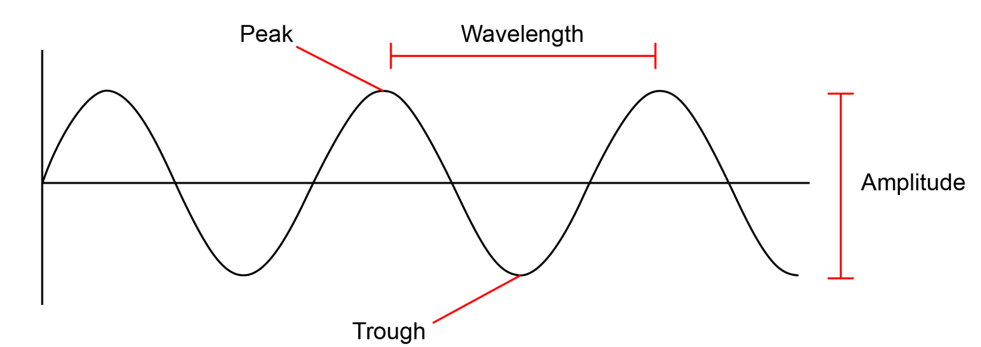
Destructive Interference | Waves combine peak + trough so that amplitudes cancel one another.
Interference Patterns | When two or more freely traveling waves interfere and merge via constructive and destructive interference.
Reflection | When a wave bounces off a barrier and changes direction of travel; a wave that encounters a hard barrier is flipped on itself.
Phase | The position of one wave in relation to another.
In Phase | Peaks and troughs directly line up.
Out of Phase | Peaks and troughs do not line up.
180० Out of Phase | Peaks and troughs are exactly opposite
Resonance | When a system vibrates at a single frequency we call this a standing wave; only wavelengths that fit within an object will resonate.
Refraction | The fact or phenomenon of light, radio waves, etc. being deflected in passing obliquely through the interface between one medium and another through a medium of varying density.
Absorption | The process or action by which one thing soaks up or blots out another.
Emission | Something that has been emitted, released, or discharged.

