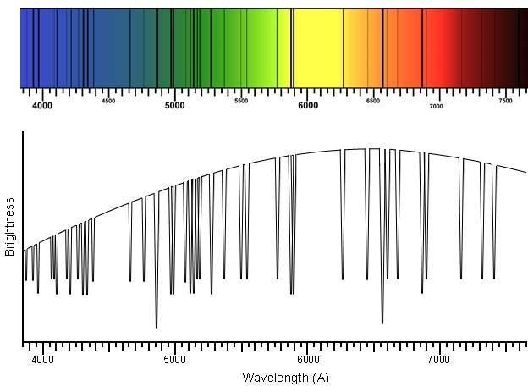
CLASSIFYING STARS WITH SPECTRA

ENGAGE:
1. What physical characteristics make stars more likely to harbor an orbiting planet with complex life on it?
2. How do we look for stars with these life-supporting characteristics?
https://ia.terc.edu/spectral_solar_spectrum.html

3. Define the terms star spectra and spectral absorption lines. What can we learn about star characteristics by studying them? It’s good to guess!

EXPLORATION:
PART A. Compare star spectra to classify 14 stars
1. Form a team as directed by your teacher.
2. Open a database of star spectra that has been curated by the Sloane Digital Sky Survey. Get the handout, click this link, or use this URL:
http://voyages.sdss.org/expeditions/expedition-to-the-milky-way/spectral-types/classifying-stars/
3. Scroll down the webpage to find a table with 14 stars (in two columns of seven) in it. This is what the top of the table looks like:
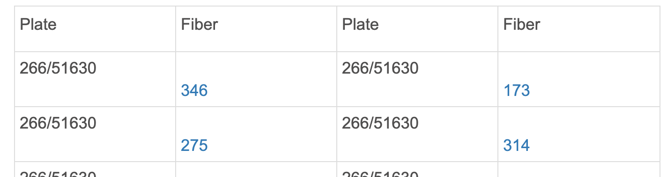
10

4. Each blue hyperlink (a “fiber”) opens an information page for a star. Scroll down the star’s page to find its spectrum. Your goal is to sort the 14 stars into stars groups using features of the spectra. What features in the spectra will you use for sorting? Brainstorm with your partner(s) as you look at the first stars in the database.
5. As you study the spectra, sort them into groups. Develop a process (maybe take notes or draw pictures) to organize your team’s work. Create as many star groups as you need. Different groups can have a different number of stars in them. For a very unusual spectrum, it is okay to make a one-star group, but it is better to carefully look for shared features in other spectra and group it. Use a table like the one below to record your classification. There is no correct number of groups, so you might not use every row in the table. Give each group of stars a name.

CLASSIFICATION OF 14 STARS BY THEIR SPECTRA: OUR TEAM
Stars in Group | Characteristics of Stars in this Group | Name for the Star Group

6. In a paragraph, summarize the process you used to classify the stars into groups.
PART B.
As directed by your teacher, your team will be partnered with another team to compare your classification systems. First, spend a few minutes comparing the team classifications.
Next, take notes while you discuss the following questions with the other team:
- Which team created fewer star groups? Is it better to have more groups or fewer groups?
- List the stars that are grouped together in both classification schemes.
- What feature(s) of the spectra did the other team focus on to sort the stars?
----
- Next, work with the other team to create a consensus classification that both teams are willing to accept. Make a table or a diagram to document this classification. Try to make a figure explains your grouping process to other groups without you explaining it.
- Was it difficult for the two teams to agree on this consensus classification? Why or why not?
- What strategies did your combined group use to discuss differences and build consensus?
- Would it be easier to classify stars into groups if you had additional information about the stars? If so, what else do you want to know about the stars?
- Do you think teams of scientists that first classified stars compared results with other teams before reaching their final classification scheme?
- In general, when and how should scientists compare their results with those from other scientists?

EXPLAIN:
Part A: Classification scheme regularly used by astronomers

Like your classification, the OBAFGKM classification system sorts stars using star spectra. The letters (O, B, A, F, G, K, and M) are labels for groups of stars. Key spectral lines and the specific elements responsible for making them are shown in Tables A1 and A2. The correlation of these star groups with star temperatures is also shown in Table A2.

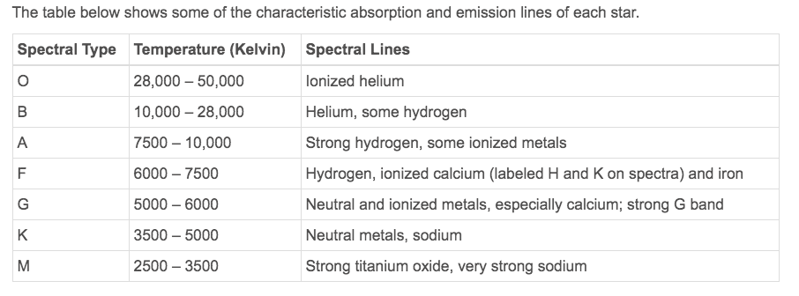
Table A1. Absorption lines in star spectra
Element Creating Spectral Line | Wavelength of Spectral Line (Angstroms)
Helium, Ionized | 4400
Helium, neutral | 4200
Hydrogen atom (H_{α}, H_{β}, H_{γ}) | 6600, 4800, 4350
Ionized Calcium (Ca) | 3800-4000
Sodium  (Na) | 5800
Titanium Oxide (O) | Lots of lines 4900 - 5200, 5400 - 5700, 6200 - 6300, 6700 - 6900
Table A2. Characteristics of OBAFGKM stars
http://voyages.sdss.org/expeditions/expedition-to-the-milky-way/spectral-types/absorption-and-emission-lines/

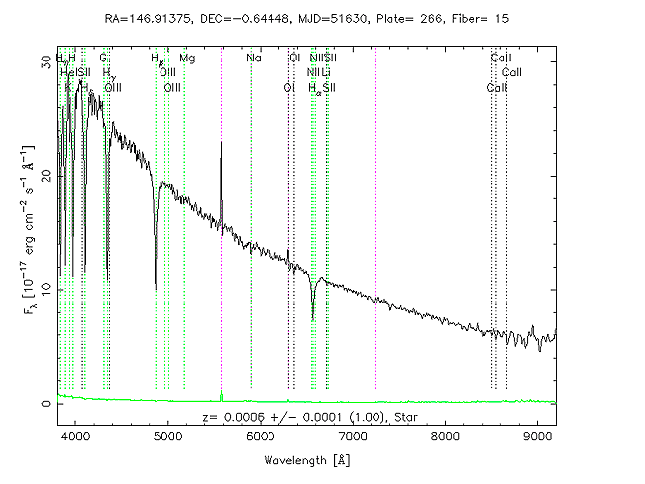
Figure A3. Spectrum of a star (not the Sun)
http://voyages.sdss.org/expeditions/expedition-to-the-milky-way/spectral-types/absorption-and-emission-lines/

Our Sun is a “G” class star. Use the data shown in Figures A1–A3 to answer the following questions about the Sun.
A1. Look at Table A2. What range of surface temperature is expected for the G-type Sun?
A2. Look at Table A2. What spectral lines are characteristic of absorption in G- type spectra?
A3. According to Table A1, ionized calcium absorbs 3800-4000 Angstrom light. Is “ionized calcium” absorption expected in the G-type Sun spectrum? Why or why not?
A4. According to Table A1, what wavelengths of light are absorbed by helium?
A5. Based on Table A2, are spectral lines from helium absorption expected in the G-type Sun spectrum? Why or why not?
Figure A3 shows a spectrum for another star (not the Sun). Refer to this spectrum, as well as Table A1 and A2, to answer the following questions:
A6. List the wavelengths of the seven strongest absorption lines (dips) in the Figure A3 spectrum.
A7. Referring to Table A1, identify the elements that cause the strong absorption lines you noted in the previous question.
A8. Based on the elements you identified in the previous question, assign this star an “OBAFGKM” type.
A9. Based on the assigned “OBAFGKM” type, predict a range of surface temperatures for this star.
A10. Which star is expected to have a higher surface temperature, the Sun (G-type) or the star shown in Figure A3? Explain briefly.
A11. How confident are you of the class and temperature range you assigned the star in Figure A3? Explain.
A12. Is star temperature an important characteristic for finding stars that can support life? Why or why not?

EXPLAIN (continued):
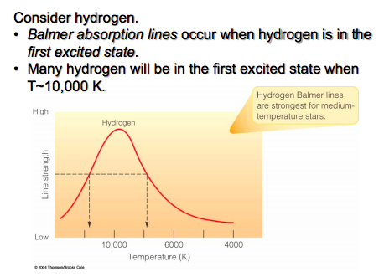
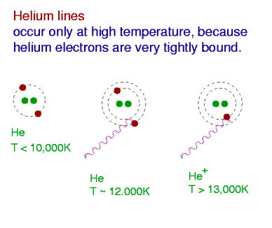
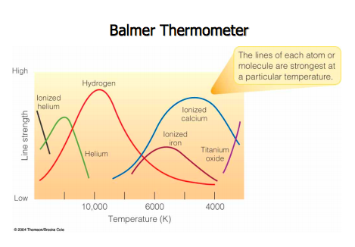
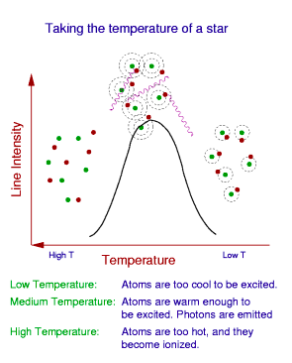
Part B. Why different elements absorb better at different temperatures

B1
B2
B3
B4
IMAGES courtesy of: Dr. Karen Leighly, University of Oklahoma

Refer to the figures above to help you answer the questions that follow:
B1. To absorb light, electrons in atoms must become “excited”. In Figures B1 and B3, atoms (green dots) are shown with electrons (red dots) occupying different energy levels in a BOHR diagram (dotted rings). In Figures B1 and B3, draw squares around atoms with excited electrons.
B2. According to Figure B2, at what star temperature does hydrogen best absorb light?
B3. True or False? According to Figure B4 and compared with hydrogen, helium best absorbs light in relatively hot stars. Justify your answer.
B4. True or False? Table A2 also indicates that helium absorbs better in relatively hot stars.
B5. Compared with hydrogen, why does helium absorb better at higher temperatures? (Two hints: this is shown in the figures and helium is a noble gas.)

EXTEND:

Questions 1–4 involve some research:
1. O-type stars are rarely observed in the universe. Given the relative temperature of O-type stars (review the data above), why are there relatively few O-type stars (good to guess)? What OBAFGKM type(s) of stars are the most abundant in the universe (good to research)?
2. Report on Annie Jump Cannon’s role in developing the OBAFGKM classification scheme.
3. Find out why letters are missing and are out of alphabetical order in the OBAFGKM system.
4. To memorize the notes on the treble clef lines in music (EGBDF), students often memorize the mnemonic “Every Good Boy Does Fine”. Create a mnemonic to memorize the order of letters in OBAFGKM. (Be creative and do not use a mnemonic you find on the web.)

Questions 5–8 are based on the following information:
Stars (and other radiating “blackbody” objects) emit light at a peak wavelength that depends on their temperature. So, a second way to measure star temperatures is to measure the peak wavelength of light emission in a star spectrum and then use this equation:

T = 2.897 x 10⁻³ m K / λ_{peak}.
The equation has two variables: T is the temperature in Kelvin, λ_{peak} is the wavelength in meters. The m and K stand for meters and Kelvin and are units for the constant, not variables.
5. According to this equation, as star temperature increases does peak wavelength increase or decrease? Explain.
6. Which star should have a higher temperature: Star A with a peak wavelength of 400 nanometers or Star B with a peak wavelength of 720 nanometers? Explain or show work.
7. Which star should have a higher peak wavelength of emission: Star X with a surface temperature of 3000 K or Star Y with a surface temperature of 10,000 K? Explain or show work.
8. Let’s use the equation to study the Sun. The peak wavelength for the Sun is 5100 Angstroms.
a. Convert the wavelength to meters (1 m = 1x10⁻¹⁰ Angstroms) for use in the equation.
b. Calculate the predicted surface temperature of the Sun in Kelvin.
c. Compare the temperature you calculated with the equation to the expected surface temperature of G-type stars shown in Figure A2. Do the two measures agree?
d. The human eye can detect wavelengths from 380 to 700 nanometers. Is it a coincidence that the peak wavelength for the Sun (640 nm, 6400 Angstroms) is in this range?

EVALUATE:
First, read the following NASA article on the connection between star types and habitable planets.
https://www.nasa.gov/feature/goddard/2020/goldilocks-stars-are-best-places-to-look-for-life

Then, use the 4-2-1 strategy to identify and discuss the most important ideas.
- On your own, identify and write down the four most important ideas from the reading.
- In pairs, share your ideas, and decide on the two most important ideas from the reading.
- In groups of four, share your ideas, and decide on the most important idea from the reading.

Finally, individually write for 3-5 minutes to explain what you have learned from this activity and reading such that a friend who has never heard the idea could understand it.
OR:
Draw and write a COGNITIVE COMIC that expresses your understanding of the main point of this reading to somebody who has not heard about this idea.

