NITROGEN DIOXIDE ENVIRONMENTAL FACTORS

General
Nitrogen dioxide (NO₂) is a strong oxidizing agent, which reacts with the air. When this happens, it turns into a strong corrosive called nitric acid. Nitrogen dioxide also plays a big role in reactions that take place in the atmosphere. One of these reactions produces ground-level ozone (O₃). Ozone is a gas composed of three oxygen atoms. It can be man-made or natural and is usually found in the Earth’s upper atmosphere.
There are three nitrogen oxides (NO_{x}) usually found in the atmosphere.
- Nitrous Oxide (N₂O). This is a stable gas that has some of the same characteristics as medicine that helps relieve pain. Usually the amount of nitrous oxide is well below what would be needed to have an effect on living organisms.
- Nitric Oxide (NO). This is a colorless gas with a typical ambient concentration less than 0.5 parts per million (ppm). This means that there is not enough naturally occuring to have a significant effect on living organisms. Nitric oxide (NO) is needed to form nitrogen dioxide.
- Nitrogen Dioxide (NO₂). This is a reddish-brown, highly reactive gas present in all urban air and one of the main ingredients needed to create ozone.

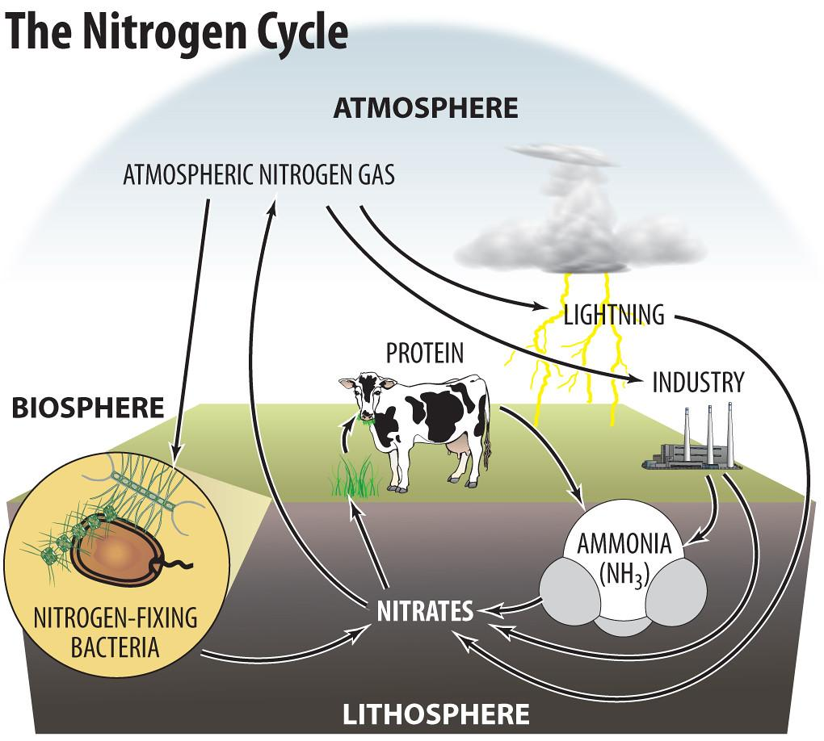
Timmeko. (2011, Sept. 2). The nitrogen cycle. [Image]. Flickr.
https://flickr.com/photos/timmeko/6106058553/in/photostream/Flickr
There are many natural and man-made sources of nitrogen dioxide. Some natural sources of nitrogen dioxide include processes that take place in the soil for living organisms to survive and atmospheric oxidation of ammonia.

Man-made sources of nitrogen dioxide are more important because they can cause ozone air pollution in populated areas and make up most of the nitrogen dioxide emissions. Man-made nitrogen dioxide can occur as a result of emissions from high-temperature fuel combustion systems such as those found in vehicles and industrial and utility boilers.
These gases usually occur in the form of nitric oxide, which is then oxidized, or chemically combined with oxygen, in the atmosphere to create nitrogen dioxide. The amount of time it takes to change to nitrogen dioxide depends on the amount of nitric oxide and ozone. If ozone is present, the change is very fast. Emissions at the ground level make-up most of the nitrogen oxides (NO_{x}) involved in this formation of ozone.
Effects
Nitrogen dioxide is a lung-related irritant affecting mostly the upper respiratory system. At normal levels, nitrogen dioxide has not been proven to be related to lung disease, but even in small amounts, healthy people can get sick. People who already have breathing diseases, like asthma, are more likely to get sick if they are exposed to high levels of nitrogen dioxide. It can lower the body's ability to breathe and fight off lung related infections. These can include the following:
- Bronchitis, which is a buildup of mucus in the airways to the lungs;
- Pneumonia, which is an infection of the air sacs in one or both of the lungs;
- Edema, which is fluid buildup and swelling of the lungs.

Nitrogen oxide (NO_{x}) in the air is a big contributor to some environmental effects like those listed below:
- Pollutes rainfall;
- Reduces oxygen in the water (hazardous to fish and other animal life);
- Increases corrosion on metals;
- Fades fabric;
- Harms vegetation;
- Limits visibility.

Standards
There are two primary National Ambient Air Quality Standards (NAAQS) for nitrogen dioxide:
- The 1-hour nitrogen dioxide standard of 100 parts per billion (ppb) as determined by the three-year average of the 98th percentile of the annual distribution of daily maximum 1-hour average concentrations.
- The annual arithmetic mean of 0.053 ppm of nitrogen dioxide .

Oklahoma Department of Environmental Quality. (2020, April). Nitrogen Dioxide. [Fact sheet]. https://www.deq.ok.gov/wp-content/uploads/deqmainresources/NitrogenDioxide_05-2021.pdf

