Graphing With Asymptotes, Part 2

Graph each rational function. Be sure to label the asymptotes.

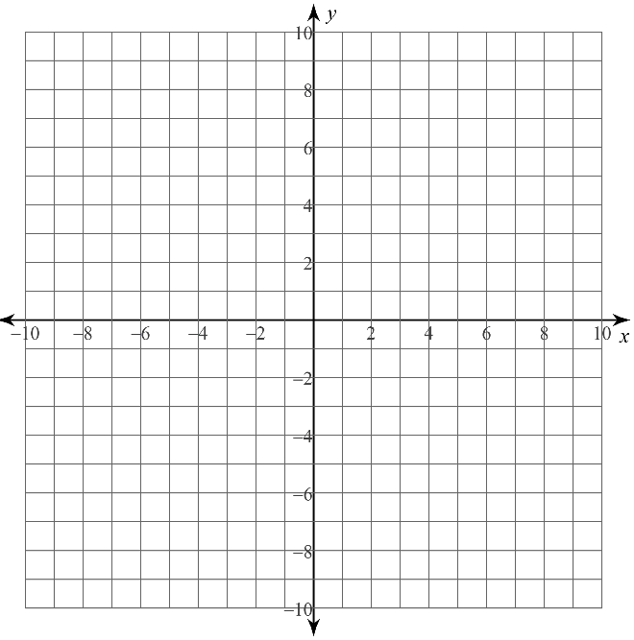

**1)** 

**2)** 

**3)** 