Photosynthesis Lab
Photosynthesis occurs when an organism uses light energy to convert carbon dioxide and water into glucose and oxygen.

Directions
Read through and answer the following questions. Then, move on to the procedure.
- What variables affect photosynthesis?

- What makes plants stop growing? Could any of these factors affect photosynthesis?

- The lab uses leaves in a solution, either with carbon dioxide or without carbon dioxide. Based on what you have learned up to this point, what is something observable that you can look for to know whether photosynthesis is occurring?

Materials
- Baking soda | - 2 plastic syringes | - Living leaves | - Hole punch
- Liquid dish soap | - 2 clear plastic cups | - Timer | - Light source

Procedure
- Using a one-hole punch, cut 20 leaf disks from young, actively growing leaves.
- Prepare one cup or beaker with 300 mL of water. In the second beaker, prepare a 0.2% solution of sodium bicarbonate (NaHCO₃) by adding approximately 1.5 g of baking soda to 300 mL of water. Stir until dissolved. Use an eyedropper to add about two drops of dish detergent to each beaker and stir gently. There should be no bubbles afterward.
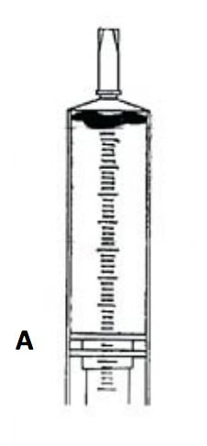
- Remove the plungers from two large, clean syringes (no needle). Place 10 leaf disks into the body of each syringe. Be sure the leaf disks are near the tip of each syringe as you reinsert the plunger so as not to damage the disks.
- Insert the tip of one syringe into the beaker of 0.2% sodium bicarbonate solution and draw 15–20 mL into the syringe. Insert the tip of the other syringe into the beaker of water and draw 15–20 mL into the syringe.
- The leaf disks should be floating at this time. Now, do this with each syringe: Hold the syringe tip upward and expel the air by depressing the plunger slowly and carefully. Stop before the solution comes out the tip.
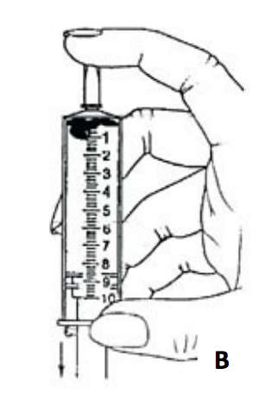
- Do this with each syringe: Seal the tip of the syringe using your left index finger and hold tightly. With your right hand, pull back on the plunger to create a partial vacuum within the syringe. If you have a good seal, it should be hard to pull on the plunger and you should see bubbles coming from the edges of the leaf disks. After holding for a count of 10, simultaneously release your index finger and the plunger. Some of the leaf disks should start to sink. Tap the side of the tube or shake it gently to break any bubbles on the edges of the disks.
- Repeat step 6 with each syringe until all the disks sink. Do not overdo it! You have been successful if the disks sink to the bottom. Don't repeat past this point "just to be sure," as it is possible to damage the cells of the leaves from overdoing it.
- Remove the plunger from each syringe. Pour the NaHCO₃ solution with leaf disks back into its original beaker. Pour the water solution with leaf disks back into the other beaker. There should be 10 leaf disks per beaker. Make sure all the disks sink to the bottom.
- Place both beakers under a light source, approximately 6–8 inches below the light. The lights are best held in a clamp on a ring stand. Begin timing the experiment as soon as the light is turned on. Record your observations on the next page.
- Notice what is happening to the leaf disks in each beaker as photosynthesis occurs. Continue to record your observations in the chart on the next page. After each time check, tap the sides of each beaker to make sure the leaf disks are not sticking to the container walls.
- Clean the lab equipment and dispose of the solutions in the sink drain.

Data Collection Sheet
After 15 minutes, consider the trial done and assume no more leaf disks will rise.
Time (minutes) | Number of Disks Floating (with CO₂) | Number of Disks Floating (no CO₂)
1
2
3
4
5
6
7
8
9
10
11
12
13
14
15

Analysis
- Use the grid on the next page to graph the results from the experiment.
- What are the independent and dependent variables of the trial?

- Explain why it was important to add sodium bicarbonate (NaHCO₃) to only one beaker.

- Based on your graph, what relationship did you find between the independent variable and the dependent variable?

- Did any of the leaf disks float in the water solution? If not, why? If yes, what might explain this result?

- What caused the disks to start floating? What happened? What role does carbon dioxide play in this process?

Determine what type of graph is best in consideration of the data. Label everything and include both data sets (solution with CO₂ and solution without CO₂) in one graph.

Adapted from Williamson, B. (2017, April 21). The Floating Leaf Disk Assay for Investigating Photosynthesis. Biology Junction. https://biologyjunction.com/floating-leaf-disk-assay/

