historical mingle cards
You are Lord Castlereagh, Foreign Minister of Great Britain.  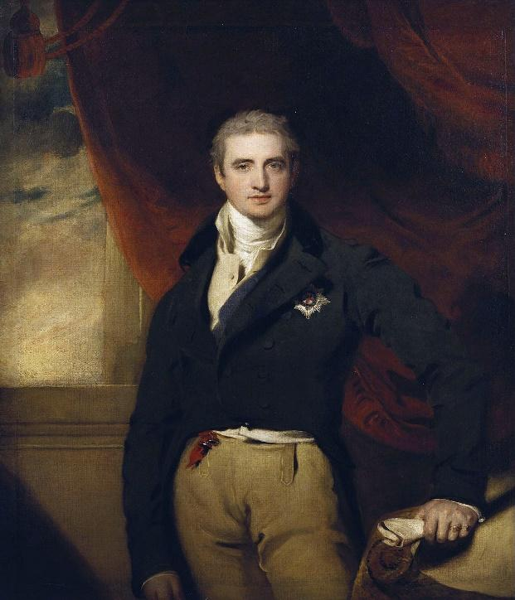  I desired a balance of power; therefore I advocated that Russia and France did not gain large amounts of territory. I was a member of the Conservative Order. I supported the creation of buffer states around France and worked to see that France’s borders went back to the 1790s, both resulted in checking France’s power. I supported giving Poland to Russia, in hopes of stopping Russia’s ambitions of acquiring land. I supported giving more land to Prussia, resulting in a strengthening of its power. I was moderately successful at balancing power in Europe, but Prussia continued to rise in power, and Russia continued to gain land, so my goal was not fully achieved. | You are Charles-Maurice de Talleyrand, Foreign Minister of France.  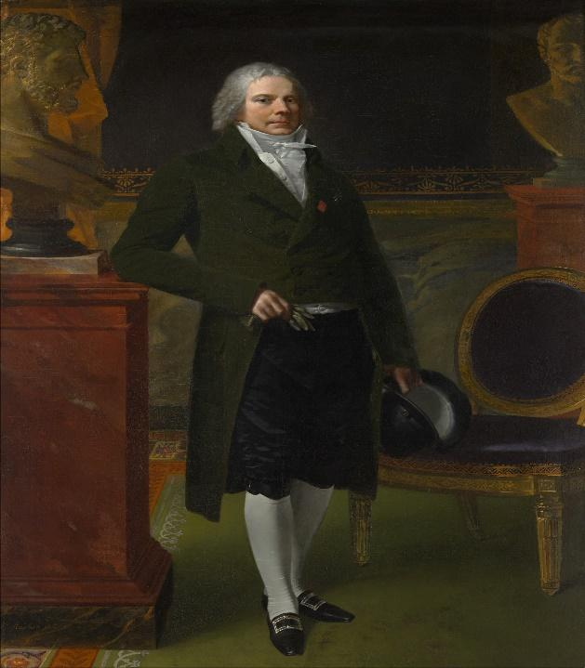  I desired for France to not be seen as a defeated country, but an historical major power at the peace negotiations. I worked to include France in major discussions and encourage the other countries to be lenient to France. I desired to have the “legitimate” Monarch, Louis XVIII, placed on the French throne after the overthrow of Napoleon and was successful as the representatives agreed to place the rightful Bourbon Monarch on the French throne.
You are Klemens von Metternich, Foreign Minister of Austria.  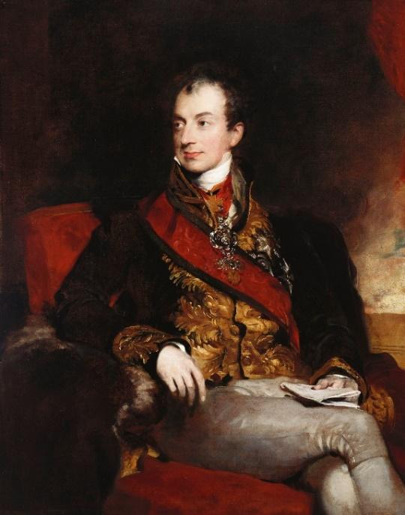  I led the Conservative Order and wanted to see the previous monarchs who had been dethroned by Napoleon put back in charge because I favored traditional leaders and disliked the possibility of letting ordinary people vote. I also supported the creation of buffer states around France to keep France from becoming too powerful. I felt that a strong monarch in France would stop Russia from attempting to expand. I also worked to ensure Russia was not given too much land as I didn’t want Russia to become too powerful. I wanted to prevent future revolutions like the one in France, so I disliked ideas of nationalism and liberty. | You are Tsar Alexander I, leader of Russia.  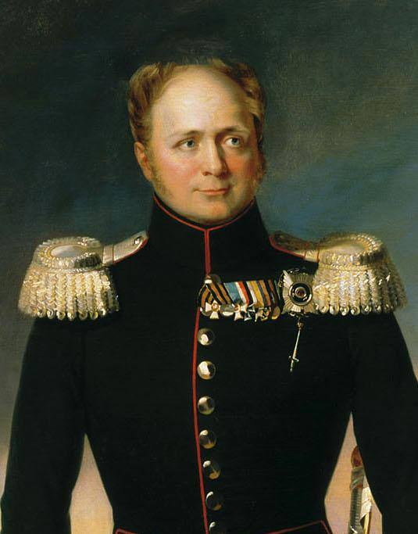  I viewed Russia as a great power who defeated Napoleon. I wanted Russia to gain land and have a goal of adding Poland to Russian control. I also wanted to ensure Russia does not lose control of Finland. I supported the return of a monarch to France and do not like the ideas of liberty. Unfortunately, people viewed me as not having many friends and saw that Russia was rising in power, so the other countries didn’t seem to trust me.

Lumen. (n.d.). Congress of Vienna. Boundless world history. https://courses.lumenlearning.com/boundless-worldhistory/chapter/the-congress-of-vienna/.
Wikimedia. (n.d.). Alexander I of Russia by G. Dawe. [Digital Image]. https://commons.wikimedia.org/wiki/File:Alexander_I_of_Russia_by_G.Dawe_(1825,_Russian_museum).jpg.
Wikimedia. (n.d.). Prince Metternich by Lawrence. [Digital Image]. https://commons.wikimedia.org/wiki/Category:Prince_Metternich_by_Lawrence.
Wikimedia. (n.d.). Robert Stewart, Viscount Castlereagh. [Digital Image]. https://commons.wikimedia.org/wiki/Category:Robert_Stewart,_Viscount_Castlereagh.
Wikimedia. (n.d.). Charles Maurice de Talleyrand [Digital Image]. https://commons.wikimedia.org/wiki/File:Charles_Maurice_de_Talleyrand_P%C3%A9rigord_(1754%E2%80%931838),_Prince_de_B%C3%A9n%C3%A9vent_MET_DP277234.jpg.

