tarjetas de artefactos
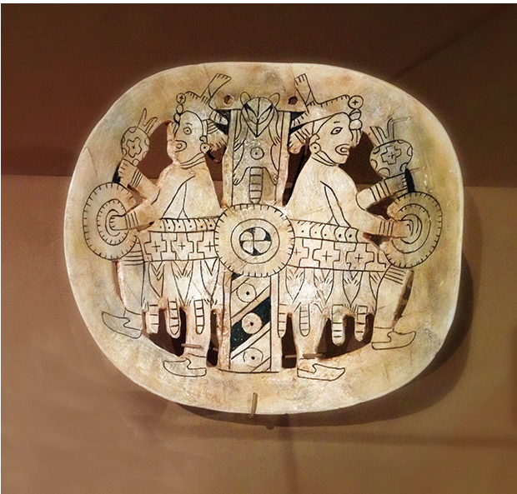 | 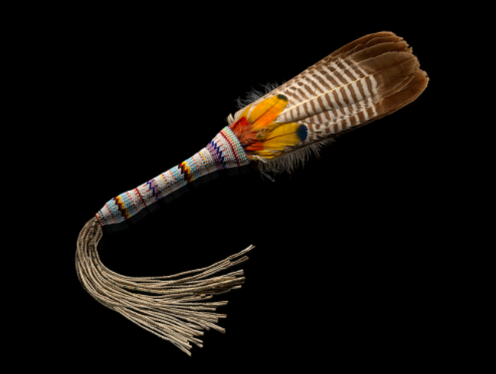
Artefacto #1: Fuente: https://www.405magazine.com/the-treasure-of-spiro-mounds
Artefacto #2: Fuente: https://www.smithsonianmag.com/blogs/national-museum-american-indian/2018/11/30/native-perspectives-american-indian-religious-freedom-act/

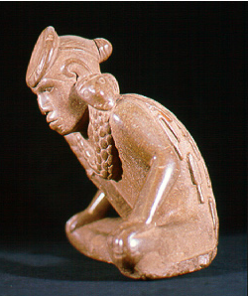 | 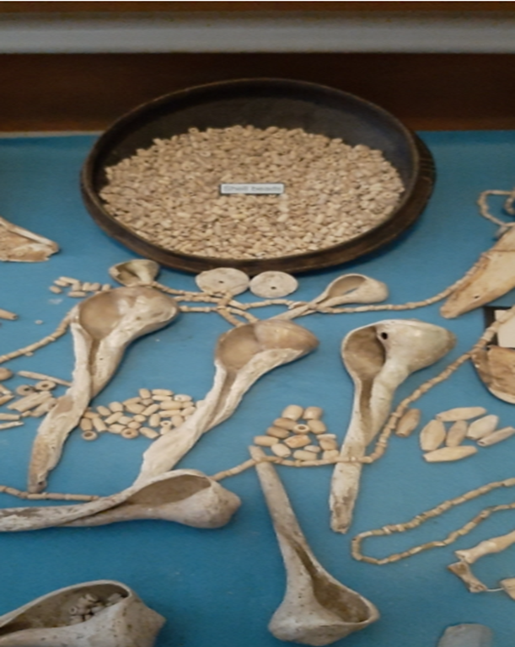
Artefacto #3: Fuente: https://archeology.uark.edu/who-we-are/50 moments/spiro-mounds
Artefacto #4: Fuente: https://okwnews.com/news/whatzup/the-first-major-exhibit-displaying-the-history-art-and-artifacts-of-the-spiro-mounds-is-at-the-national-cowboy-western-heritage-museum-through-may-9
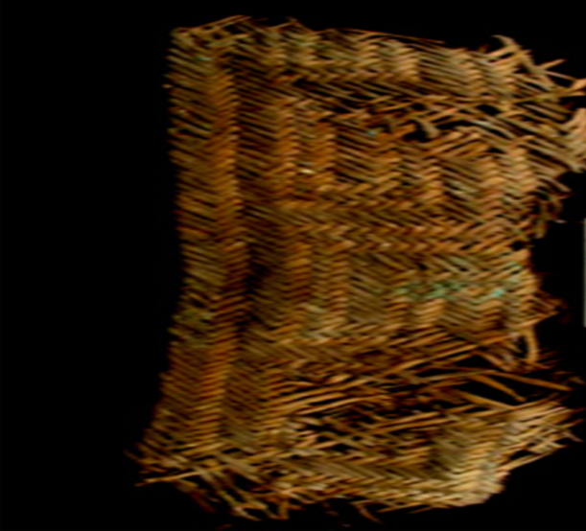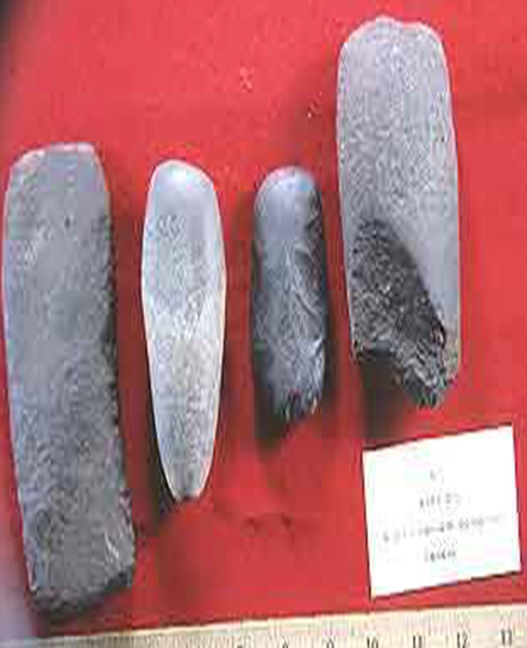
Artefacto #5: Fuente: https://archeology.uark.edu/who-we-are/50moments/spiromounds/
Artefacto #6: Fuente: https://archeology.uark.edu/who-we-are/50moments/spiromounds/
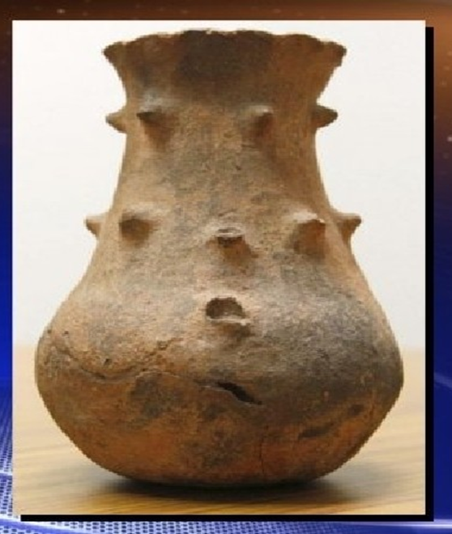 | 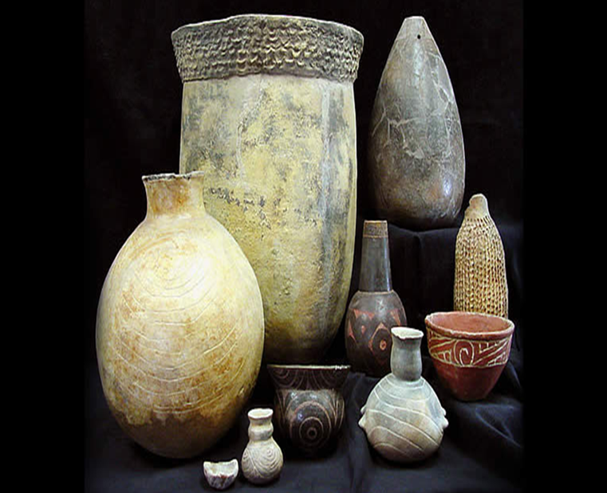
Artefacto #7: Fuente: https://ktul.com/archive/gallery/spiro-mounds-artifact-turns-up-at-goodwill?photo=1
Artefacto #8: Fuente: https://www.texasbeyondhistory.net/tejas/clay/tradition.htm

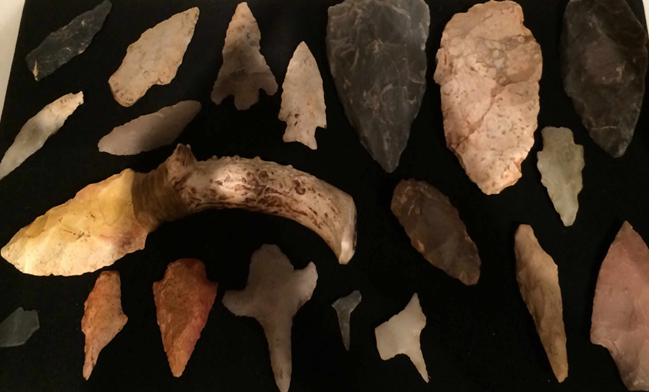 | 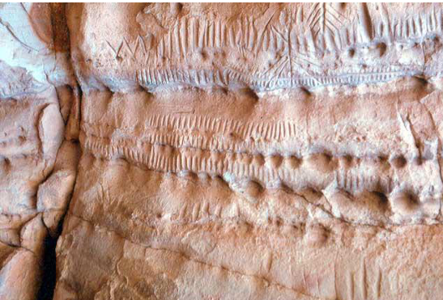
Artefacto #11: Fuente: https://www.gannmusuem.com/native-americans-of-benton/
Artefacto #12: Fuente: http://ou.edu/content/dam/archsurvey/docs/archsur-Sites_By_County.pdf

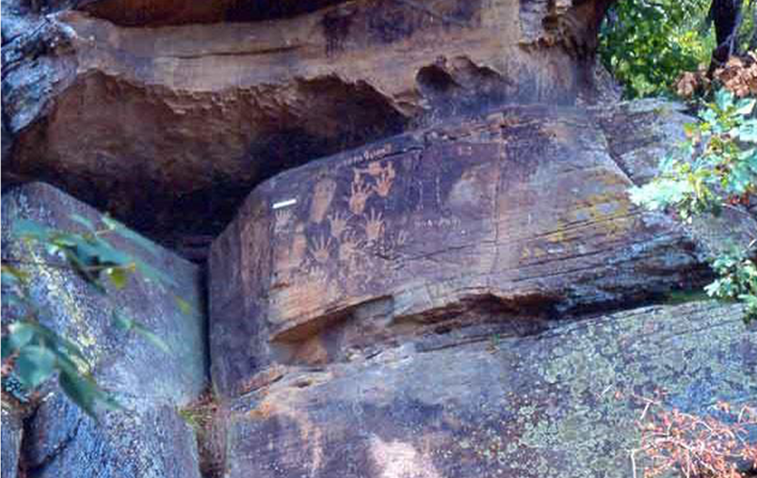 | 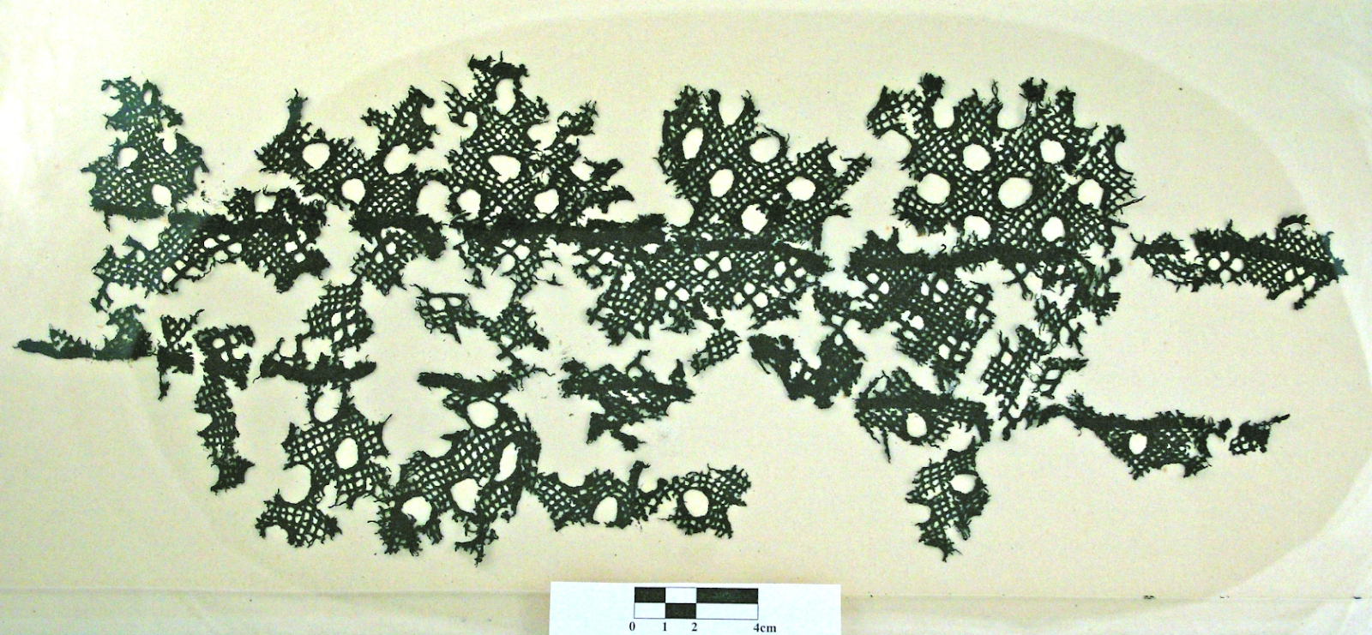
Artefacto: #13: Fuente: http://ou.edu/content/dam/archsurvey/docs/archsur-Sites_By_County.pdf
Artefacto: #14: Fuente: http://ou.edu/content/dam/archsurvey/docs/archsur-Sites_By_County.pdf

