Creating Composites
Select one solid from each column in columns 1–4 and circle your selections. Use your selected solids to create a model. Sketch your model and find the surface area of your model. All given dimensions are in inches.
Ready for an extra challenge? Also include a solid from the Extra Challenge column in your model and surface area calculations.
Column 1 | Column 2 | Column 3 | Column 4 | Extra Challenge
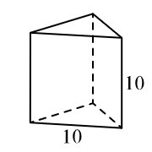  Regular Triangular Prism | 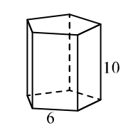  Regular Pentagonal Prism | 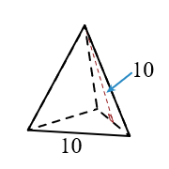  Regular Triangular Pyramid | 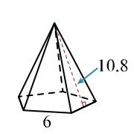  Regular Pentagonal Pyramid | 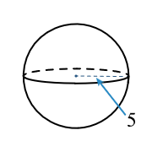  Sphere
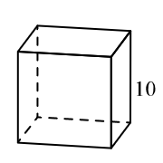  Cube | 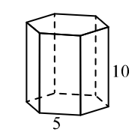  Regular Hexagonal Prism | 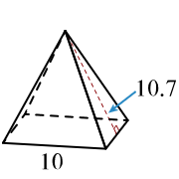  Square Pyramid | 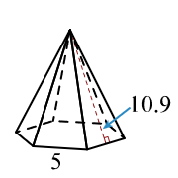  Regular Hexagonal Pyramid | 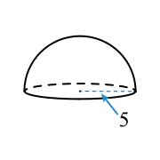  Hemisphere
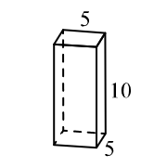  Rectangular Prism | 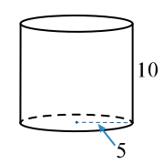  Cylinder | 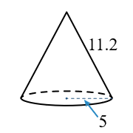  Cone | 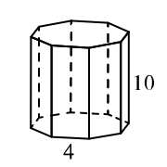  Regular Octagonal Prism | 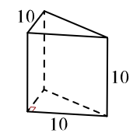  Right Triangular Prism

