Measure your solid.  Label your measurements. |  | Find the surface area of the solid.  Show your work.
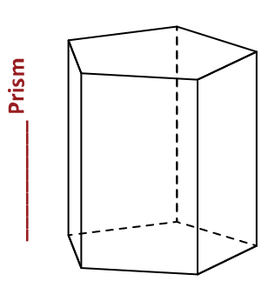
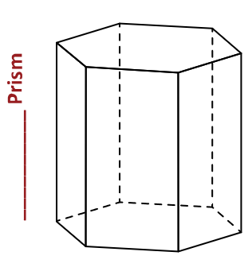
Prism Reflection: Do you notice any patterns when finding the surface area of the prisms?
If so, what pattern did you notice?

Using words, write a formula for the surface area of a prism.

Measure your solid.  Label your measurements. |  | Find the surface area of the solid.  Show your work.
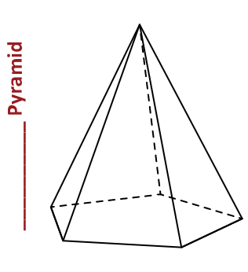
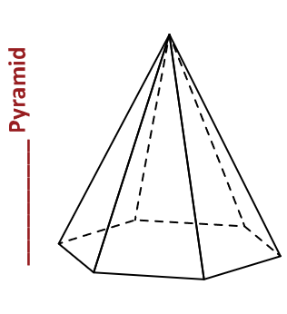
Pyramid Reflection: Do you notice any patterns when finding the surface area of the pyramids? If so, what pattern did you notice?

Using words, write a formula for the surface area of a pyramid.

Measure your solid.  Label your measurements. |  | Find the surface area of the solid.  Show your work.
Prism Reflection: Do you notice any patterns when finding the surface area of the prisms?
If so, what pattern did you notice?

Using words, write a formula for the surface area of a prism.

Measure your solid.  Label your measurements. |  | Find the surface area of the solid.  Show your work.
Pyramid Reflection: Do you notice any patterns when finding the surface area of the pyramids? If so, what pattern did you notice?

Using words, write a formula for the surface area of a pyramid.

