S-I-T (SURPRISING, INTERESTING, TROUBLING)
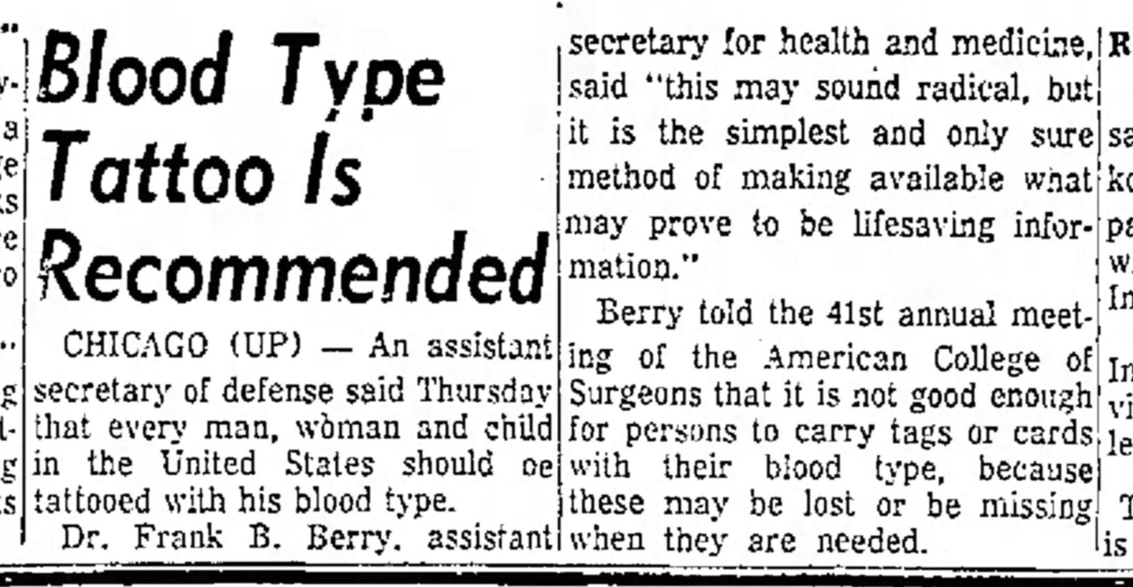
Source: United Press. (1955, November 4). Blood type tattoo is recommended. Anderson Herald. https://i2.wp.com/orangebeanindiana.com/wp-content/uploads/2020/01/Anderson_Herald_Fri__Nov_4__1955_.jpg?ssl=1

After you finish reading this article, enter one surprising fact or idea, one interesting fact or idea, and one troubling fact or idea in the designated columns. Share what you’ve discovered with an elbow partner.

Surprising Fact/Idea | Interesting Fact/Idea | Troubling Fact/Idea

