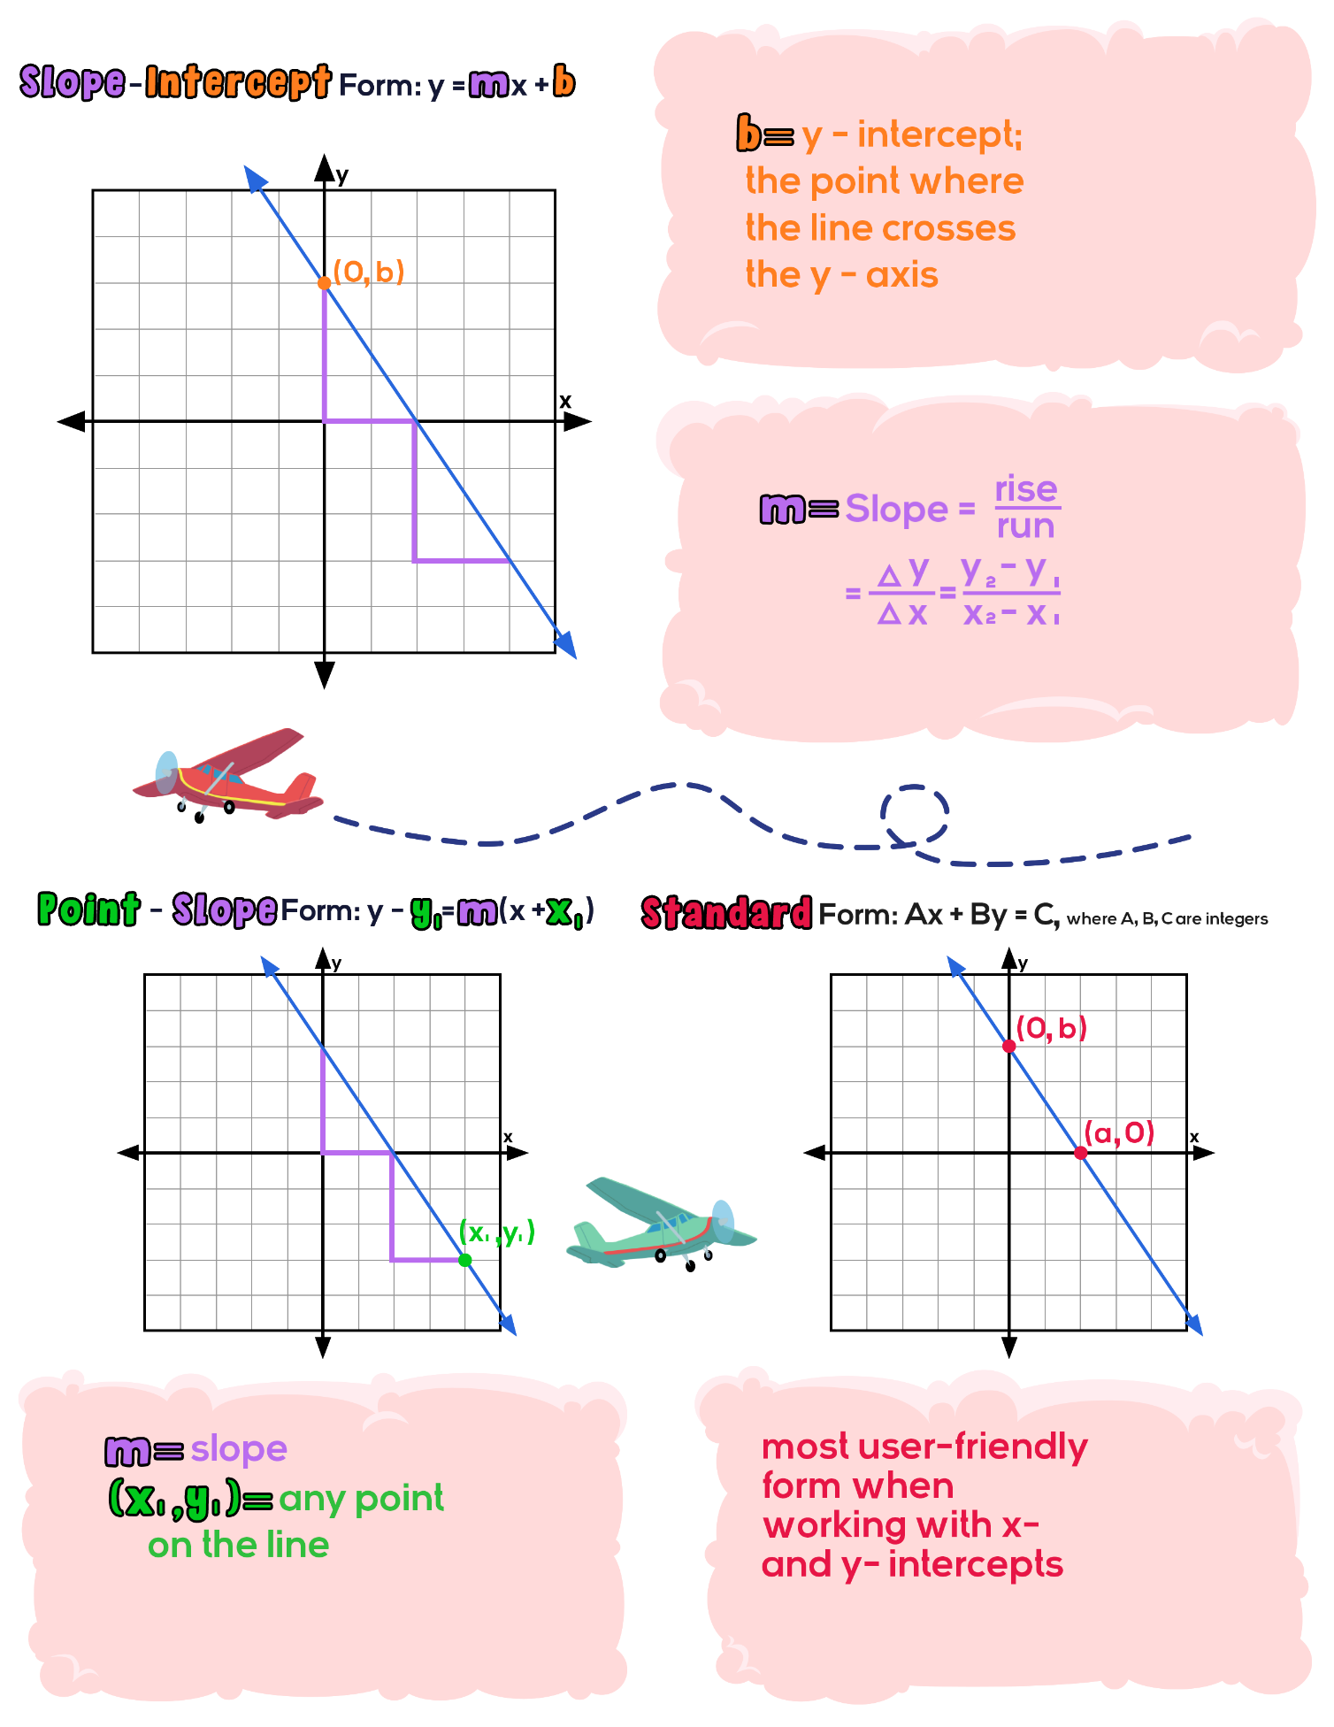Linear Equations: Guided Notes

# Screen 9

# Screen 10

