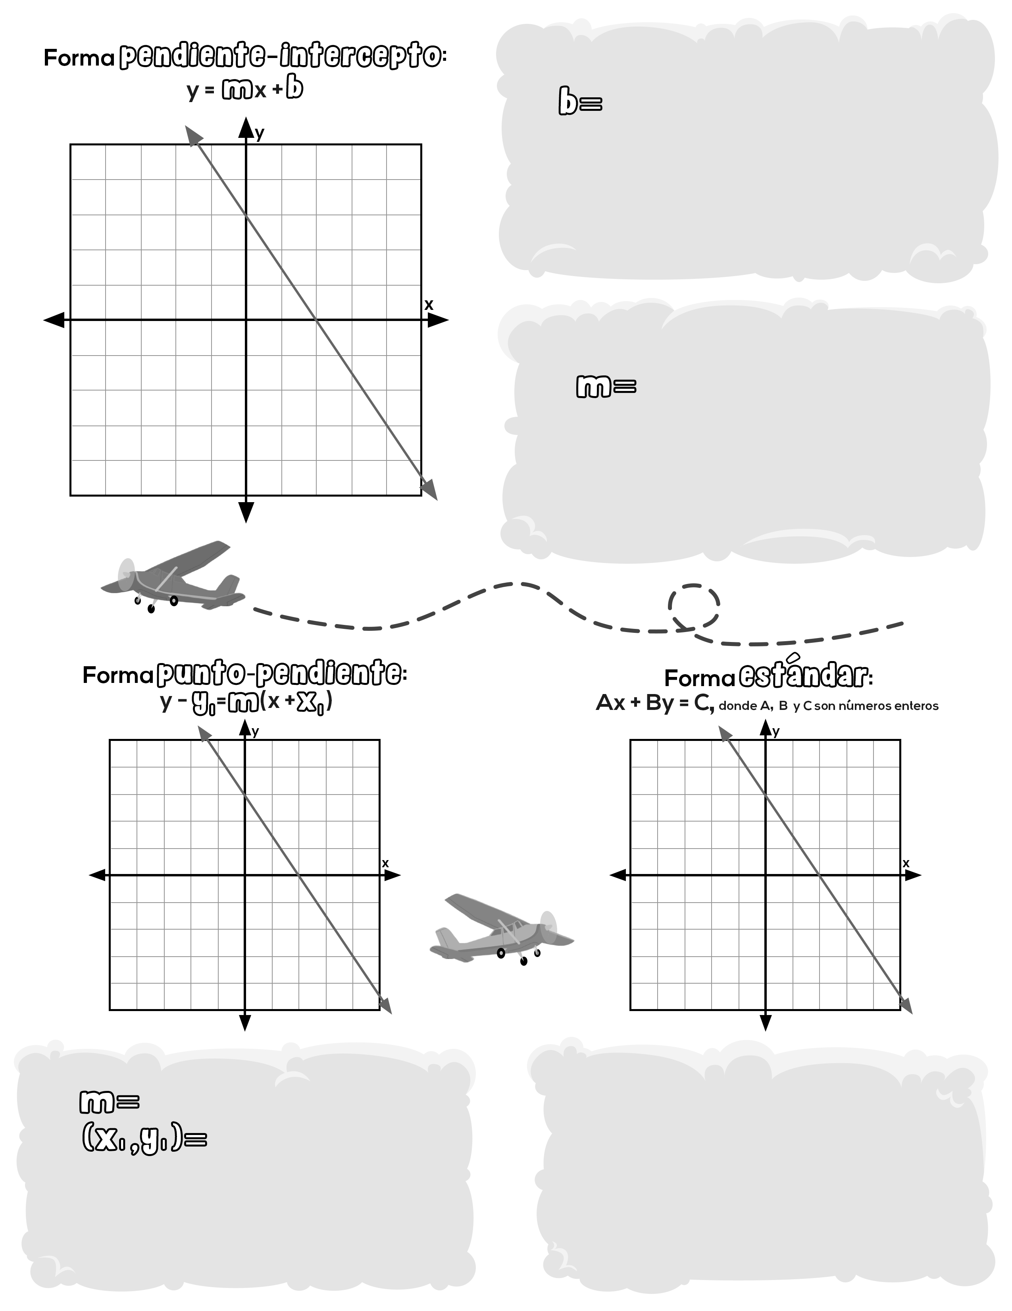notas guiadas: ecuaciones lineales

# Pantalla 9

# Pantalla 10

