Cut out the cards below. Match the images and text to create 5 pairs of cards. You will need the two blank cards later in the lesson.
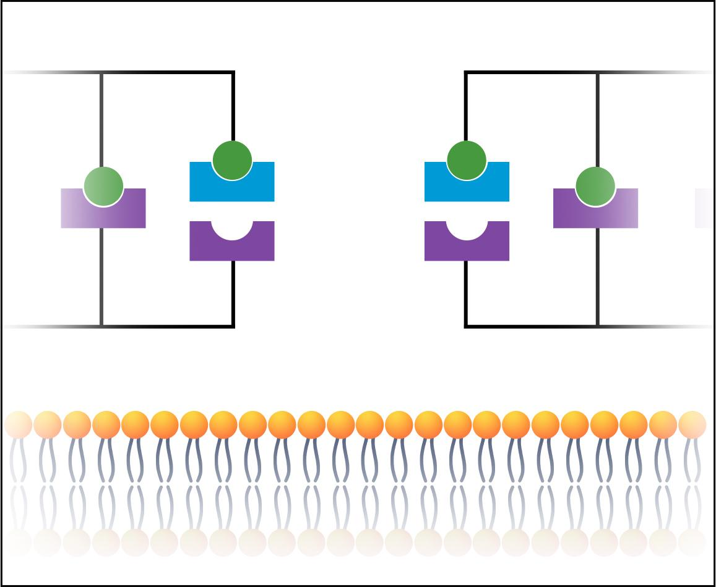 | 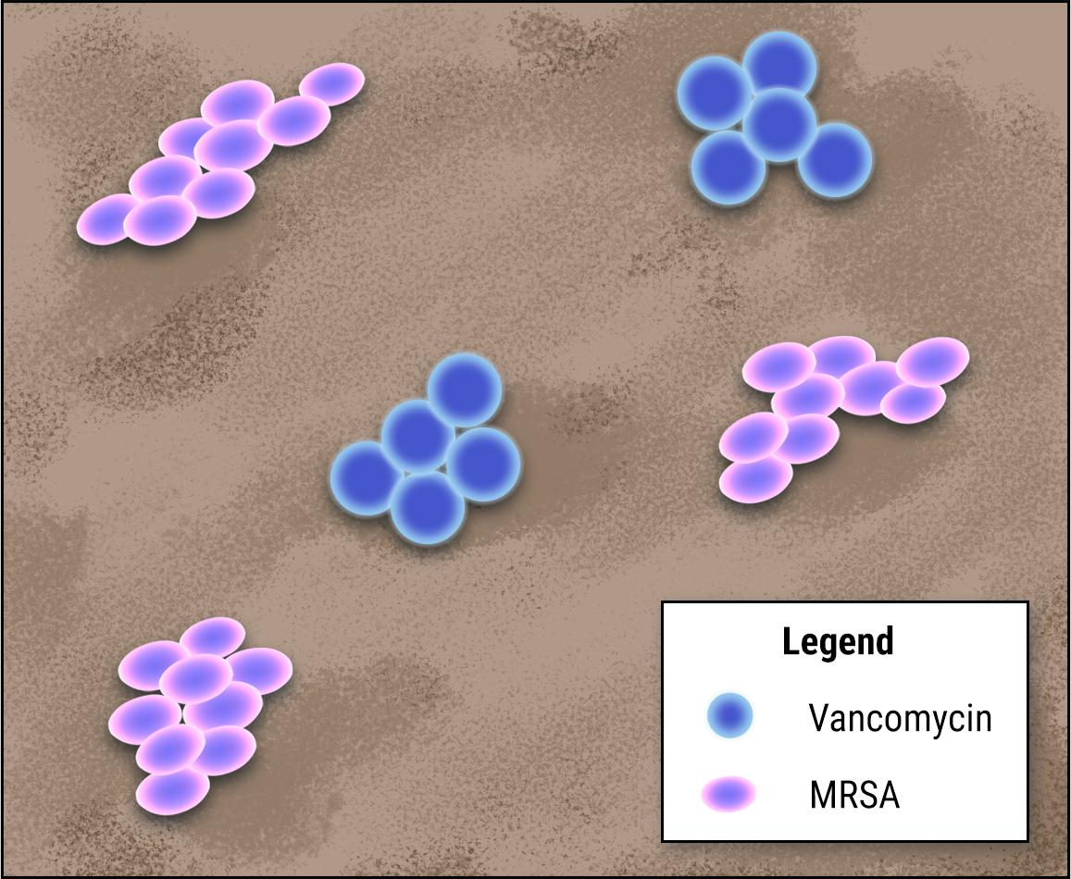 | A person becomes infected with MRSA and is treated with the antibiotic vancomycin.
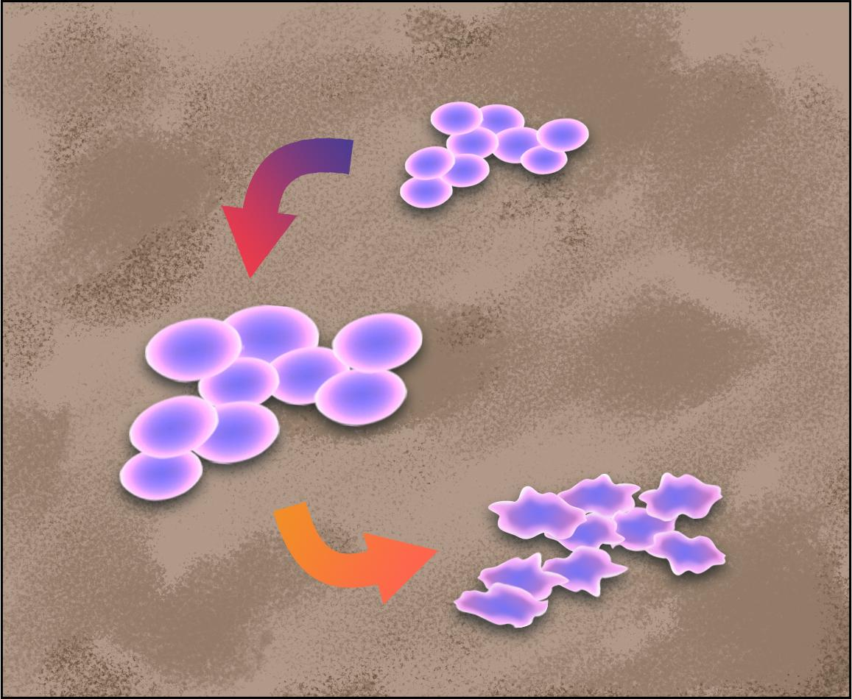 | 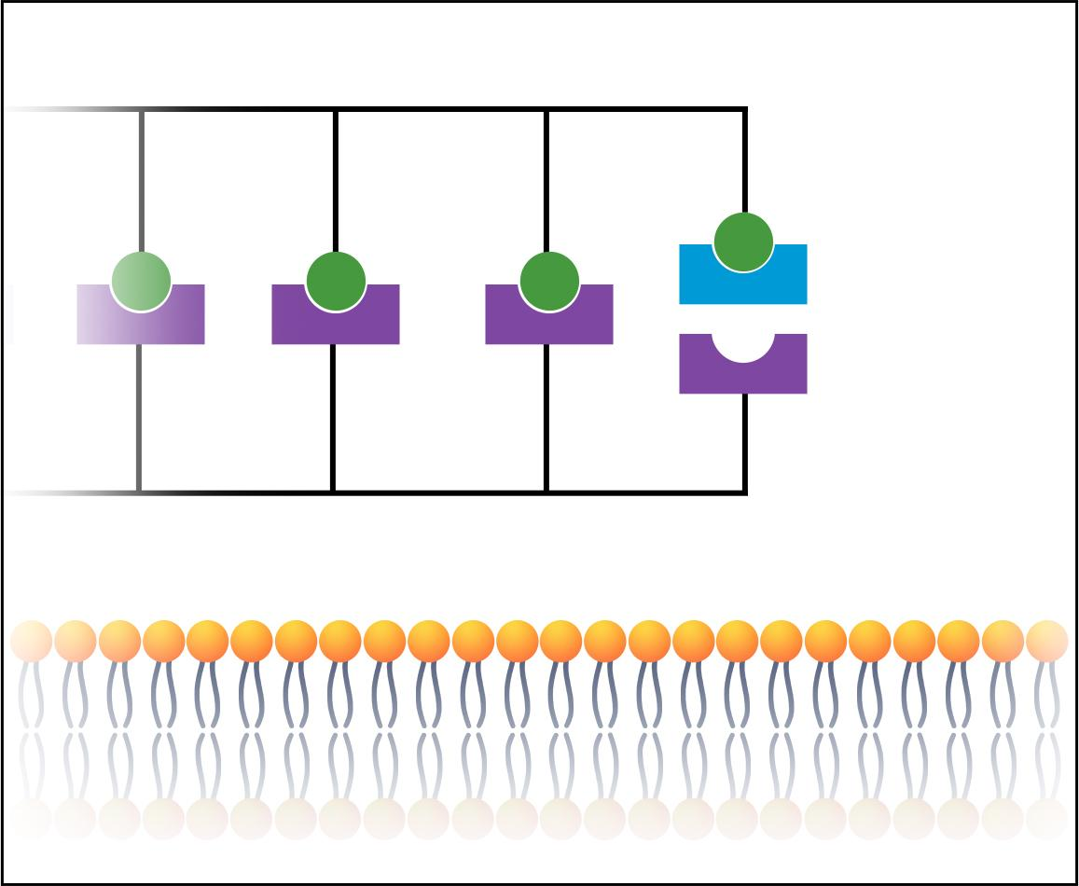 | Vancomycin binds to the end of one wall-protein building block. This prevents the two cell wall proteins from binding to each other.
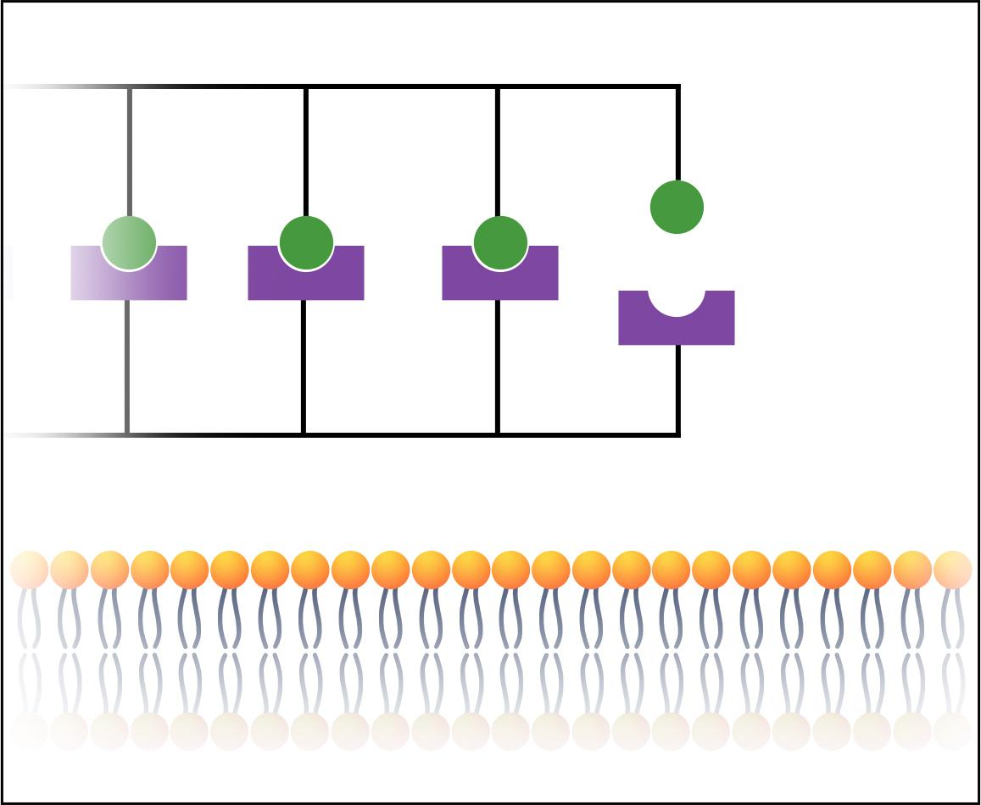 | Two protein “building blocks” bind at their ends to create new cell wall as the MRSA bacteria grow and replicate. | The MRSA cell swells, bursts, and collapses. This is a process called lysis.
A hole forms in the cell wall and the plasma membrane becomes exposed.

