Create your own
Your Situation: | Table:  x units: _____ y units: _____
Your Graph:  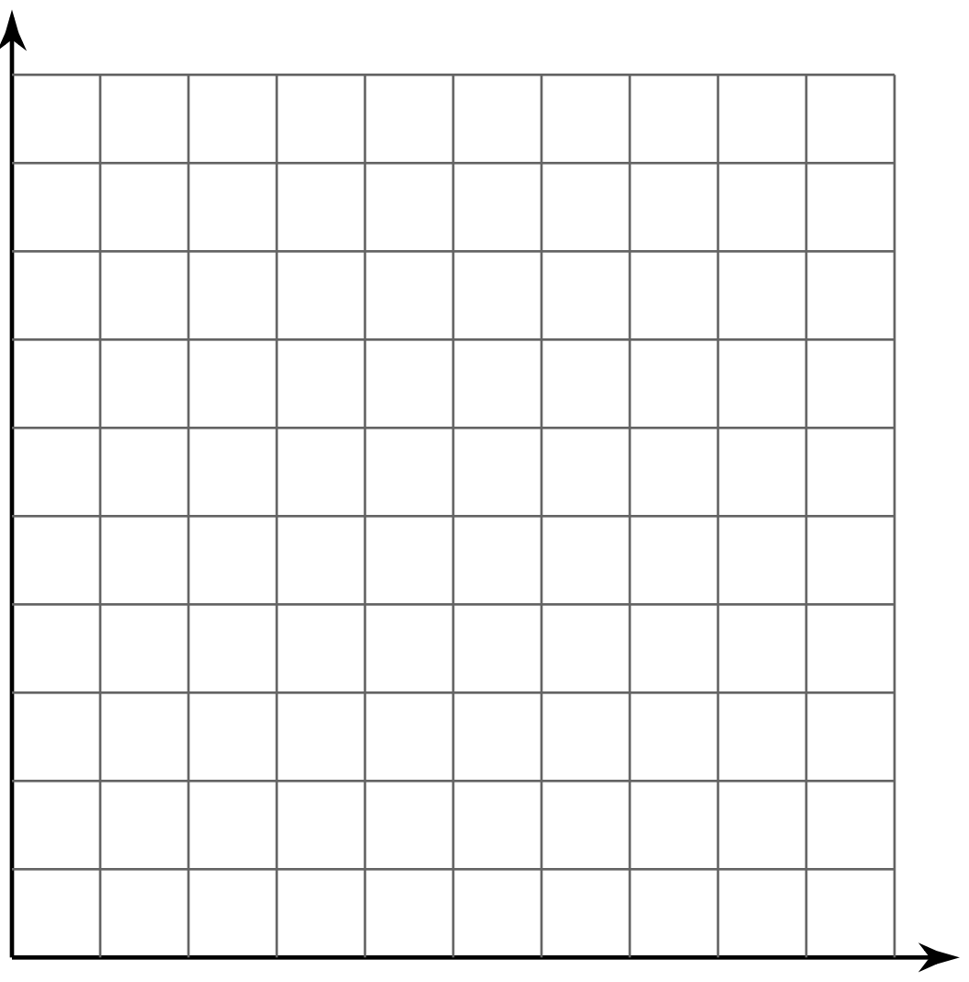 | Your Equation:  First, identify your rate of change  (with units):  Secondly, identify your y-intercept:  Lastly, write your equation (y = mx + b):

