Situation 1: You love the book you’re reading for English class. Once, you read 100 pages in 30 minutes. Another time, you read 150 pages in 45 minutes. However, one time you read 140 pages in 42 minutes, which felt slower than usual. | Graph: Create a graph for this situation.  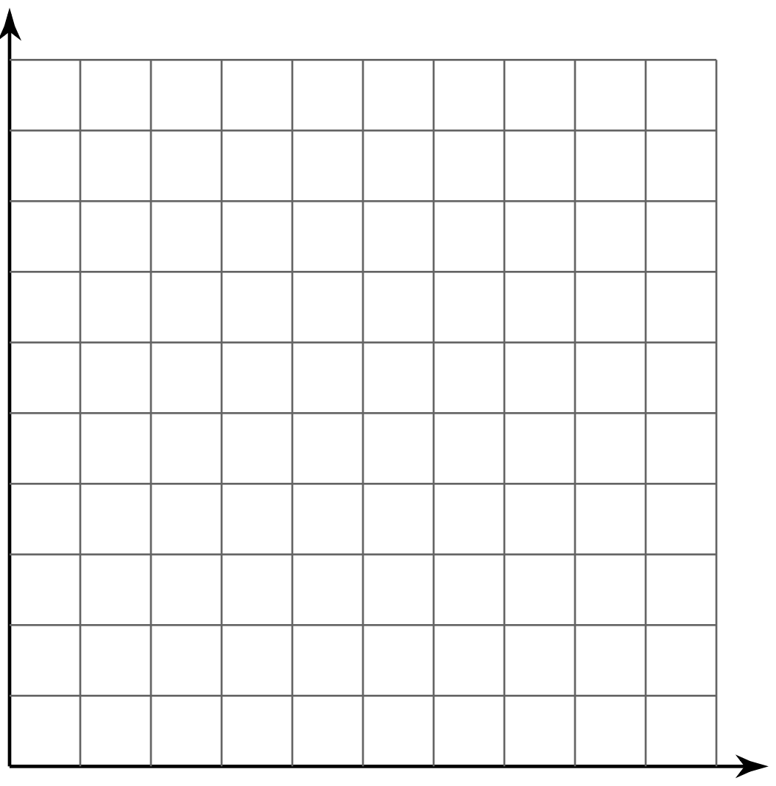 | Description: Is this graph a line? Explain your thinking.
 |  | Characteristics: Identify the y-intercept.
Situation 2: Your parents have started a new healthy lifestyle diet. They do a pretty good job of sticking to it, even though in the beginning they were a little grumpy. After the first week, they lost 5 pounds. After the first four weeks, they lost 16 pounds, and after 9 weeks they lost 20 pounds. | Graph: Create a graph for this situation. | Description: Is this graph a line? Explain your thinking.
 |  | Characteristics: Identify the y-intercept.

Situation 3: You are saving money to buy a new video game. You currently have $20 in your piggy bank. After 1 week, you have $25. After 5 weeks, you have $45, and after 9 weeks you have $65. | Graph: Create a graph for this situation. | Description: Is this graph a line? Explain your thinking.
 |  | Characteristics: Identify the y-intercept.
Situation 4: Your club is selling lemonade as a fundraiser, and you are in charge of keeping track of the sales. In the first week, the club sold 47 drinks. After the 3rd week, they sold 141 drinks, and after 7 weeks, they sold 329 drinks. | Graph: Create a graph for this situation. | Description: Is this graph a line? Explain your thinking.
 |  | Characteristics: Identify the y-intercept.

