Great Depression Slang Cards
Hoover flag | Pockets turned inside out to symbolize the lack of money someone has. | 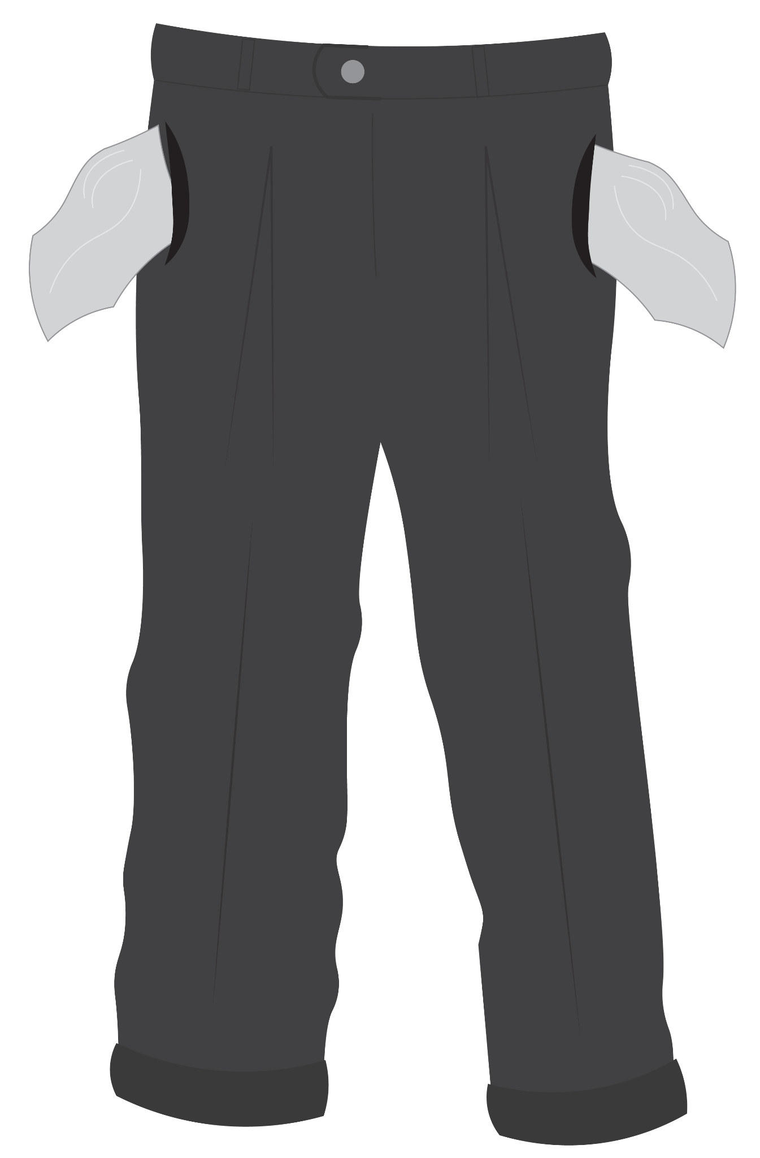
Hoover wagon | A car pulled by horses because it is out of gas or has broken down. | 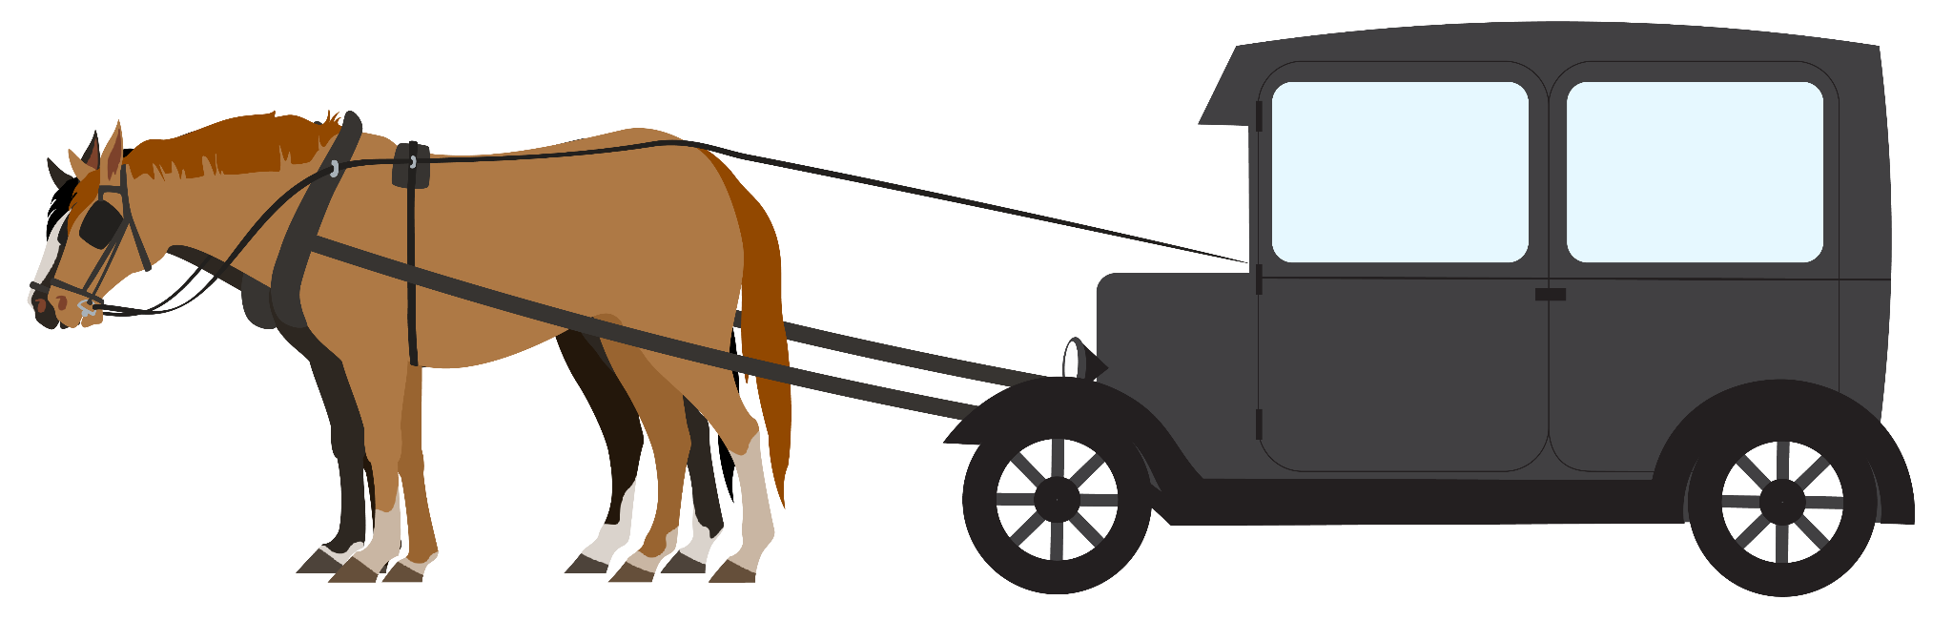
Hooverville | A group of homes ranging from a hundred to thousands built from materials such as cardboard, tar paper, lumber, glass, tin, or whatever materials could be easily found. | 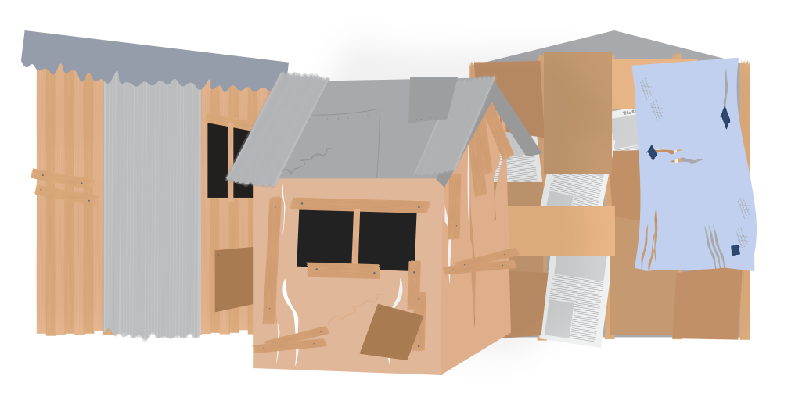
Hoover blanket | Newspaper used as blankets, typically by people without shelter available. | 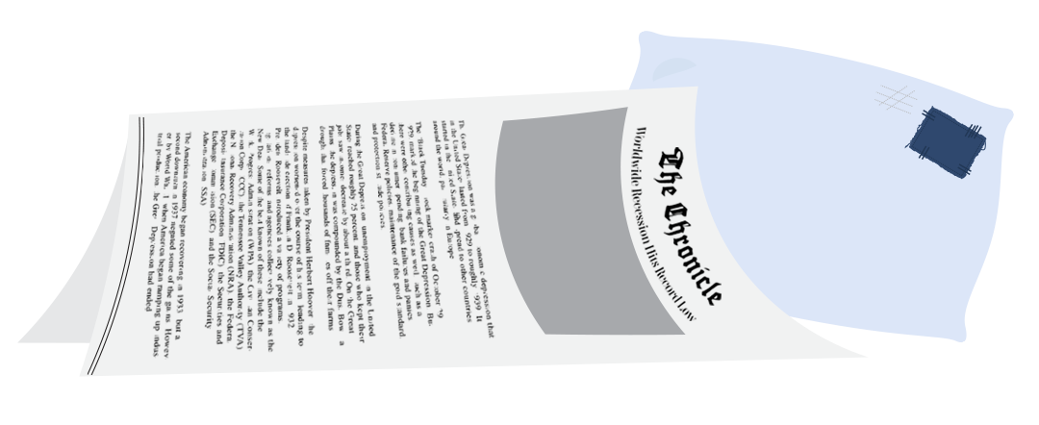
Hoover leather | Cardboard lining of shoes that had started to lose their soles. | 