SINÉCTICA
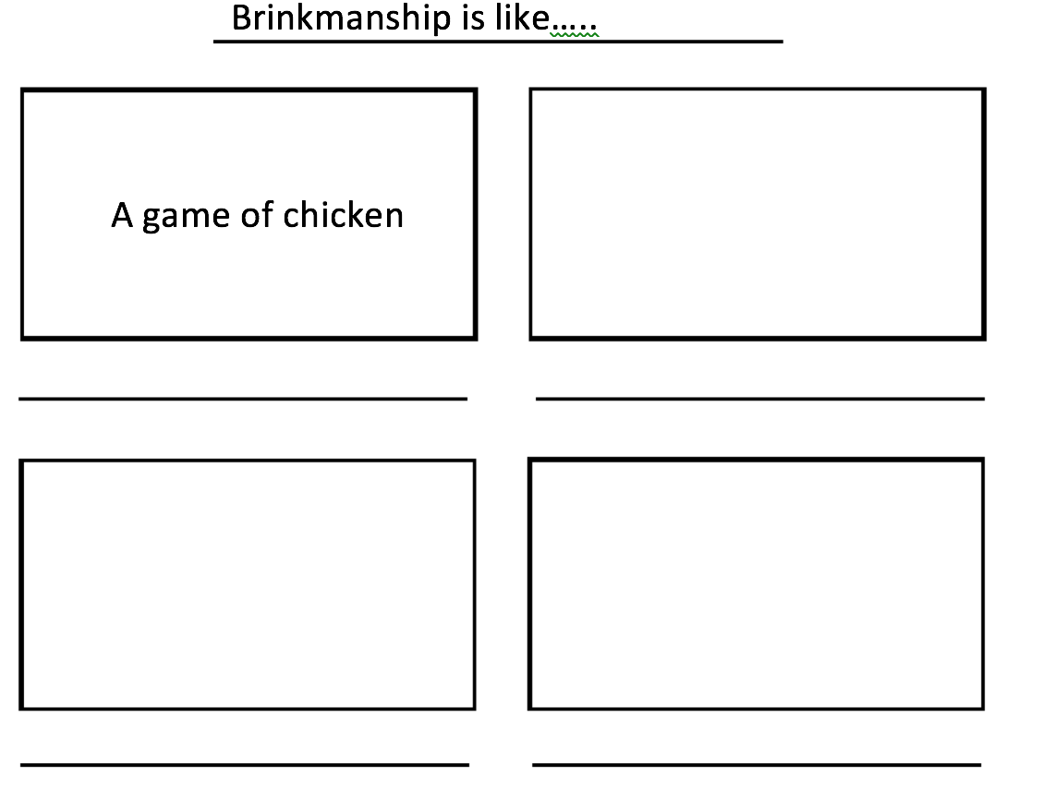

La política arriesgada es como ____________________ porque __________________________
______________________________________________________________________________________________________________________________________________________________________________________________________________________________________________________________________________________________________________________________________________________________________________________________________

