SYNECTICS
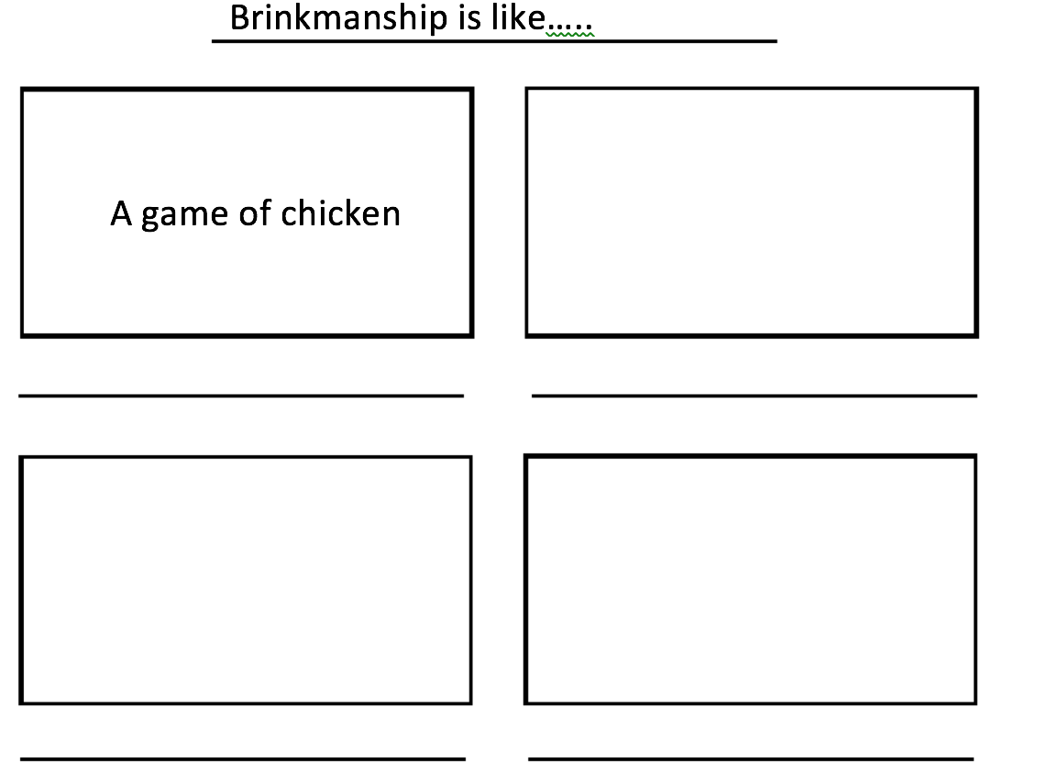

Brinkmanship is like ____________________ because __________________________________
______________________________________________________________________________________________________________________________________________________________________________________________________________________________________________________________________________________________________________________________________________________________________________________________________

