TEACHER RESOURCES – FALLOUT, BRINKMANSHIP, MAD

Duck and Cover in School Systems

The nation’s Civil Defense Agency’s efforts to prepare Americans for a nuclear attack extended to children in schools. Repeated drills taught them to “duck and cover” when the nuclear alarms went off.

Adapted from Weeks, L. (2011, March 17).living in the atomic age: Remember these images? NPR The Picture Show. http://www.npr.org/sections/pictureshow/2011/03/17/134604352/images-of-the-atomic-age

Fallout Shelters

A fallout shelter is a civil defense measure intended to reduce casualties in a nuclear war. It is designed to allow those inside it to avoid exposure to harmful fallout from a nuclear blast and its likely aftermath of radiation until radioactivity has dropped to a safer level. A basic fallout shelter consists of shielding that reduces gamma-ray exposure. Since the most dangerous fallout has the consistency of sand or finely ground pumice, a successful fallout shelter need not filter fine dust from air. The fine dust both emits relatively little radiation and does not settle to the earth, where the fallout shelter exists. Concrete, bricks, earth, and sand are some of the materials that are dense or heavy enough to provide fallout protection.

Adapted from United States History. (n.d.). Fallout shelters. http://www.u-s-history.com/pages/h3706.html

Fallout Shelters: A Booming Business

Based on the fear of a nuclear attack, families who could afford a shelter were willing to spend large amounts of money on keeping their family safe. Magazines and newspapers overflowed with advertisements selling nuclear fallout shelters.
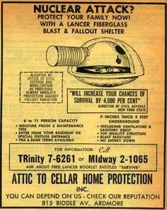

$1,195 in the 1950s is equivalent to about $11,752 today

Brinkmanship

Cold War politics have been compared to the game of “chicken.”

“Brinkmanship is a shared risk of war in which each side pushes the other toward the brink of disaster or war ever closer in order to force the other side to capitulate at the last second. Soviet-American interactions at several points during the Cold War manipulated this situation in order to extract favorable gains none so clearly as during the Cuban Missile Crisis.
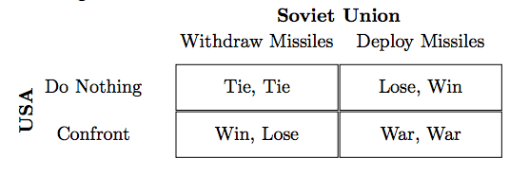

“The chicken game also introduces an interesting point about uncontrollable risk and rationality. Here, even if both drivers are acting rationally, uncontrollable events can still trigger a crash between the drivers if both believe the other will swerve at the last second. This generates the possibility of ‘accidental nuclear wars’ or nuclear instability caused by misinformation or wrong beliefs about the other side.”

Malone, I. (n.d.). PS 114s. International security in a changing world nuclear weapons, brinkmanship, and deterrence: A cheat sheet. Stanford University. Retrieved from https://web.stanford.edu/~imalone/Teaching/pols114/AddendumNuclearDeterrenceGameTheory.pdf
Mutually Assured Destruction (MAD)
Rube Goldberg’s 1948 Pulitzer Prize winning cartoon [top] shows the risky nature of America’s supposed “peace” after WWII. This “peace” was based largely on the threat of nuclear annihilation.

“In 1962, the concept of mutually assured destruction started to play a major part in the defense policy of the US. President Kennedy's Secretary of Defense, Robert McNamara, set out in a speech to the American Bar Foundation a theory of flexible nuclear response.
“In essence it meant stockpiling a huge nuclear arsenal. In the event of a Soviet attack the US would have enough nuclear firepower to survive a first wave of nuclear strikes and strike back. The response would be so massive that the enemy would suffer ‘assured destruction’.
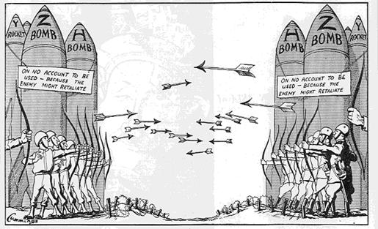
“Thus the true philosophy of nuclear deterrence was established. If the other side knew that initiating a nuclear strike would also inevitably lead to their own destruction, they would be irrational to press the button.”

de Castella, T. (2012, February 15). How did we forget about mutually assured destruction? BBC News Magazine. Retrieved from http://www.bbc.com/news/magazine-17026538

