Bandlab Instructions – Loop Me In

- Click on “Start Assignment.” Now click on the name of the assignment to start a new project.

- You’ll see a window that says “New Track” with several options. Select “Browse Loops” in the bottom right-hand corner of that window.

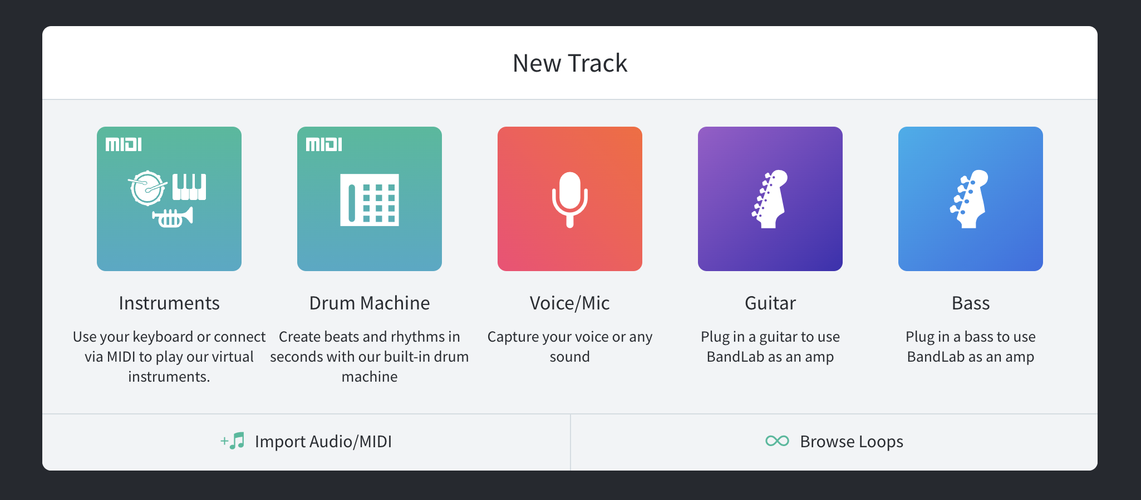

Click “Browse Loops,” and a new options panel will appear on the right- hand side of the screen.

- Click “Loops,” located in the upper right-hand corner of the screen, next to the search bar.

Note: There is an item in the bottom right-hand corner, “∞ Loops.” This is not the item to click in this step.
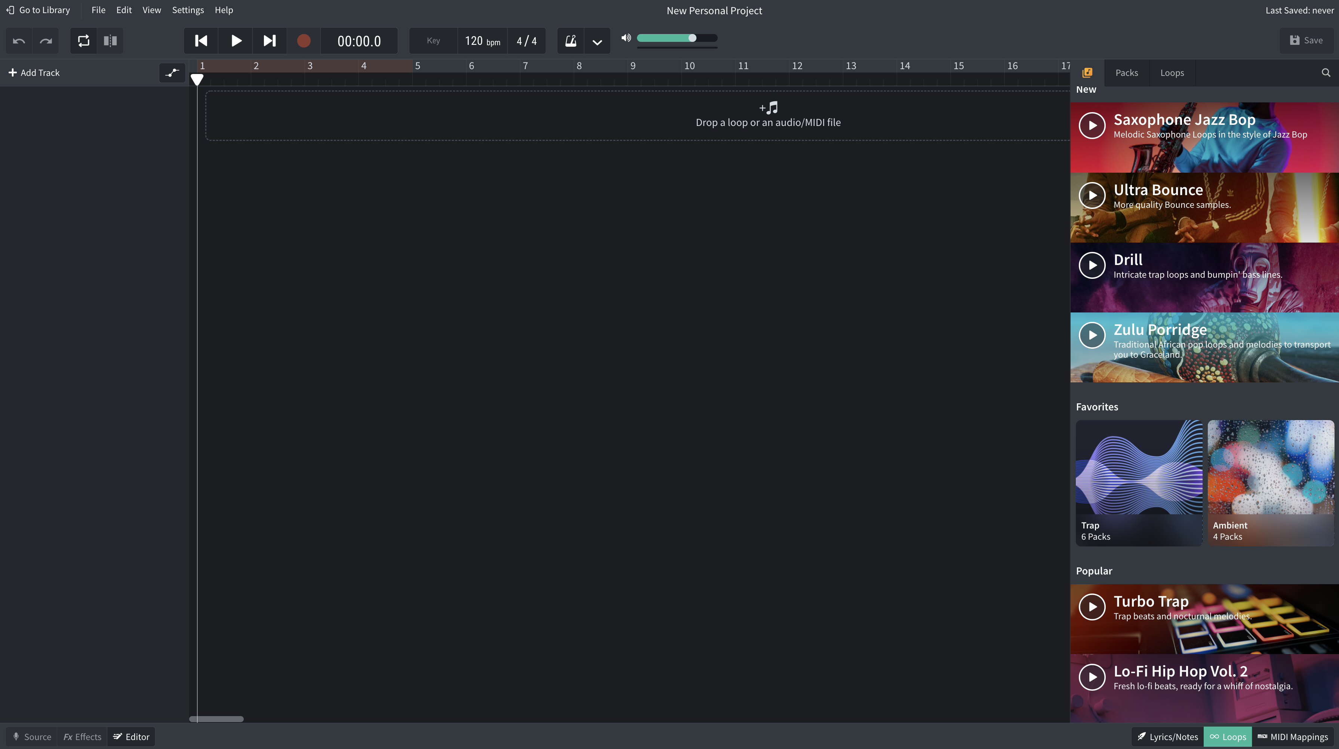
Click “Loops” in the upper-right hand corner of the page.

- Click “Instruments,” located under the search bar and select ‘Beats’.
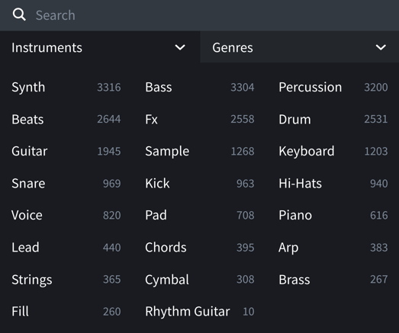

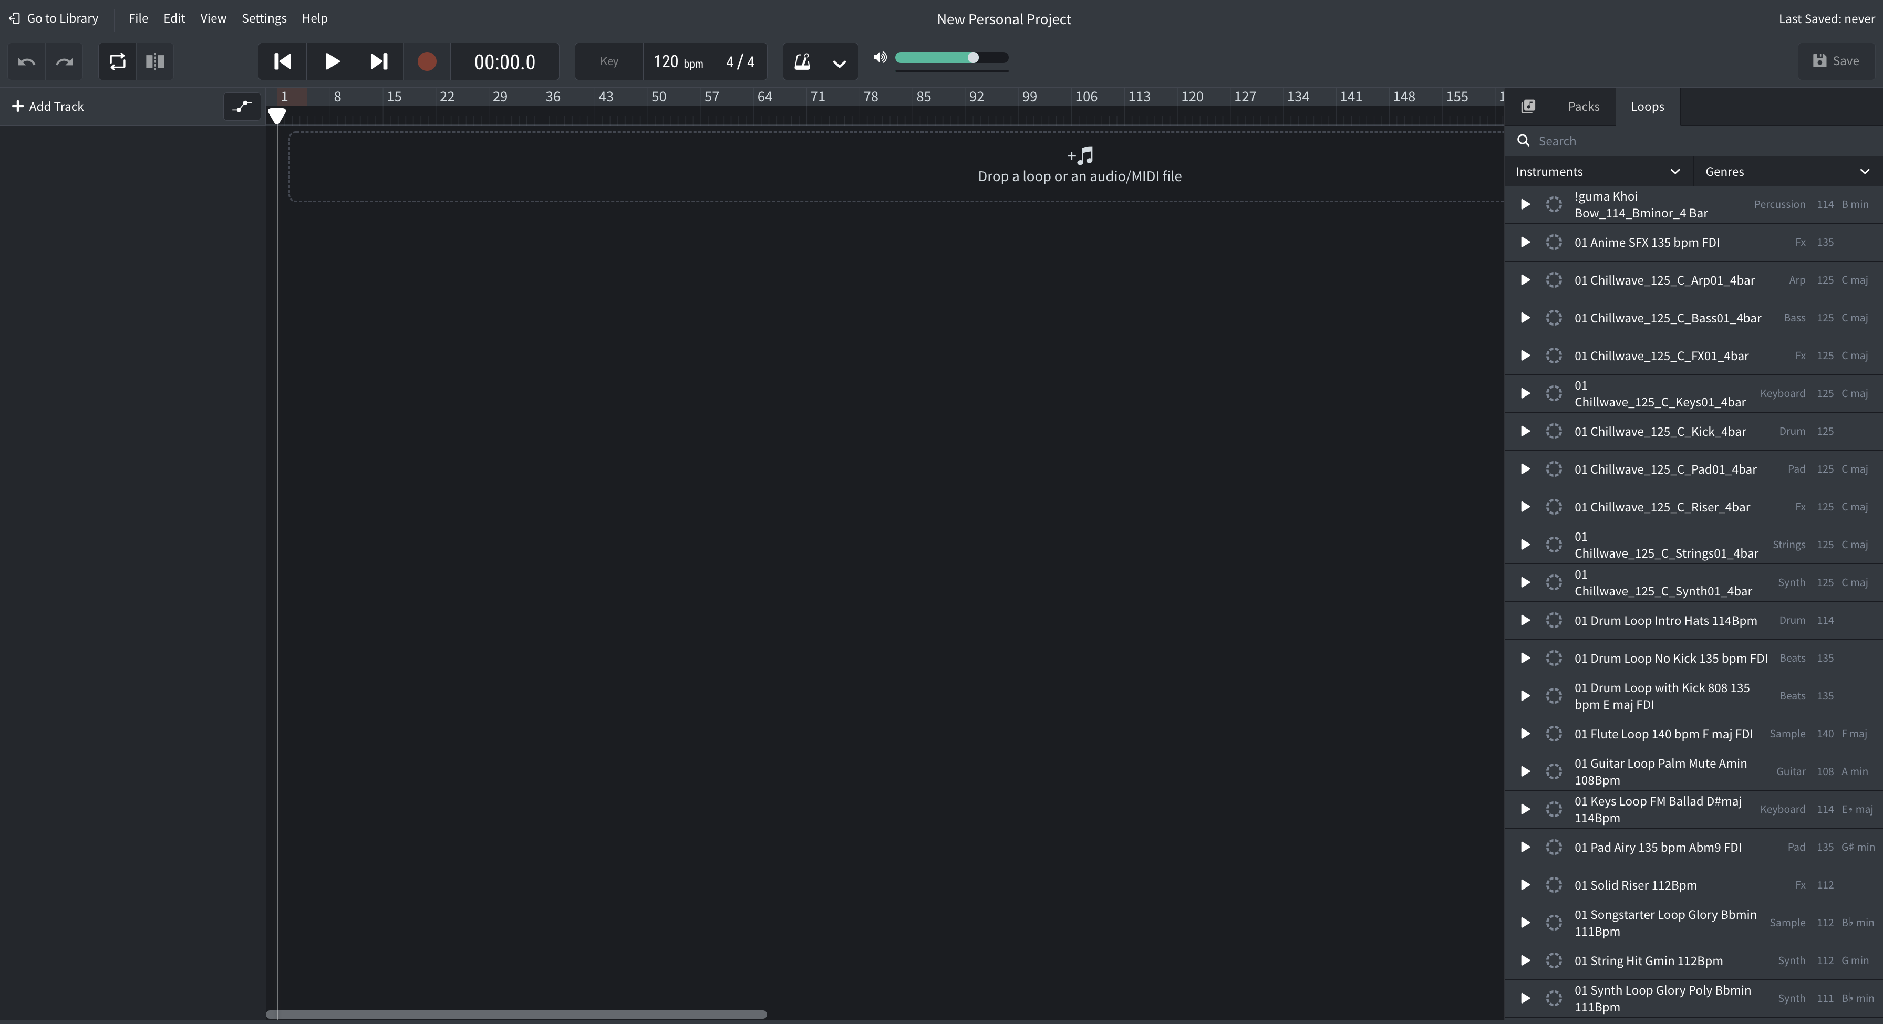
Under instruments, select beats.

- Select two beats and drag them to the area that says, “Drop a loop or an audio midi file.” Place each selection on a different track and align each to the far left of the timeline.
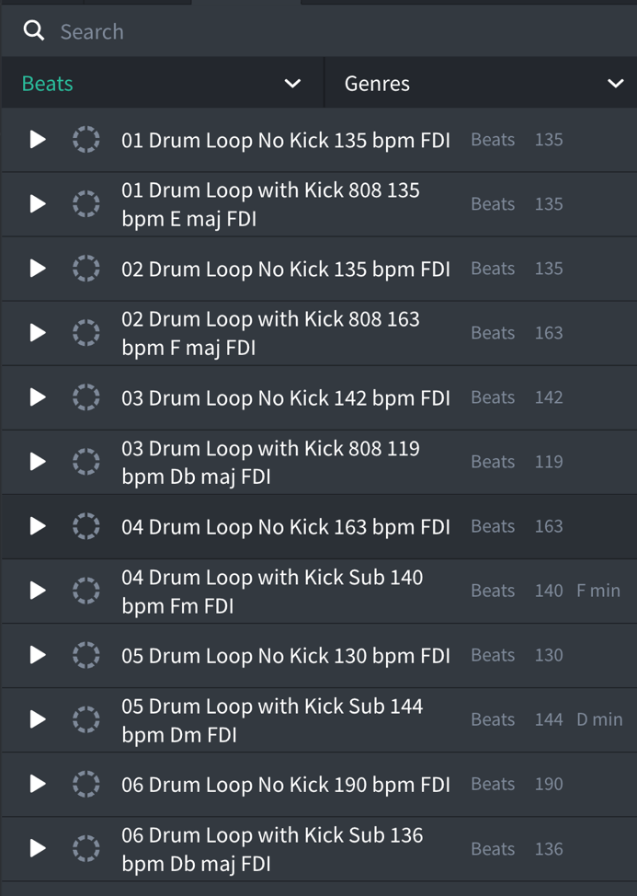

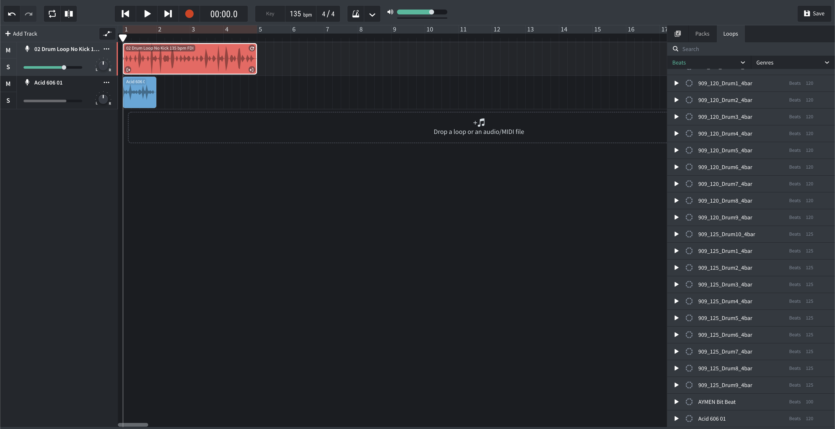
Select a beat from the list on the right and drag it onto a track.

- If one loop is shorter than the other, lengthen it by clicking on the circular arrow in the upper right-hand corner of the loop and dragging it to the right.

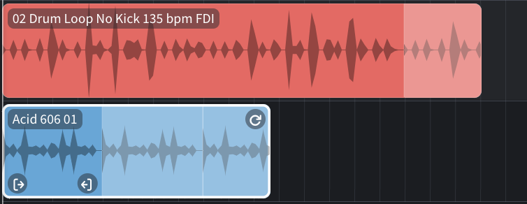
Click the arrow in the top-right corner of the selection to drag and lengthen the loop.

- Click on the word “Beats” that is highlighted in green below the search bar and select “Bass.” Repeat the same process you used when selecting beats to select a Bass loop and a Pad loop. When finished, your screen should look something like the one below.

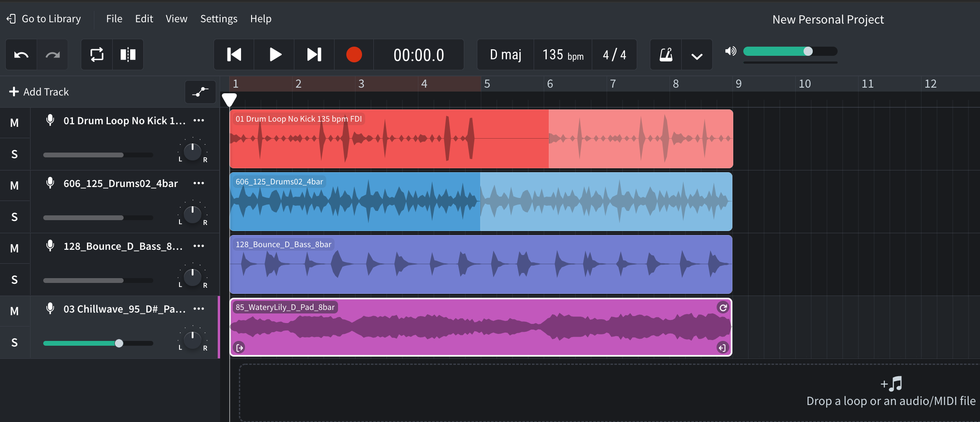
Two beat loops, a bass loop, and a pad loop.

- Using the same method, add one of each of the following tracks: piano, guitar, and voice. Don’t edit the length of these yet. When finished, your screen may look something like the one below.

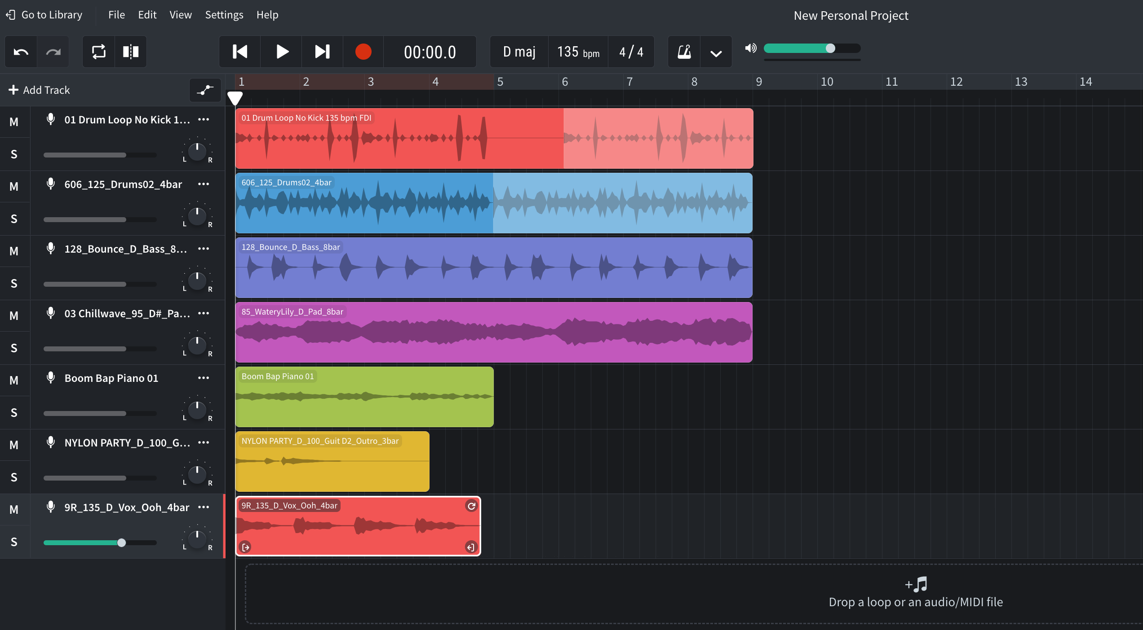
Here, a piano, guitar, and a voice loop have been added.

- Now, using both the drag feature to adjust length and by moving entire tracks to different places on the play bar, arrange the tracks so that no more than five are playing at one time. Your screen may look something like the one below. When you’ve completed this portion of the activity, raise your hand and inform your teacher.

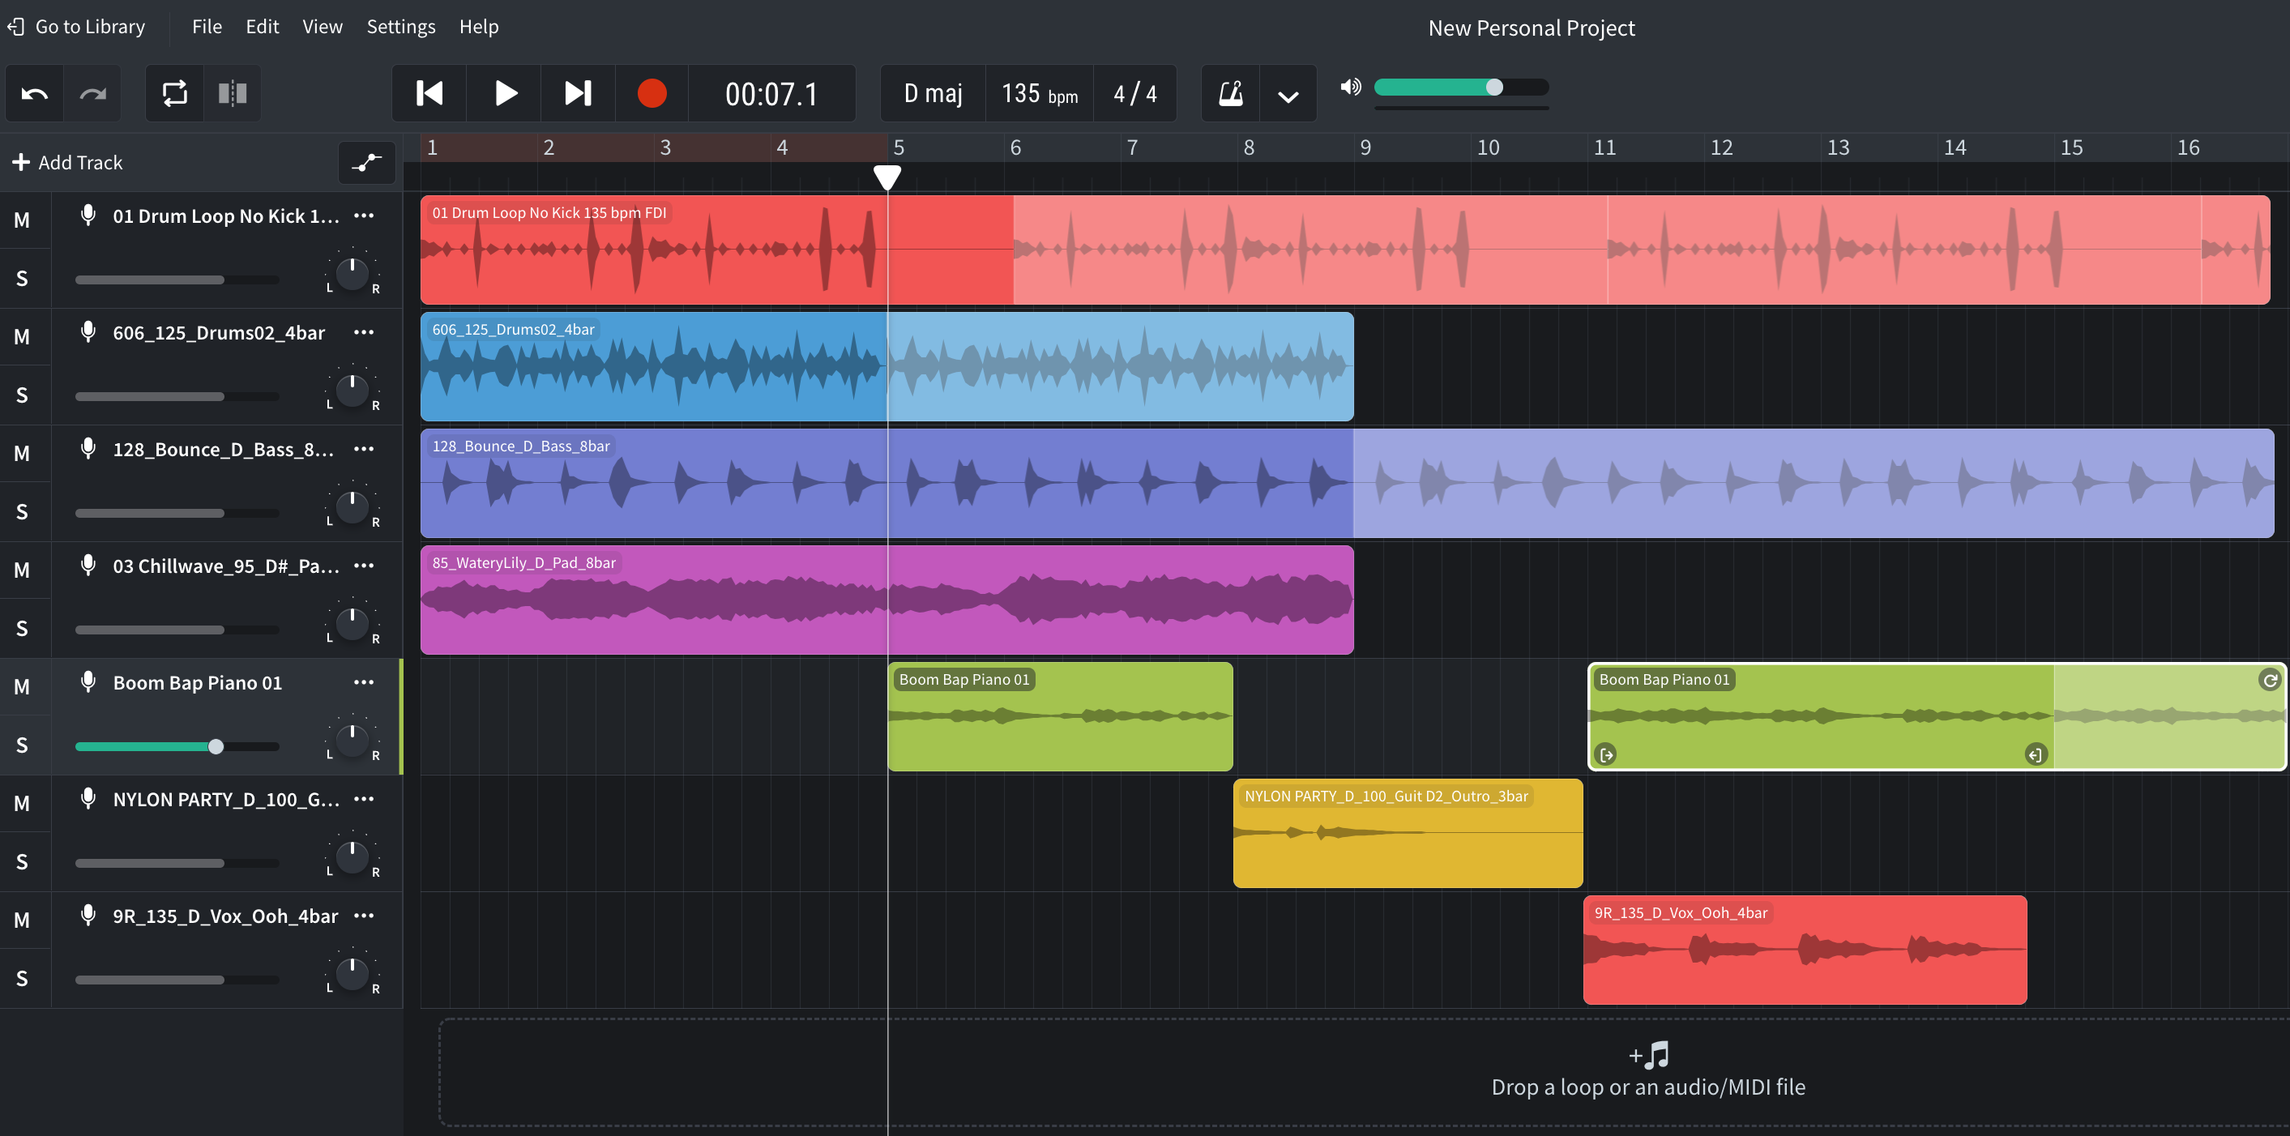
Loops should be arranged so that no more than five are playing at a time.

- At your teacher’s instruction, stand up and move to a different computer. Add up to five more loops of your choosing on different tracks to your classmate’s project in front of you. Do not rearrange their length or position. The screen should look something like the one below.

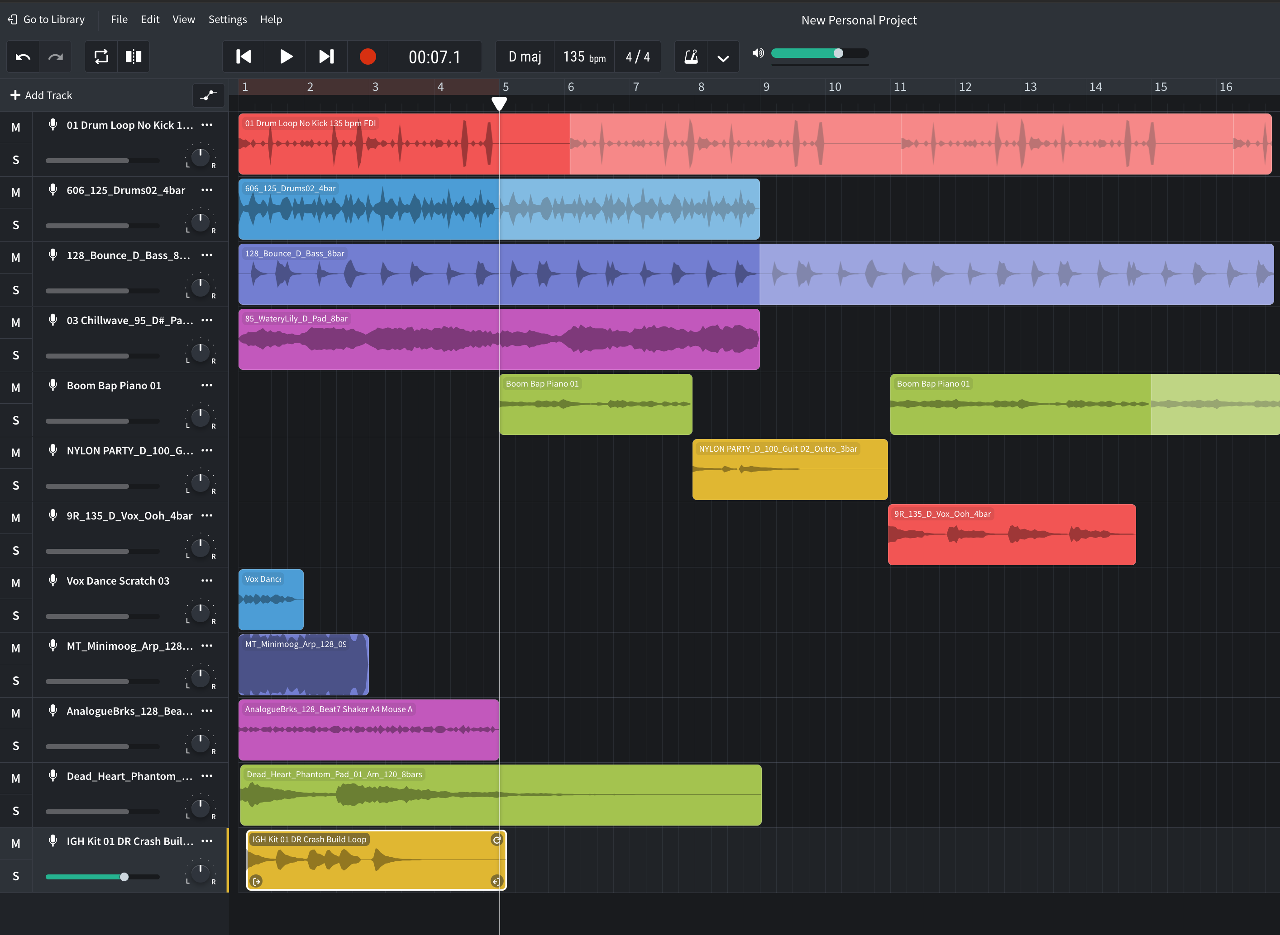
Add five loops to a composition created by a classmate.

- Return to your original computer and arrange the additional five loops into your song. They must be audible! It should look something like the screen below.

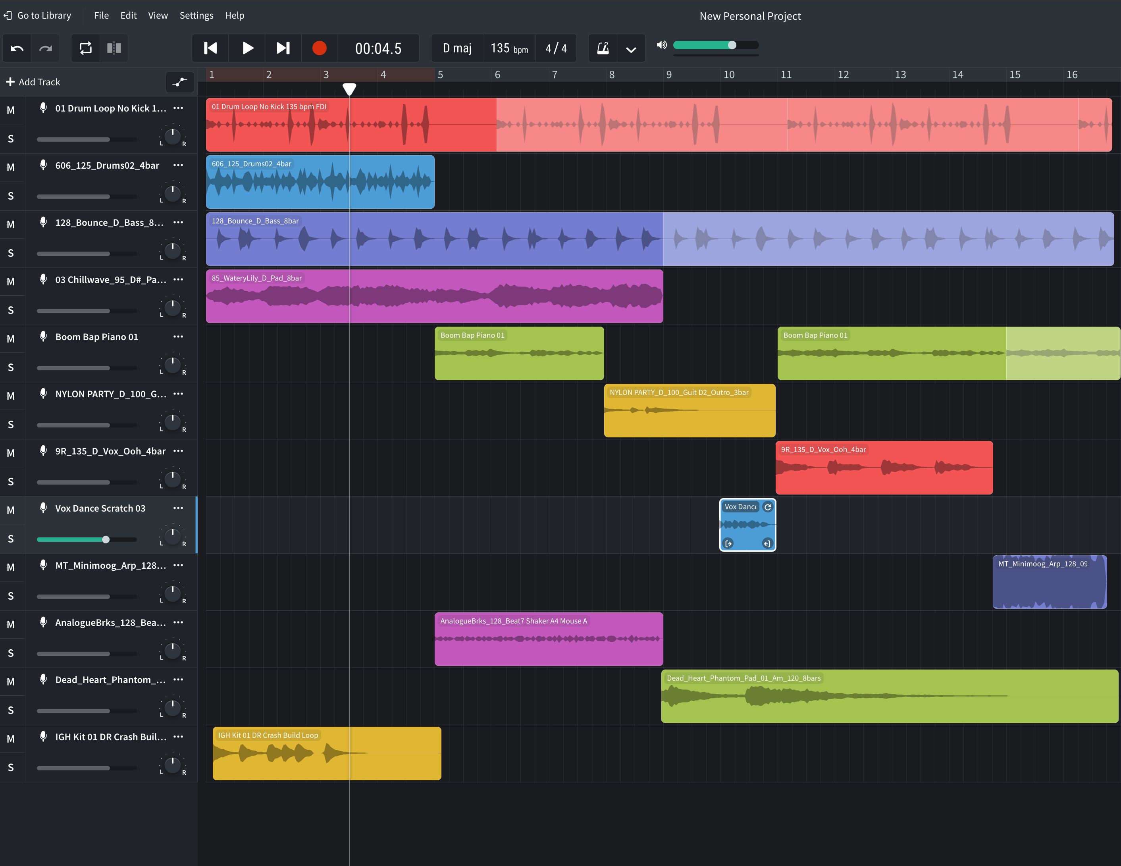
Find a way to arrange the new loops into your composition.

- Change the title of the song to your first and last name. You can do this by clicking on the text that says “New Personal Project” in the upper center of the screen.

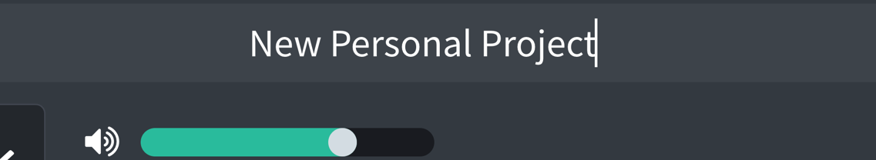
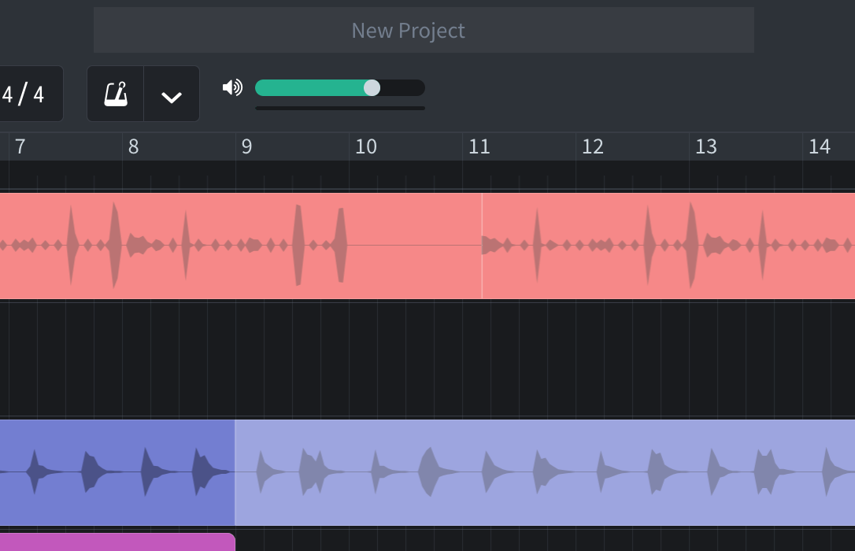
Enter your name in the file name box that says, “New Personal Project.”

- Once completed, click on File in the upper left-hand corner of the screen and select “download,” then “mixdown as.”

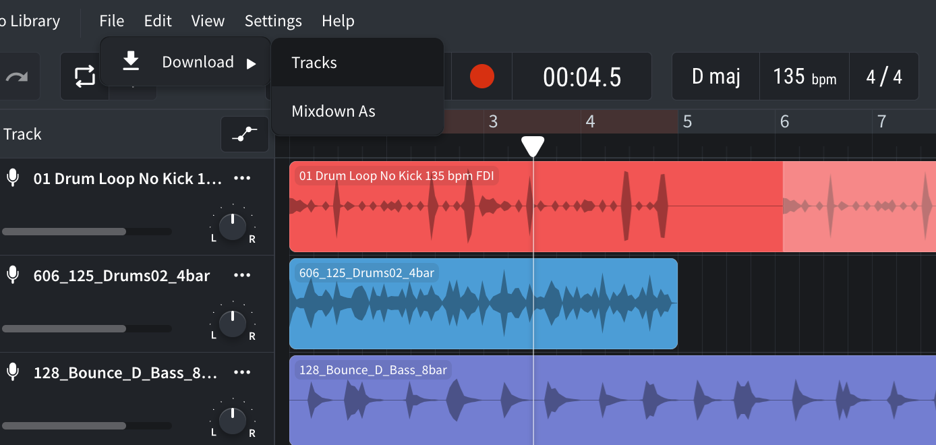
Download a mix of your composition.

- From the popup options, select “Highest Quality MP3.”

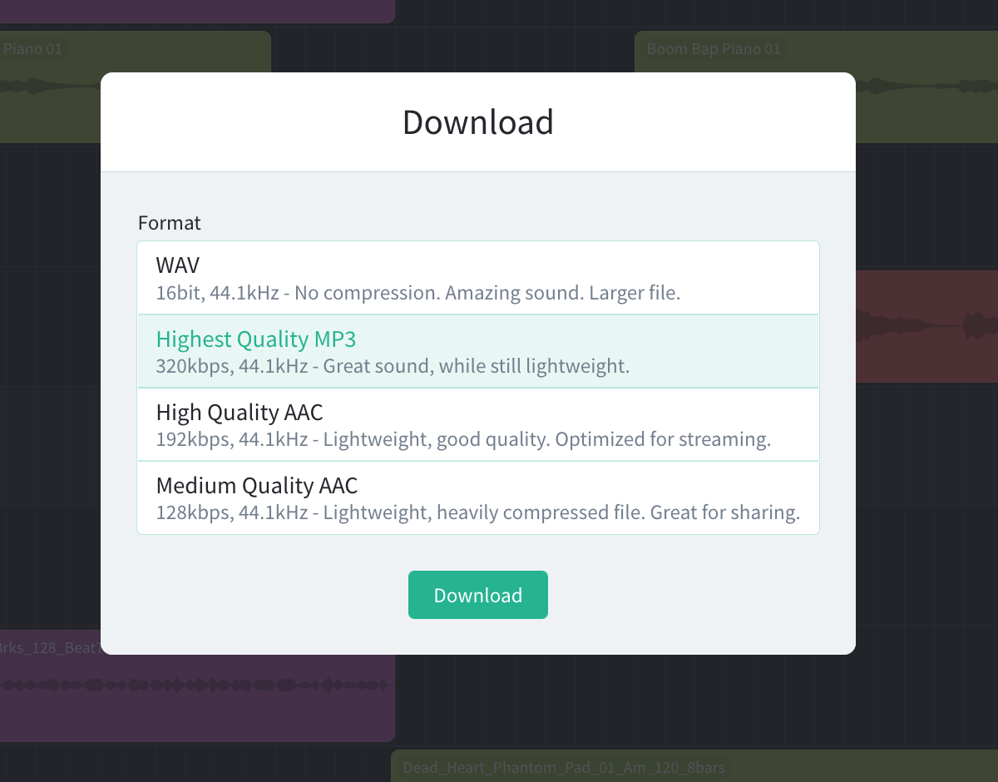
Download the highest quality MP3.

- Share the completed MP3 in a shared drive folder or by email—whichever method your teacher requests.

