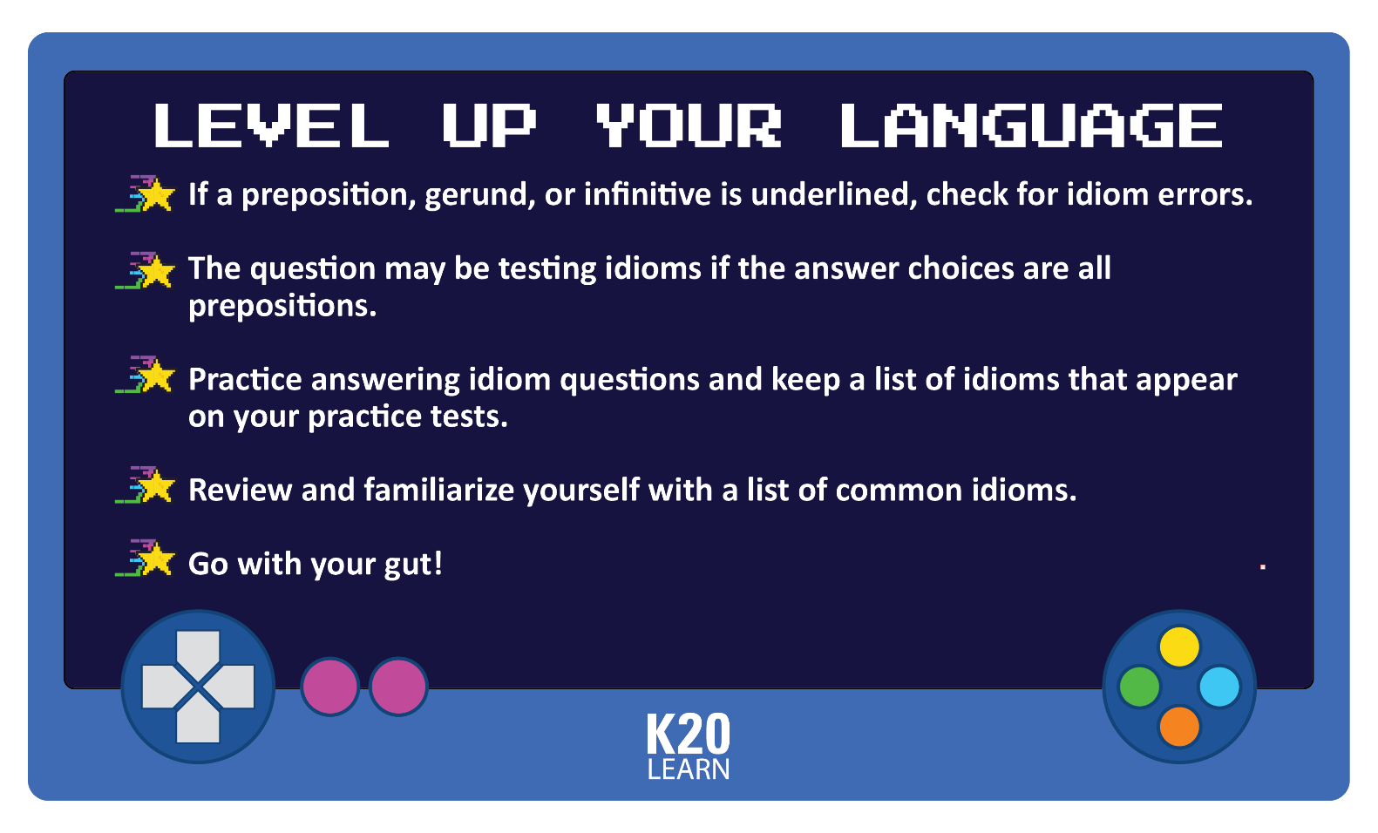
How to Play
Recognizing Idioms on the Test:
- Read the full sentence and identify the verb or adjective.
- Check if the preposition or verb form "sounds right."
- Eliminate choices that use awkward or incorrect pairings.
- Trust your ear and practice with common idiomatic patterns.


Item Inventory
Idioms Collected from ACT Practice Tests:
- come to a conclusion
- come to a halt
- come to an end
- earned a living from/by doing
- in the dusk
- modeled on
- principles of
- such as



