Gallery Walk Example
Checks and Balances
By creating three branches of government, the delegates built a "check and balance" system into the Constitution. This system was built so that no one branch of our government could become too powerful.

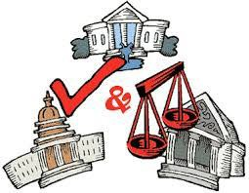
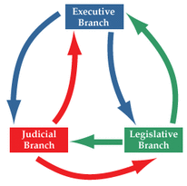

“No branch is more powerful than the other.” “It’s all about give and take.”
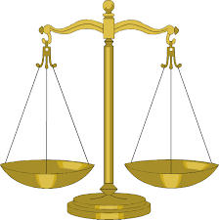

“Unbalanced power will tip the scales in favor of one branch.”

