WRITING IS ELEMENTARY, MY DEAR WATSON—HANDOUT 1

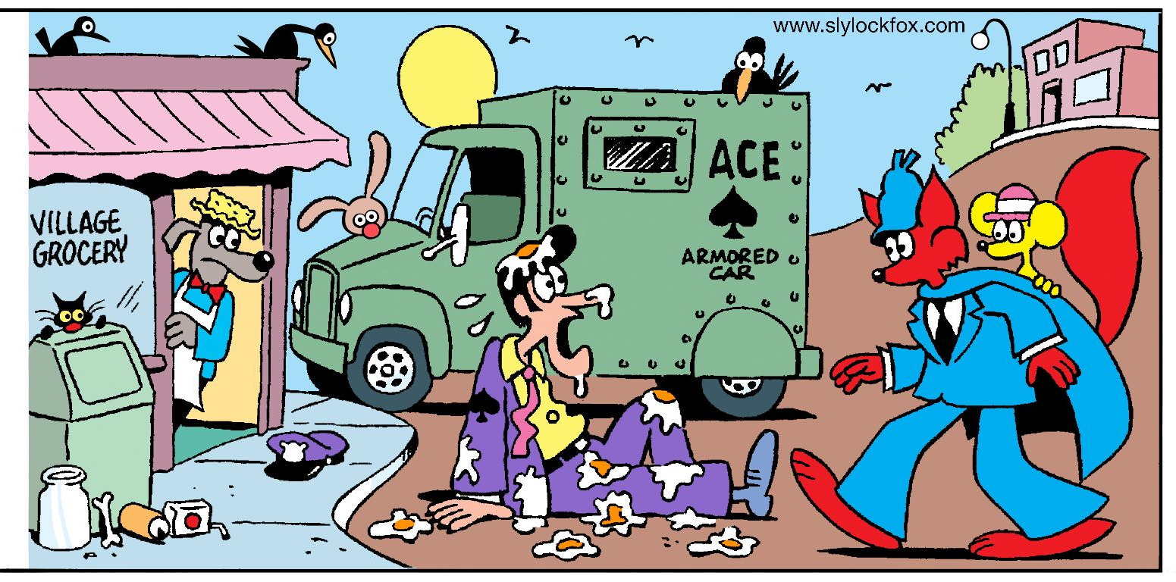Smitty was hired by a security company. On his first day on the
job, Smitty Claims a robber pelted him with eggs from a carton and grabbed the sack of money he was carrying to the truck. Do you believe Smitty’s story? What evidence can you find to support or contradict his story?

