1  B | 2  C | 3  C | 4  A | 5  D | 6  A
7  C | 8  B | 9  A | 10  D | 11  B | 12  D
13  0 squares  2 rectangles  4 circles  5 triangles | 14 N/A  For 14-20 You can have students take a picture and upload it to Seesaw. | 15  N/A | 16  N/A | 17  N/A | 18  Most=10  Fewest=3
19  Most=6  Fewest=2 | 20  Most=9  Fewest=2 | 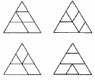  21 | 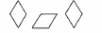  22 | 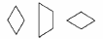  23 | 24  N/A

