Shape |  | Sides/Edges | Vertices /Corners
triangle |  | 3 sides | 3 vertices
square |  | 4 sides | 4 vertices
rectangle |  | 4 sides | 4 vertices
trapezoid |  | 4 sides | 4 vertices
rhombus | 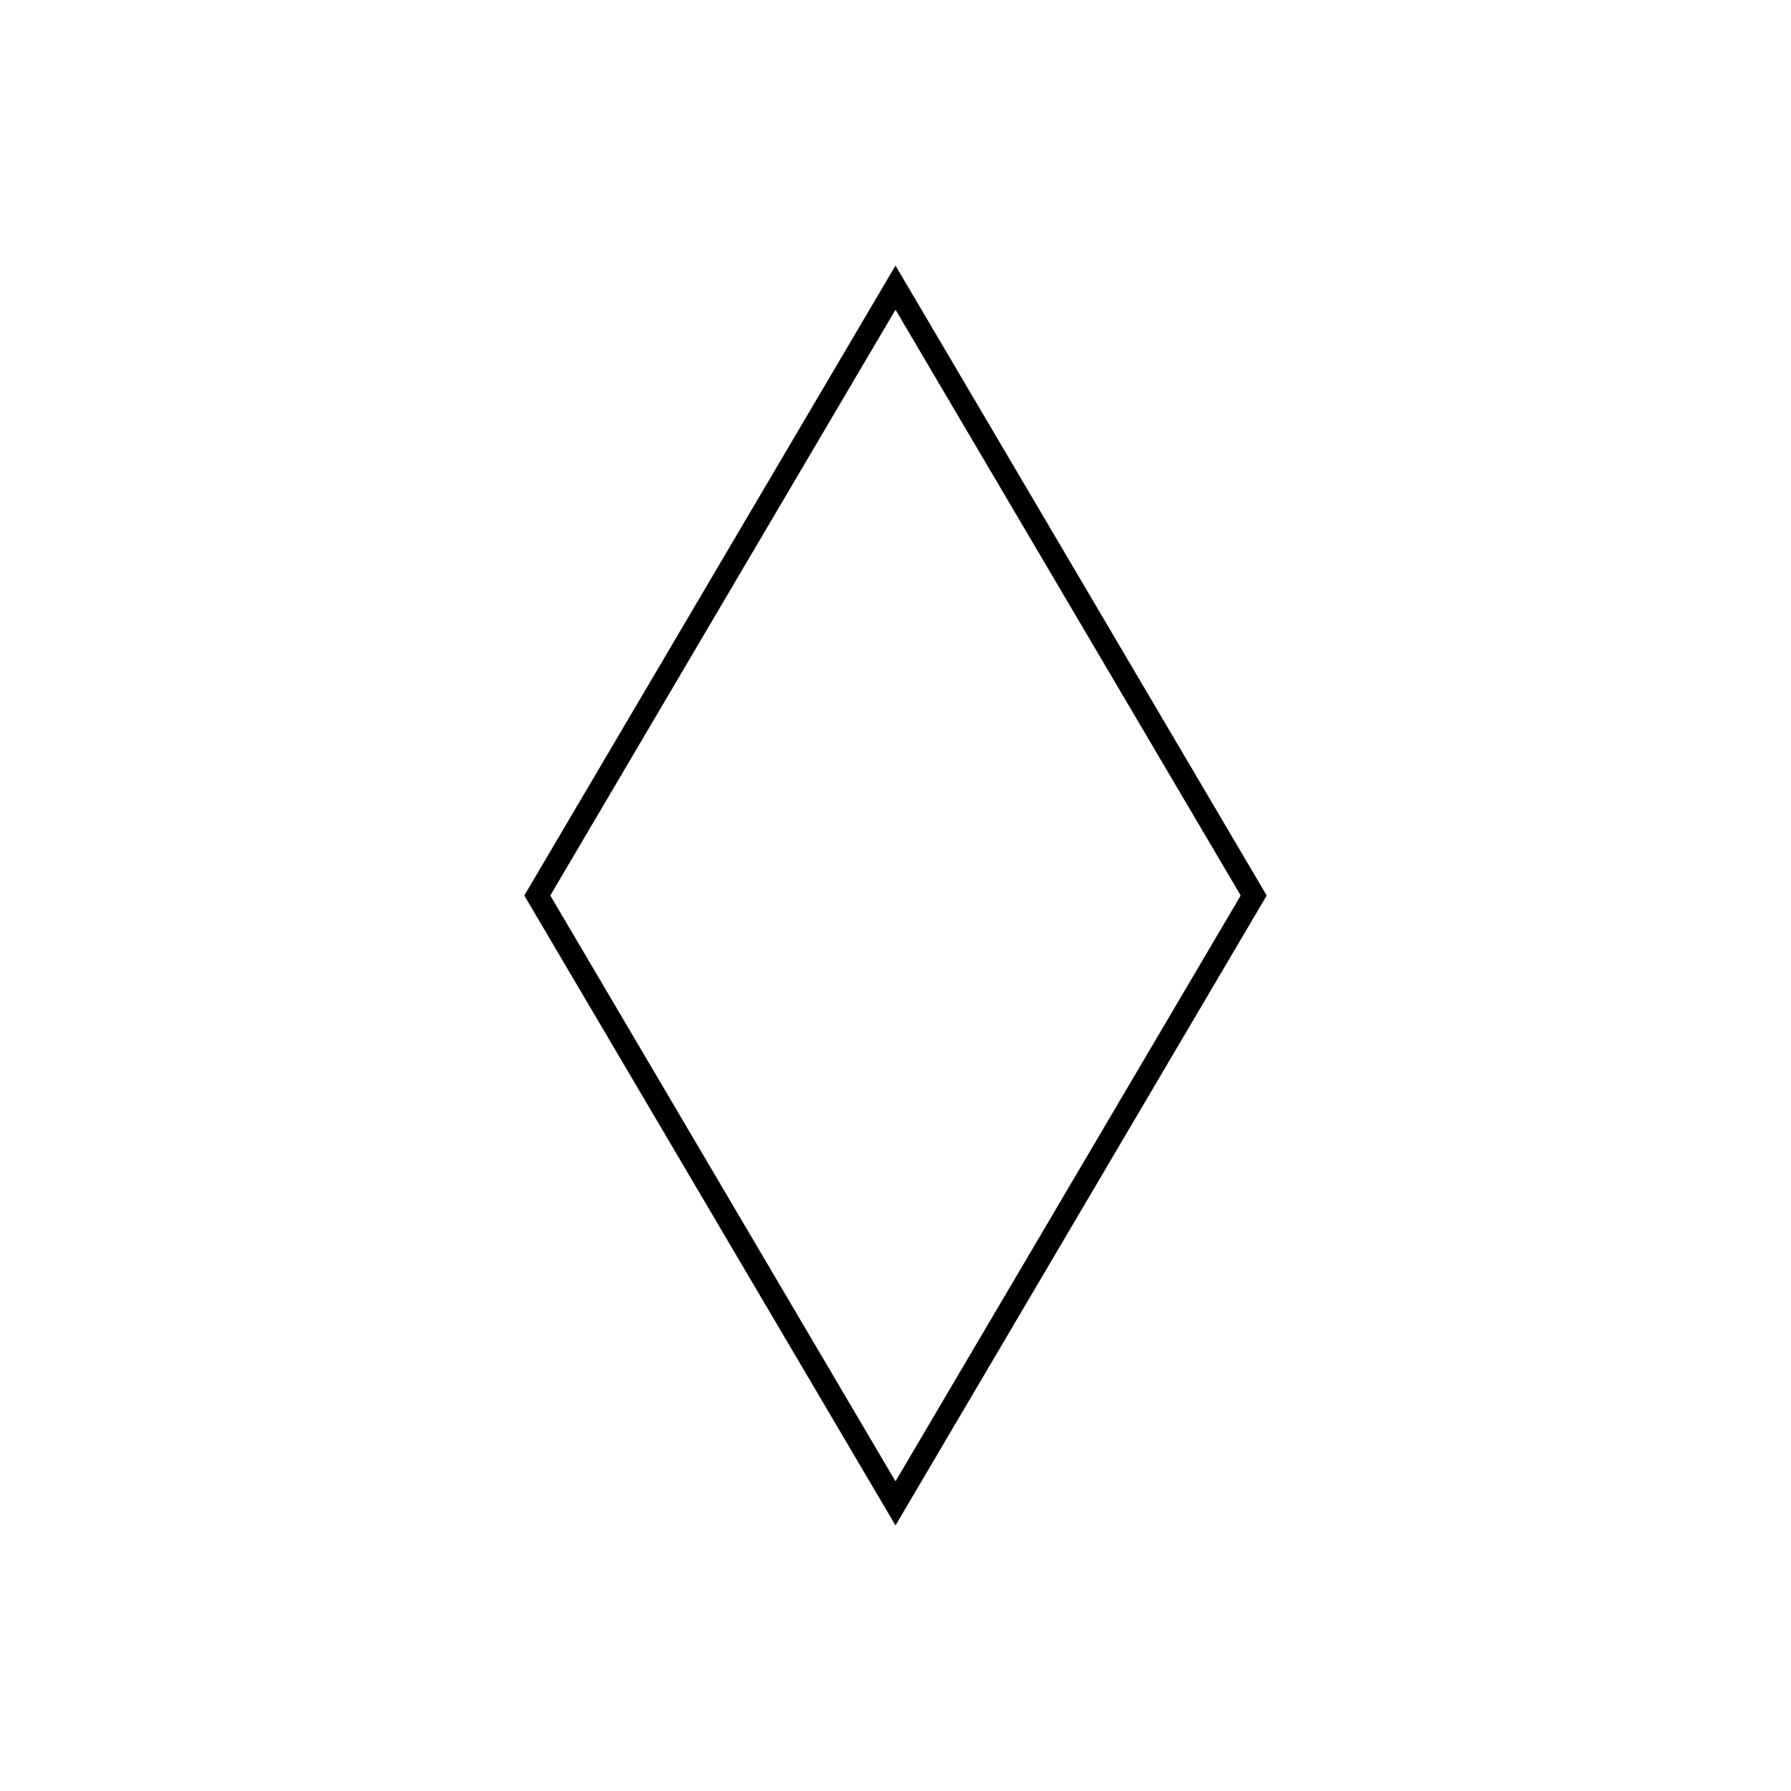 | 4 sides | 4 vertices
hexagon |  | 6 sides | 6 vertices
circle |  | 0 sides | 0 vertices

