Tribal Government relations Jigsaw
Each person will complete one of the four tasks below. Use the QR code to watch the video that corresponds to your task before answering the question. When everyone finishes their individual tasks, answer the last question together.
Task 1 | What is the Major Crimes Act? List three takeaways.
Task 2 | What was the McGirt v. Oklahoma case?
Task 3 | Describe the tensions between the state of Oklahoma and the tribes. | 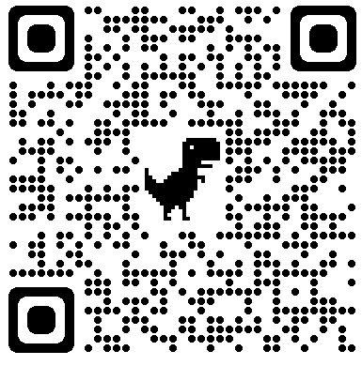
Task 4 | Explain how the Castro-Huerta case can help and hurt tribal sovereignty.

As a group, review all that you have learned and explain how relations between the US government, state governments, and tribal governments sometimes lead to tension.

