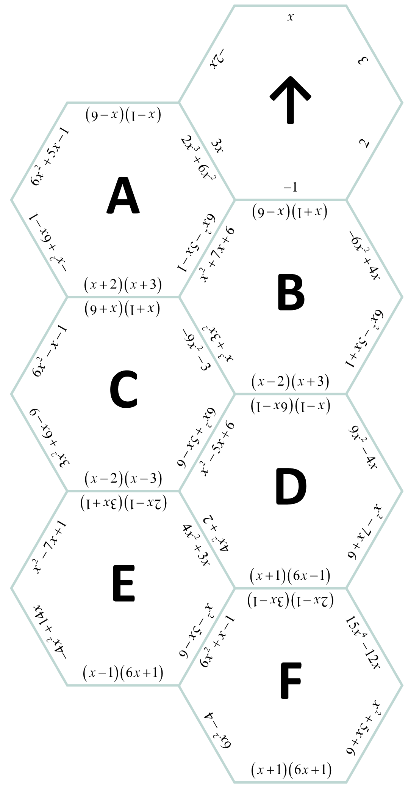
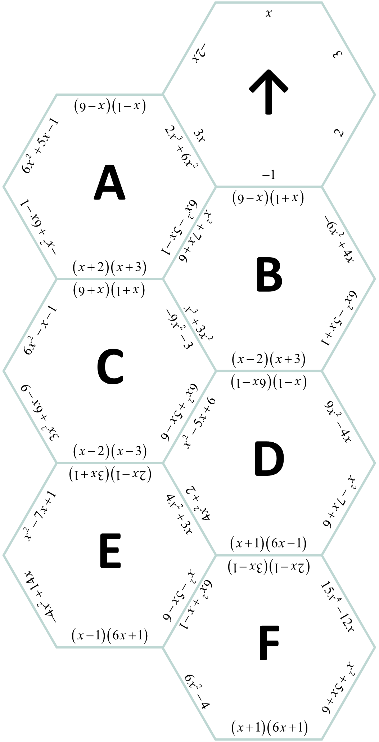
Hexagon Puzzle
Cut out each hexagon and arrange them
by matching each side with an
equivalent expression or with
the expression’s greatest
common factor.
The hexagon in the
center should be
the one with the
arrow, and it contains
all the GCFs.

