3D Shape Picture cards
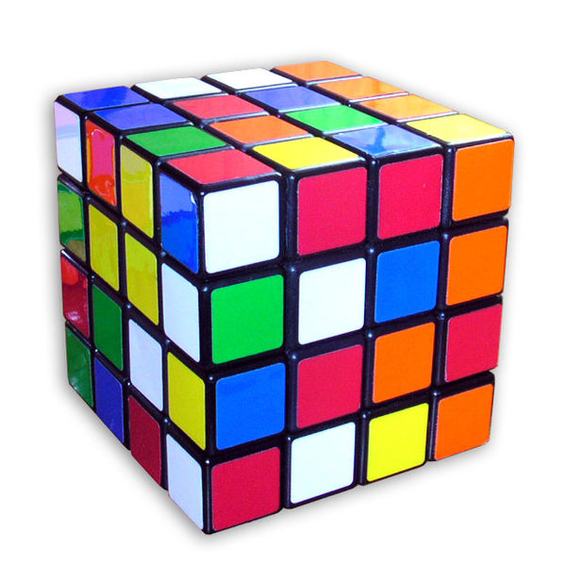 | 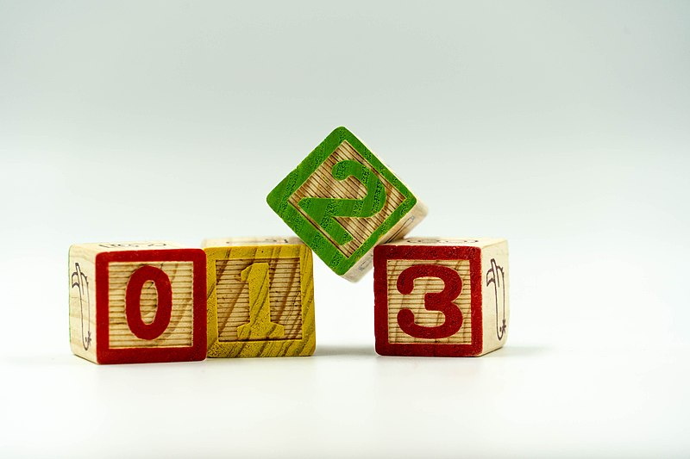
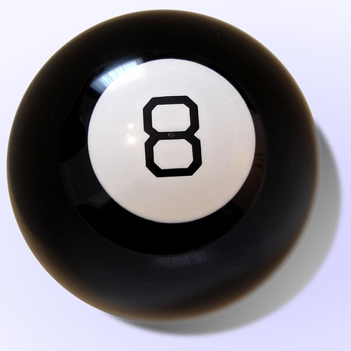 | 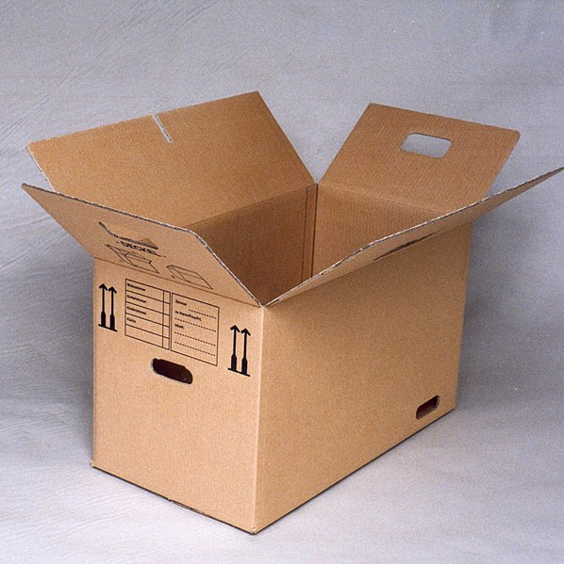

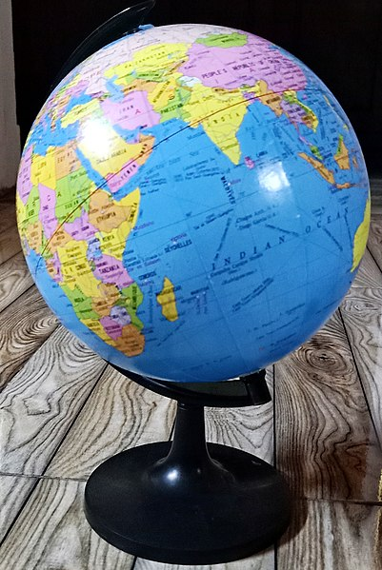 | 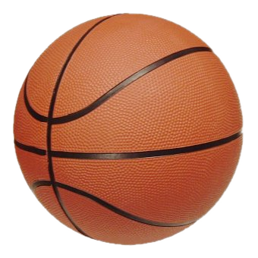
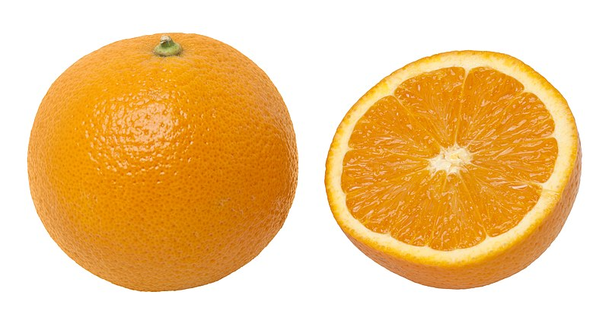 | 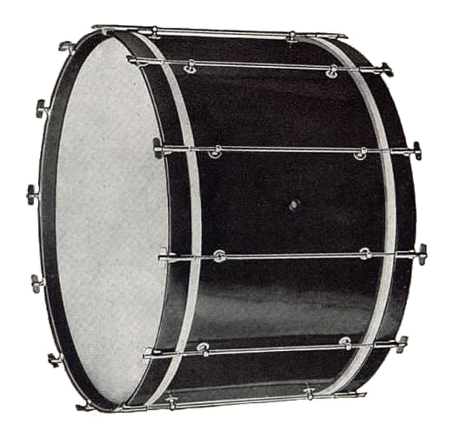
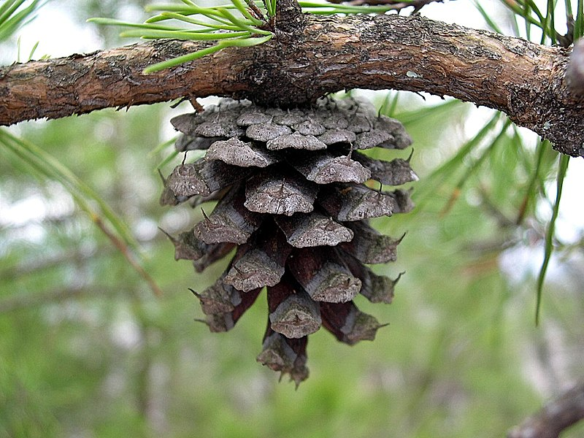 |  | 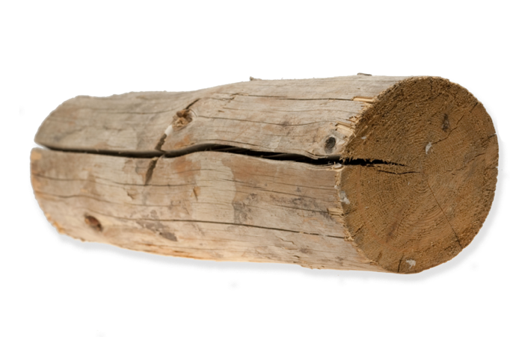

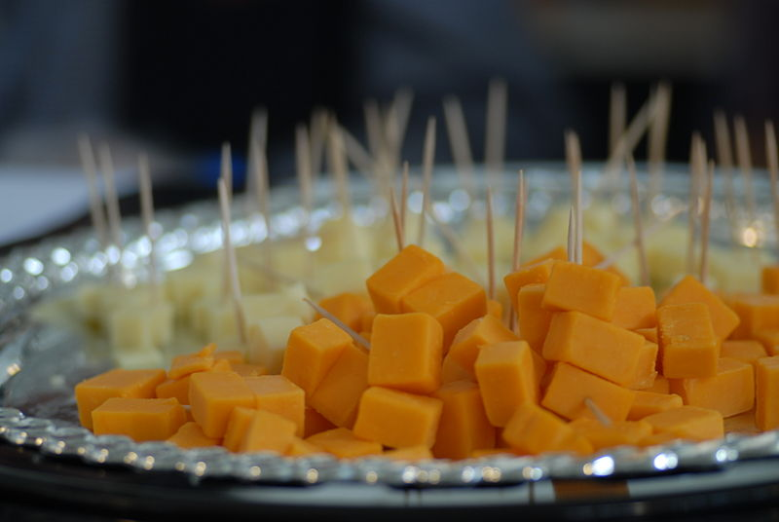 | 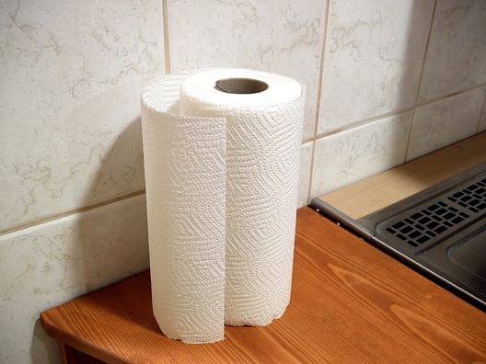
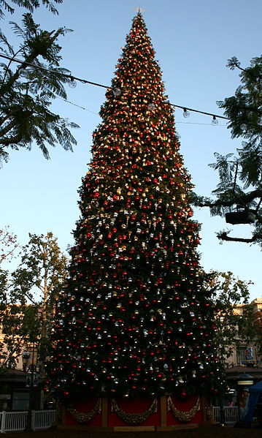 | 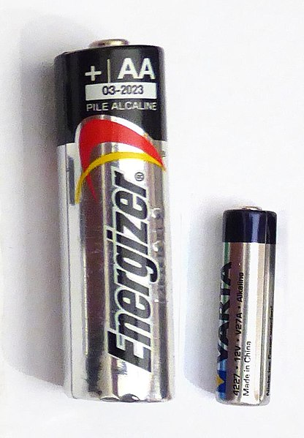
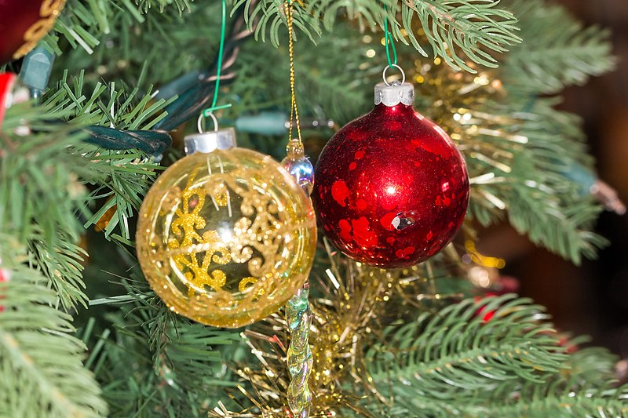 | 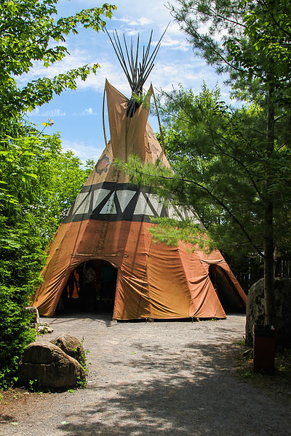
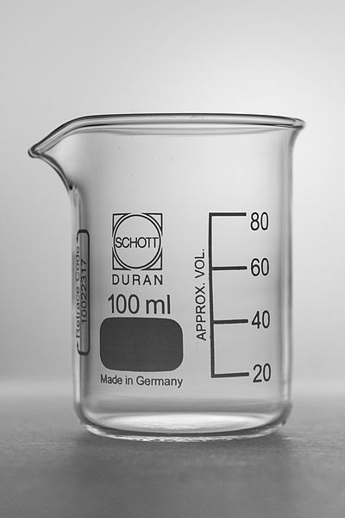 | 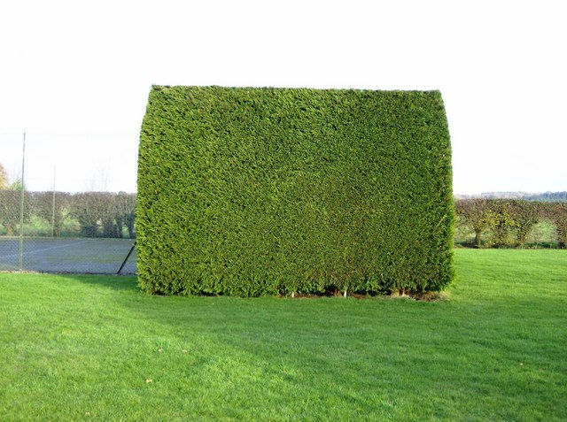

Gonzalez, M. (2005). Rubiks revenge scrambled [Photograph]. Wikimedia Commons. https://commons.wikimedia.org/wiki/File:Rubiks_revenge_scrambled.jpg
Perpetual.fostering. (2021). Learning to count with Children’s Number Blocks – 51070634001 [Photograph]. Wikimedia Commons. https://commons.wikimedia.org/wiki/File:Learning_to_count_with_Children%27s_Number_Blocks_-_51070634001.jpg
ChristianHeldt. (2007). Magic8Ball [Photoghraph]. Wikimedia Commons. https://commons.wikimedia.org/wiki/File:Magic8ball.jpg
HornM201. (2000). Umzugskarton [Photograph]. Wikimedia Commons. https://commons.wikimedia.org/wiki/File:Umzugskarton.jpg
Ali, I. (2019). World Globe Map [Photograph]. Wikimedia Commons. https://commons.wikimedia.org/wiki/File:World_Globe_Map.jpg
Reisio. (2006). Basketball [Photograph]. Wikimedia Commons. https://commons.wikimedia.org/wiki/File:Basketball.png
Evan-Amos. (2012). Orange-Whole-&-Split [Photograph]. Wikimedia Commons. https://commons.wikimedia.org/wiki/File:Orange-Whole-%26-Split.jpg
Ludwig & Ludwig. (1919). 1919 Ludwig New Inspiration Model bass drum [Photograph]. Wikimedia Commons. https://commons.wikimedia.org/wiki/File:1919_Ludwig_New_Inspiration_Model_bass_drum.jpg
Van Helsing, R. (2006). Wizard Hat [Photograph]. Wikimedia Commons. https://commons.wikimedia.org/wiki/File:Wizard_Hat.jpg
Twitter. (2014). Twemoji12 1f4e3 [Photograph]. Wikimedia Commons. https://commons.wikimedia.org/wiki/File:Twemoji12_1f4e3.svg
Sturner, J. (2011). Virginia Pine - Scrub Pine cone (Pinus virginiana) along Crest Trail - Flickr - Jay Sturner [Photograph]. Wikimedia Commons. https://commons.wikimedia.org/wiki/File:Virginia_Pine_-_Scrub_Pine_cone_%28Pinus_virginiana%29_along_Crest_Trail_-_Flickr_-_Jay_Sturner.jpg
Wotlarx. (2018). YK-JackLondon [Photograph]. Wikimedia Commons. https://commons.wikimedia.org/wiki/File:YK-JackLondon.png
Paumier, G. (2010). Cheese at the SF Chronicle Wine competition Public tasting 2010-02-20 1 [Photograph]. Wikimedia Commons. https://commons.wikimedia.org/wiki/File:Cheese_at_the_SF_Chronicle_Wine_competition_Public_tasting_2010-02-20_1.jpg
Viinamaki, S. (2017). Paper towel [Photograph]. Wikimedia Commons. https://commons.wikimedia.org/wiki/File:Paper_towel.jpg
Prayitno. (2009). Christmas Tree at the Grove (4159122936) [Photograph]. Wikimedia Commons. https://commons.wikimedia.org/wiki/File:Christmas_Tree_at_the_Grove_%284159122936%29.jpg
B Jonas. (2017). Batteries-a27-1 [Photograph]. Wikimedia Commons. https://commons.wikimedia.org/wiki/File:Batteries-a27-1.jpg
Crisco 1492. (2014). Christmas ornaments on an artificial tree, 2014-12-31 02 [Photograph]. Wikimedia Commons. https://commons.wikimedia.org/wiki/File:Christmas_ornaments_on_an_artificial_tree,_2014-12-31_02.jpg
Fortin, P. (2012). Tee-pee géant sur le site traditionnel huron Onhoüa chetek8e, Wendake [Photograph]. Wikimedia Commons. https://commons.wikimedia.org/wiki/File:Tee-pee_g%C3%A9ant_sur_le_site_traditionnel_huron_Onho%C3%BCa_chetek8e,_Wendake.jpg
Lucasbosch. (2012). Schott Duran Beaker low form 100ml [Photograph]. Wikimedia Commons. https://commons.wikimedia.org/wiki/File:Schott_Duran_Beaker_low_form_100ml.jpg
Horn, G. (2007). The ultimate green square^ - geograph.org.uk – 630462 [Photograph]. Wikimedia Commons. https://commons.wikimedia.org/wiki/File:The_ultimate_green_square%5E_-_geograph.org.uk_-_630462.jpg

