3D shape sorting activity name: _________________________________
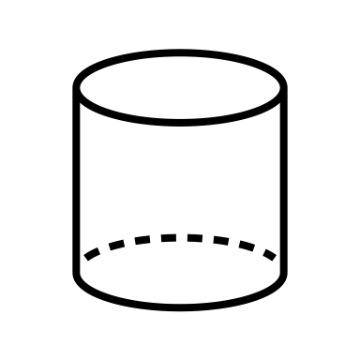  Cylinder | 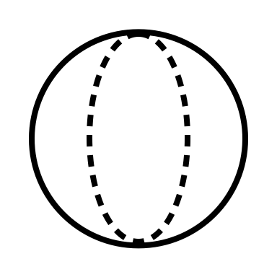  Sphere
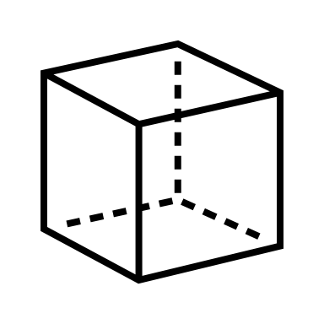  Cube | 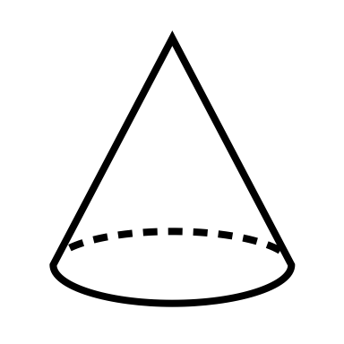  Cone
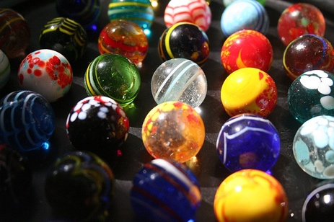 | 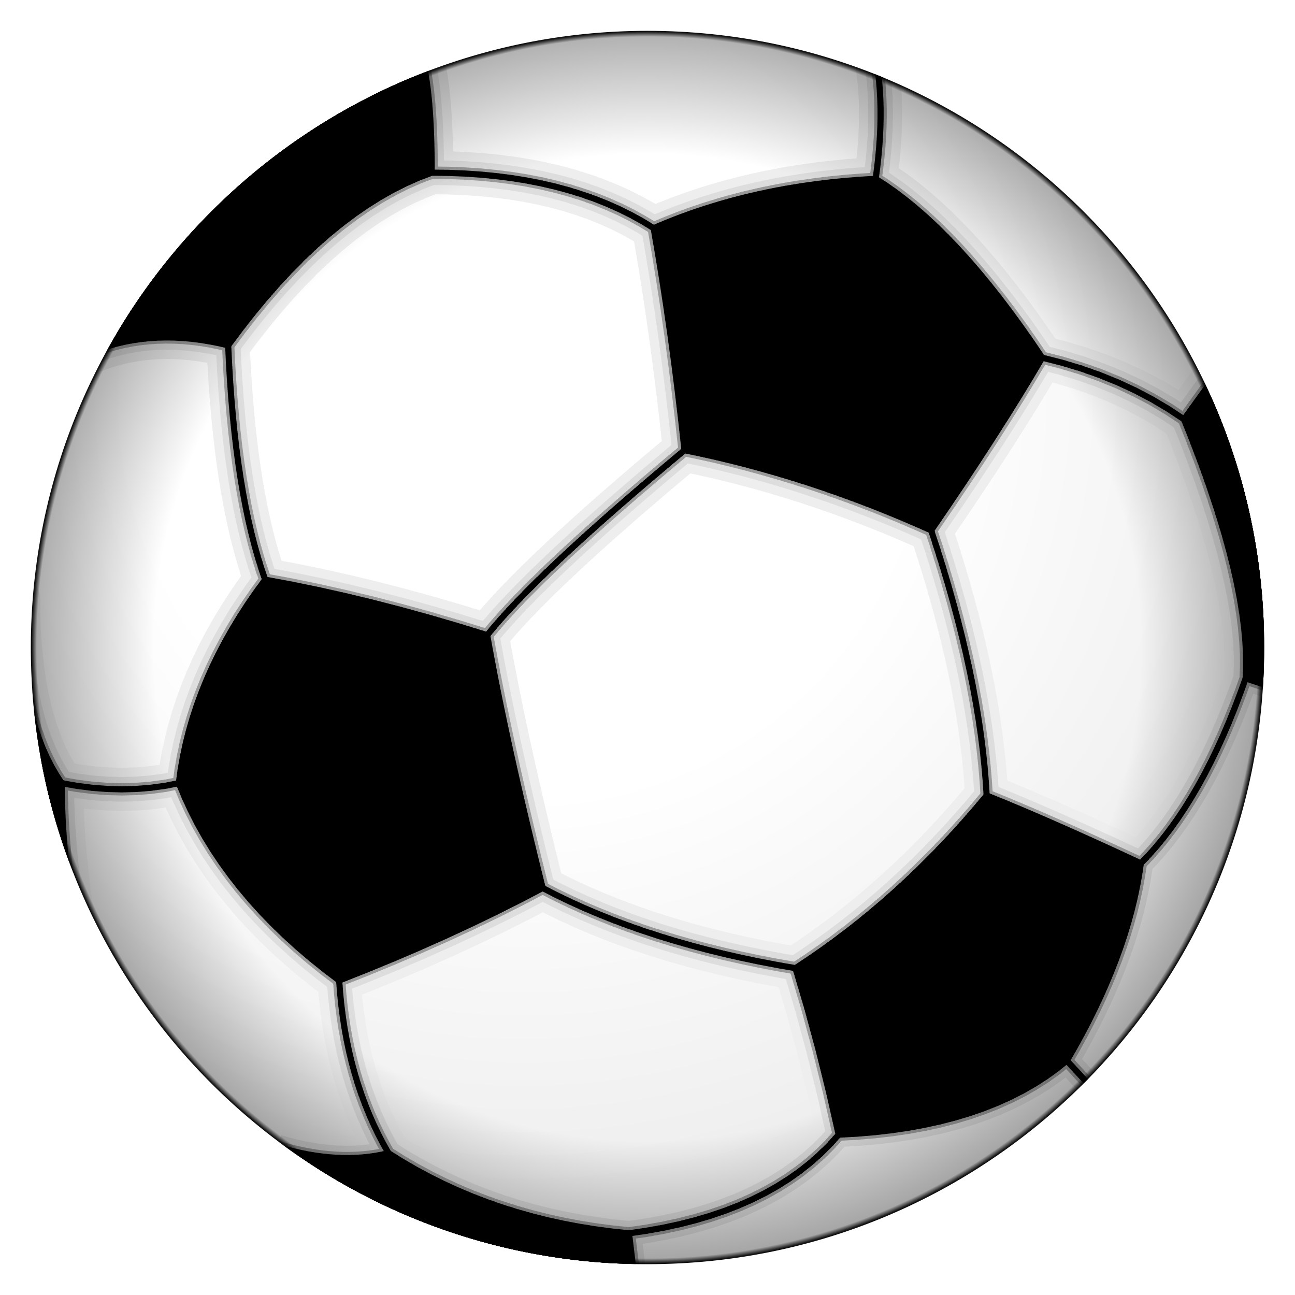 | 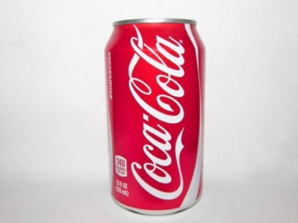 | 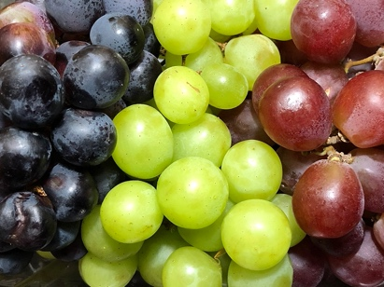
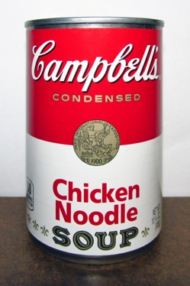 | 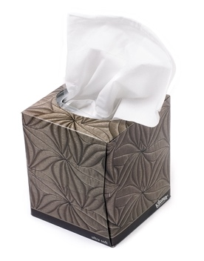 | 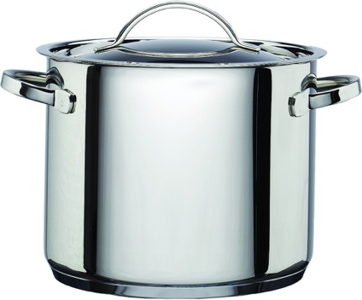 | 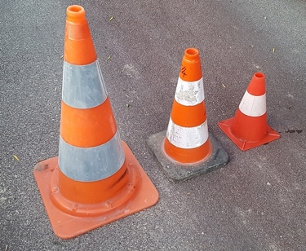
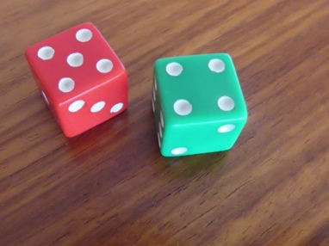 | 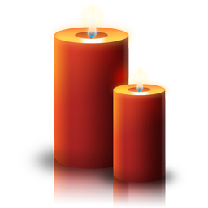 |  | 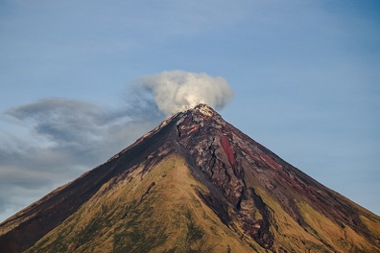
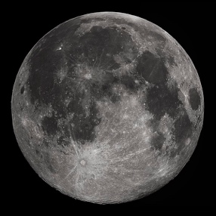 | 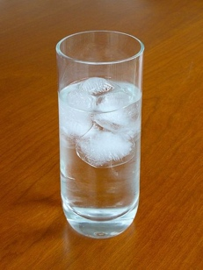 | 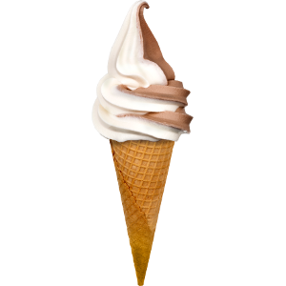 | 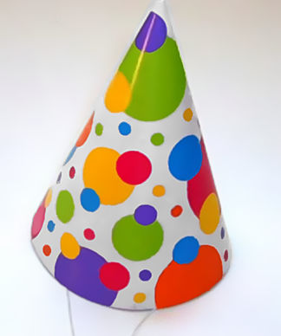
Fentress, S. (2005). WestAfricanMarbles [Photograph]. Wikimedia Commons. https://commons.wikimedia.org/wiki/File:WestAfricanMarbles.jpg
Pumbaa80. (2006). Soccer ball [Photograph]. Wikimedia Commons. https://commons.wikimedia.org/wiki/File:Soccer_ball.svg
Lam, W. (2016). Can of Coca Cola [Photograph]. Wikimedia Commons. https://commons.wikimedia.org/wiki/File:Can_of_Coca_Cola_(26899145485).jpg
Famartin. (2021). 2021-08-24 23 06 08 Red, green and black table grapes at the Ramada by Wyndham Rochelle Park Near Paramus in Rochelle Park Township, Bergen County, New Jersey [Photograph]. Wikimedia Commons. https://commons.wikimedia.org/wiki/File:2021-08-24_23_06_08_Red,_green_and_black_table_grapes_at_the_Ramada_by_Wyndham_Rochelle_Park_Near_Paramus_in_Rochelle_Park_Township,_Bergen_County,_New_Jersey.jpg
Lam, W. (2015). Campbell's Chicken Noodle Soup (16184220183) [Photograph]. Wikimedia Commons. https://commons.wikimedia.org/wiki/File:Campbell%27s_Chicken_Noodle_Soup_(16184220183).jpg
Evan-Amos. (2010). Kleenex-small-box [Photograph]. Wikimedia Commons. https://commons.wikimedia.org/wiki/File:Kleenex-small-box.jpg
Cooks & Kitchens. (2010). Hahn 20ck Stockpot [Photograph]. Wikimedia Commons. https://commons.wikimedia.org/wiki/File:Hahn_20ck_Stockpot.jpg
Qvent13. (2020). Cones FR [Photograph]. Wikimedia Commons. https://commons.wikimedia.org/wiki/File:Cones_FR.jpg
JonRichfield. (2019). A throw of two dice as in the game of hazard IMG 1705s [Photograph]. Wikimedia Commons. https://commons.wikimedia.org/wiki/File:A_throw_of_two_dice_as_in_the_game_of_hazard_IMG_1705s.jpg
petercui. (2008). Christmas candle icon [Photograph]. Wikimedia Commons. https://commons.wikimedia.org/wiki/File:Christmas_candle_icon.png
Startswithj. (2014). Jokey-Smurf-Gift-512 [Photograph]. Wikimedia Commons. https://commons.wikimedia.org/wiki/File:Jokey-Smurf-Gift-512.gif
Balderama, E.B. (2020). Erickson Banzuela Balderama - Mayon Volcano [Photograph]. Wikimedia Commons. https://commons.wikimedia.org/wiki/File:Erickson_Banzuela_Balderama_-_Mayon_Volcano.jpg
Revera, G. (2010). FullMoon2010 [Photograph]. Wikimedia Commons. https://commons.wikimedia.org/wiki/File:FullMoon2010.jpg
Blacus, V. (2010). Water and ice [Photograph]. Wikimedia Commons. https://commons.wikimedia.org/wiki/File:Water_and_ice.jpg
Bbxxayay. (2014). Sorvete [Photograph]. Wikimedia Commons. https://commons.wikimedia.org/wiki/File:Sorvete.png
Polylerus. (2006). Partyhat [Photograph]. Wikimedia Commons. https://commons.wikimedia.org/wiki/File:Partyhat.JPG

