vocabulary word wall cards

Side

Surface

* 3-dimensional
* 6 square faces
* All edges equal

Cube

Vertex

A basketball is a sphere. It has a rounded surface.

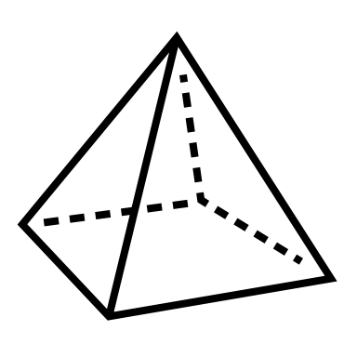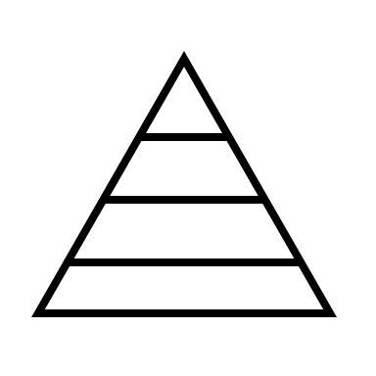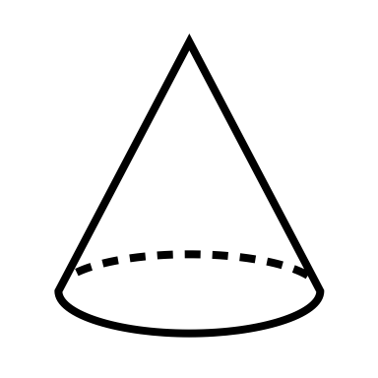

*Reisio. (2006). Basketball [Photograph]. Wikimedia Commons.* [*https://commons.wikimedia.org/wiki/File:Basketball.png*](https://commons.wikimedia.org/wiki/File:Basketball.png)

Face

Face

Face

Face

Point

what it looks like

Attribute

SiZe

S h a p e

Color

Edge