Retrieved from: http://usslave.blogspot.com/2011/03/education-prohibited.html

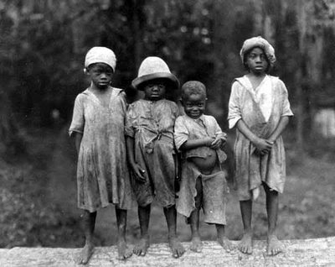

In the picture, I notice that…
I wonder…

