POLITICAL CARTOON Explanations
GROUP 1
Retrieved from: http://users.humboldt.edu/ogayle/hist110/unit4/SectionalIssues.html
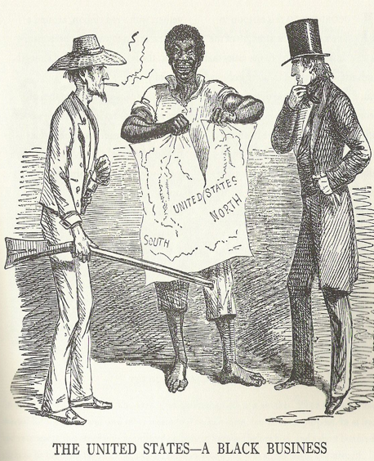
This political cartoon published in the British Magazine Punch on November 8, 1856 accurately predicted, as many in Americans were beginning to realize, that the business of slavery was tearing the nation apart. Here, a slave, standing between a southern armed and rough-clothed planter and a solemn businessman from the North, tears apart a map of the United States, seeming to follow the Mason-Dixon Line - the boundary showing a geographic, if not political, dividing line between North and South.

GROUP 2
Retrieved from: https://adastracomix.com/
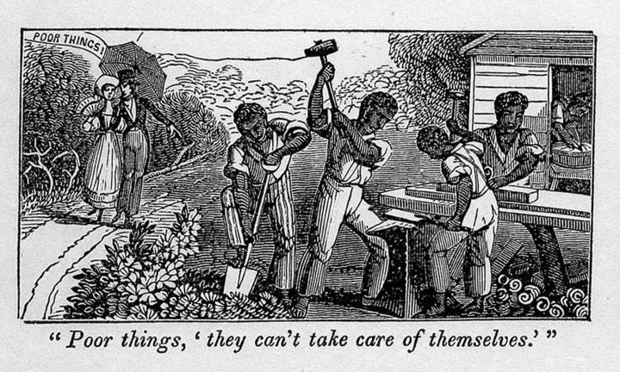
Abolitionist cartoon satirizing slave holders racist justifications for enslavement of blacks. A white couple passing a group of slave laborers says, ‘Poor things, they can’t take care of themselves.’ Illustrations of the Antislavery Almanac for 1840.
Whites looked upon slaves as uneducated and unable to even take care of themselves, however, in actuality, it was the slaves that knew how to accomplish tasks as depicted in the picture.

GROUP 3
Retrieved from: http://www.sonofthesouth.net/leefoundation/civil-war-feb-1861/civil-war-slave-cartoon.htm
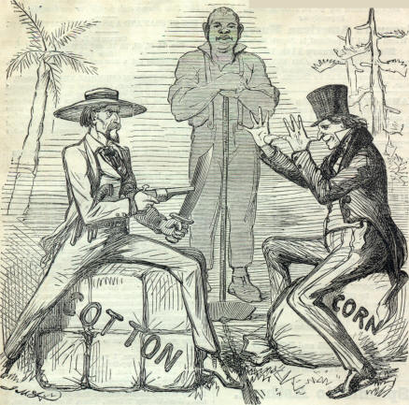
This cartoon depicts the North’s stance on holding firm to their way of life with farming corn and the South’s way of life growing cotton. The South says, “Don’t talk to me, Sir!” and is portrayed as a southern gentlemen with weapons. The North replies while making a hand gesture and being dressed in city attire of a top hat with, “Oh! You be derned!” In the background is a slave watching to see what will happen between them. The meaning behind the cartoon was that the Union was at a standstill with the division and the slave being caught in the middle as an unfortunate observer of what would happen.

GROUP 4
Retrieved from: https://apus-b.wikispaces.com/political+cartoons
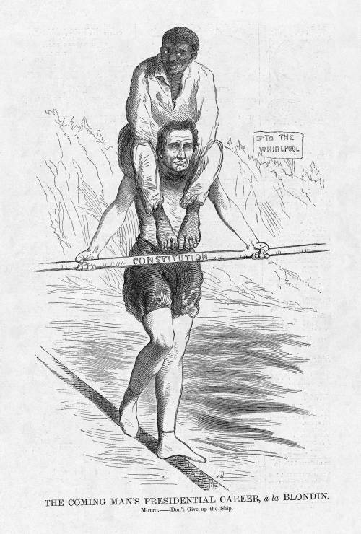
This cartoon is not as slanted as many of the other cartoons of the day. For one, it is published in Harper’s Weekly, which was a popular magazine with little to no political affiliation. It was to that time as the Economist is today. Both the magazine and the cartoon published within seem to be relatively impartial. Superficially, the cartoon merely depicts Lincoln’s campaign status in a generally unbiased way. However, when probing further, one can note a pro-Lincoln attitude from the cartoonist. Though the African American is a burden for Lincoln that could cause him to fall into the raging waters below, Lincoln is portrayed as standing upright and steady. The calm yet somber demeanor that Lincoln has is not indicative of any major panic that falling into the cascade is a strong possibility. Dallas (the cartoonist) is showing that Lincoln can successfully manage the trek over the turbulent flow beneath him as long as his grip on the constitution stays unyielding. At the very bottom of the cartoon, under the title, there is some small print adding to the pro-Lincoln undertone. It says “Don’t give up the ship.” This could be a reference to a quote by James Lawrence, a United States naval officer in the early 1800s. Lawrence was the captain of the USS Chesapeake during the War of 1812. He was mortally wounded during battle and uttered those famous last words referenced by the cartoonist. The inclusion of this quote in the cartoon could suggests that supporters of Lincoln should not give up their stance on slavery no matter how the conflict over it goes. This quote could also be meant to reinforce the image of Lincoln as a captain, steering the ship of America through treacherous waters.

GROUP 5
Retrieved from: http://www.gettyimages.com/detail/news-photo/cartoon-of-abraham-lincoln-feeding-bedridden-black-slave-news-photo/96738811
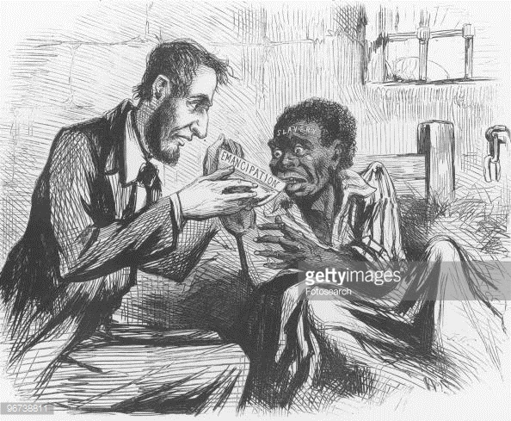
Abraham is depicted here as giving nourishment to a slave through emancipation. This cartoon is implying that the Emancipation was going to heal the sickness that slavery had caused and he was the one that was providing it.

