POLITICAL CARTOONS FOR GROUPS

GROUP 1
Retrieved from: http://users.humboldt.edu/ogayle/hist110/unit4/SectionalIssues.html
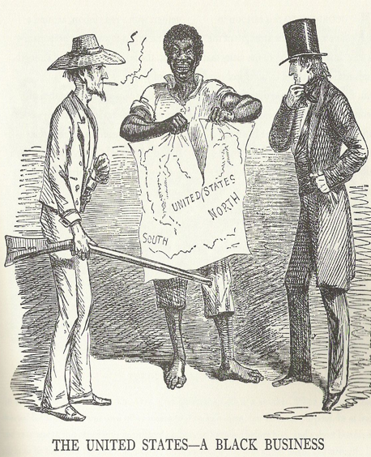

GROUP 2
Retrieved from:
https://adastracomix.com/

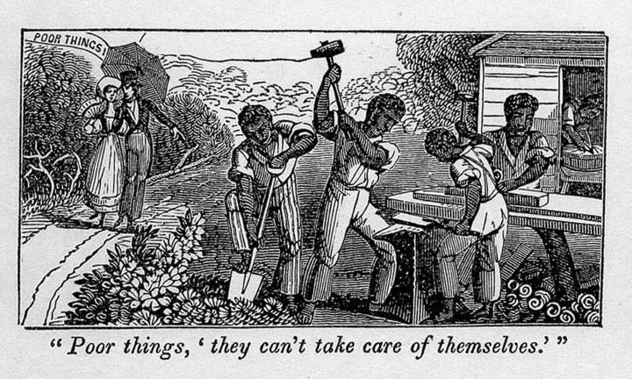

GROUP 3
Retrieved from: http://www.sonofthesouth.net/leefoundation/civil-war-feb-1861/civil-war-slave-cartoon.htm

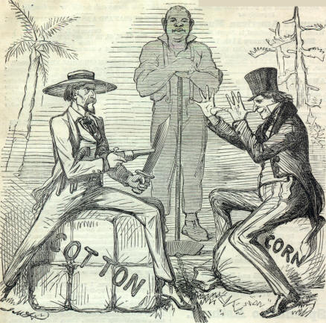

GROUP 4
Retrieved from: https://apus-b.wikispaces.com/political+cartoons
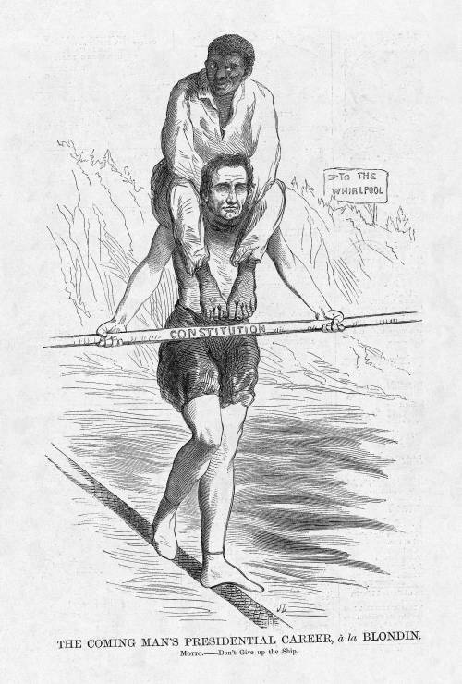
GROUP 5
Retrieved from: http://www.gettyimages.com/detail/news-photo/cartoon-of-abraham-lincoln-feeding-bedridden-black-slave-news-photo/96738811
