MAP VOCABULARY SHEET
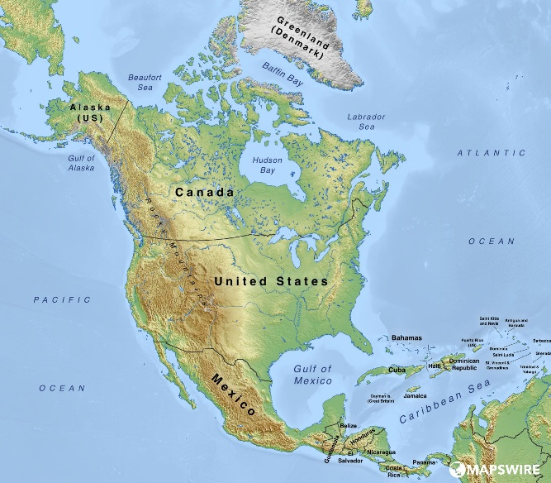
Mapswire (2019). Free Physical Maps of North America [Image]. Mapswire. https://mapswire.com/north-america/physical-maps/

Physical Map
A map that focuses on land features such as mountains and bodies of water
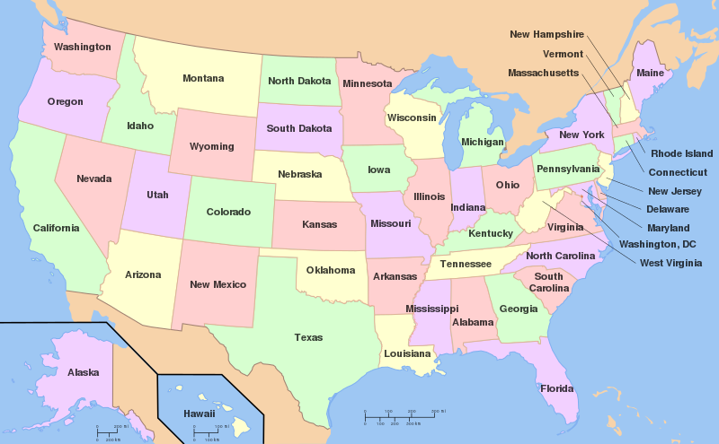
Wapcaplet. Map of USA with state names.svg [Image]. Wikimedia Commons. Retrieved [May 6, 2022] from https://commons.wikimedia.org/wiki/File:Map_of_USA_with_state_names.svg

Political Map
A map that focuses on borders between cities, counties, states, or countries

