PICTOGRAPH STORY TRANSLATION
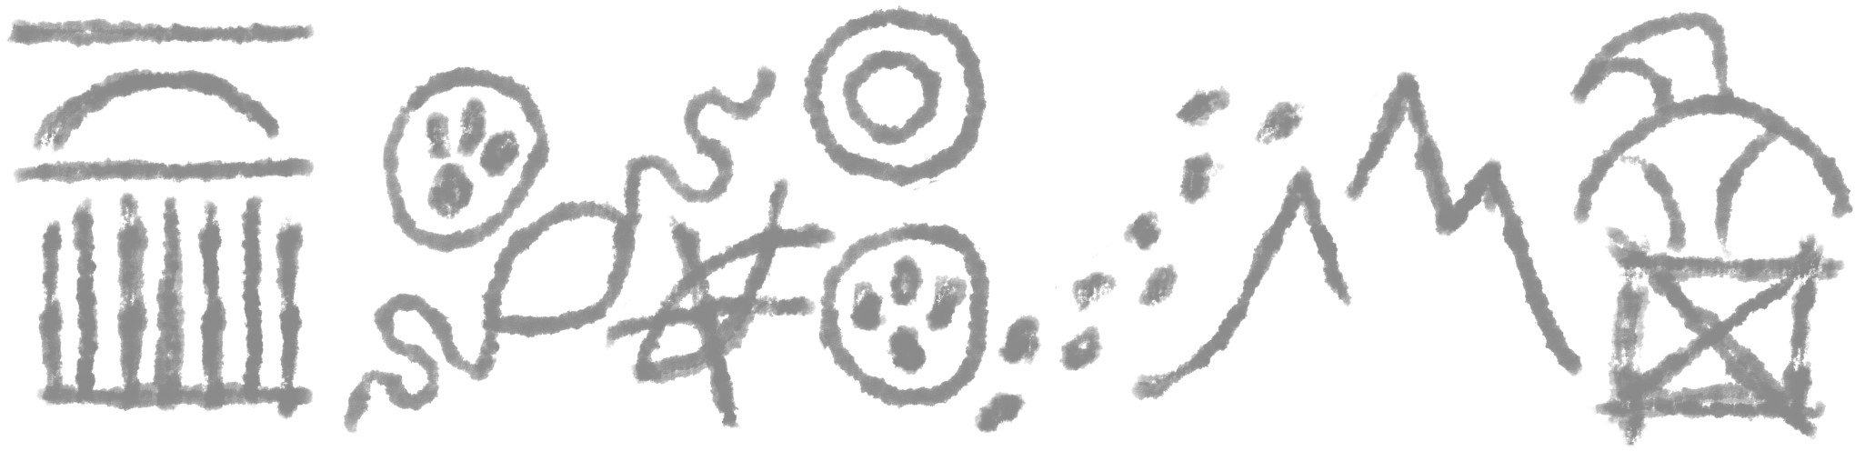
Task 1. Archeologists have discovered a series of symbols painted on a secluded cliff wall somewhere in the American Midwest. The images seem to relay some kind of message. Using the space provided below the image, translate what you see here into a story (1st attempt).
1st attempt:

Quick Discussion Topic: Which symbols do you find easier to recognize and which ones appear more unfamiliar or strange to you?

Task 2. Use the Picture Dictionary to help you interpret the meaning of the symbols above. Translate the image again the in space below.
2nd attempt:
Task 3. More symbols were later discovered, near the first series. These were exposed to more weathering and have faded more with time. Based on what you know, translate the next part of the story in the space provided below.
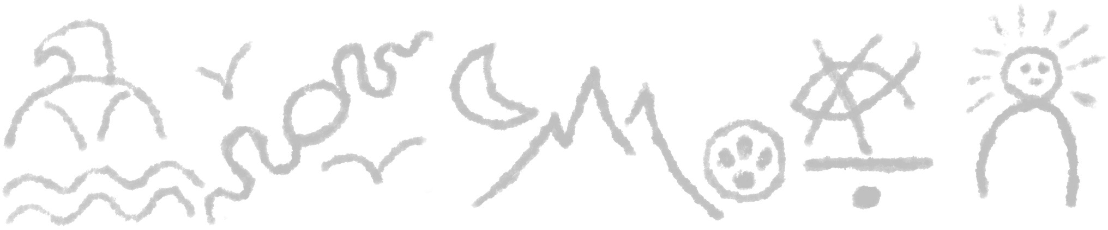

Task 4. The archeologists suggest this story is incomplete! Unfortunately, any other symbols that may have been present are now lost or faded beyond recognition. It is up to you to complete the story in the spaces below.
Draw the pictographs in the top section, followed by their translation.

