PICTURE DICTIONARY
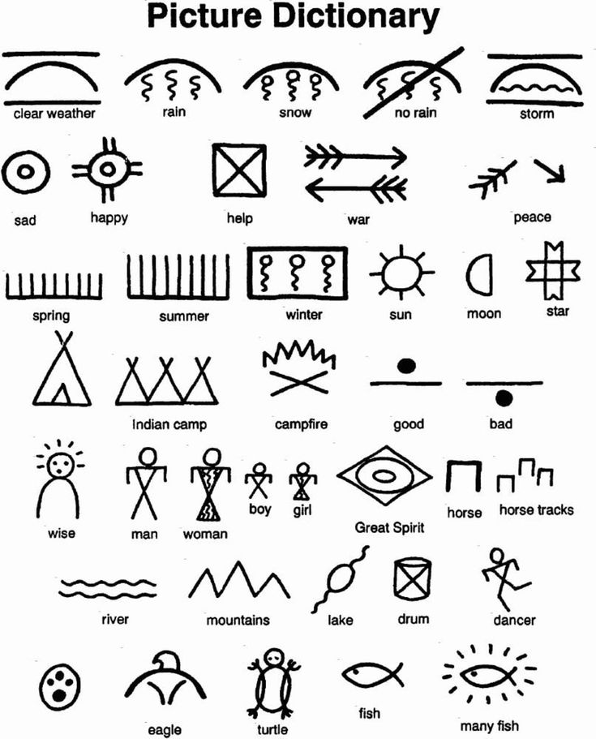
Native American Pictographs | Activity | Education.com
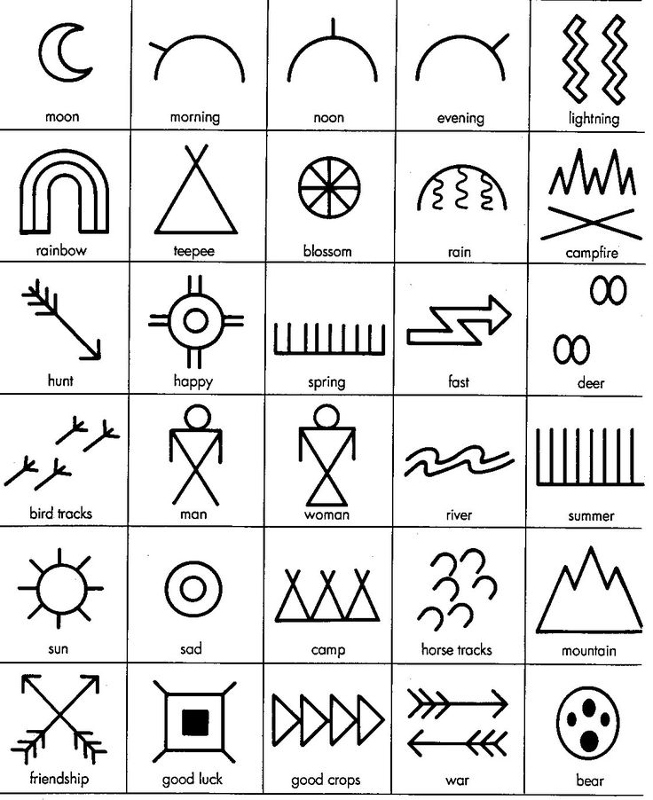
Native American Pictographs | Activity | Education.com

