**PICTURE DICTIONARY**

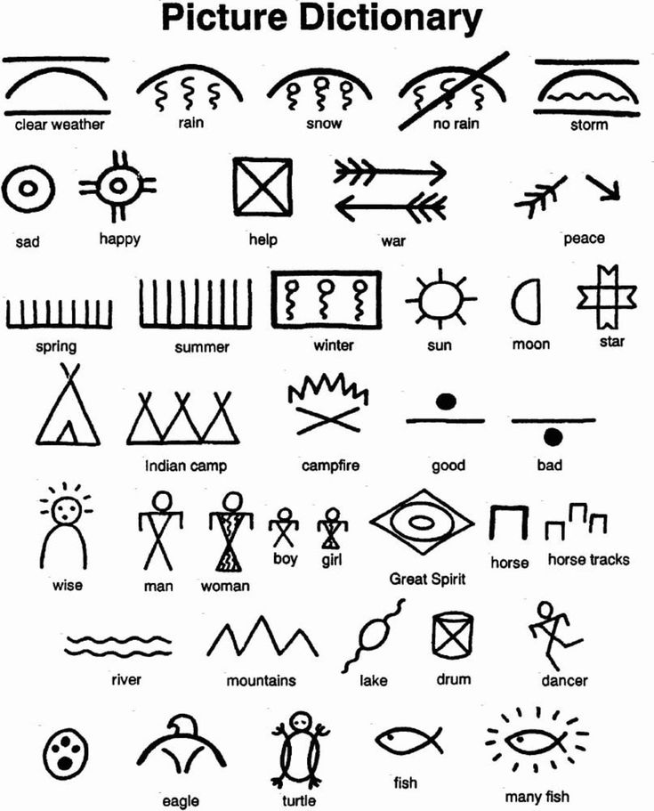

[Native American Pictographs | Activity | Education.com](https://www.education.com/activity/article/native-american-pictographs/)

[Native American Pictographs | Activity | Education.com](https://www.education.com/activity/article/native-american-pictographs/)