Tarjetas de animales
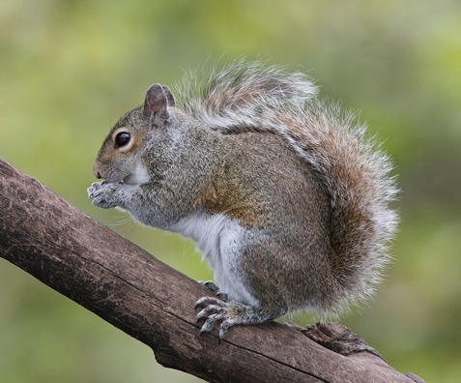  ardilla | 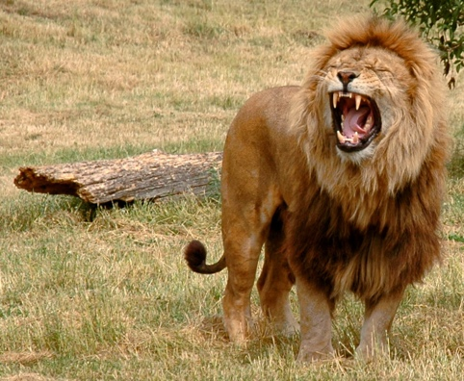  león
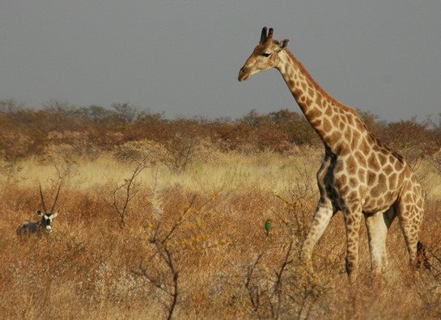  jirafa | 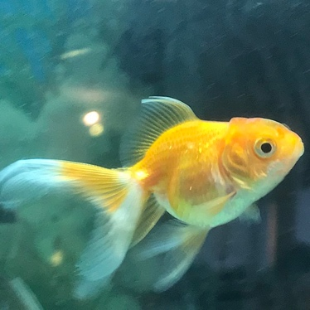  pez
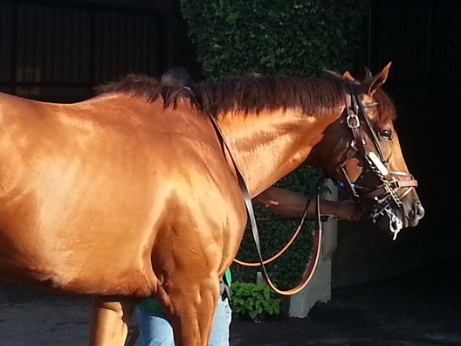  caballo | 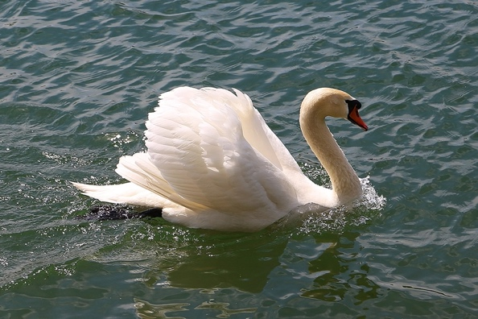  cisne
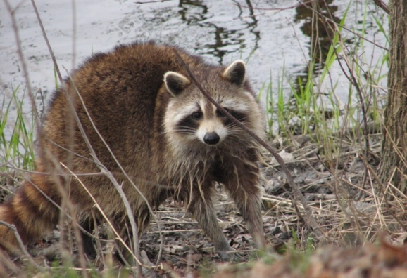  mapache | 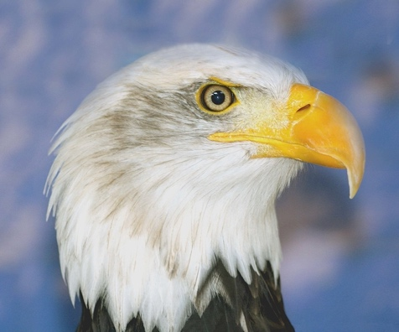  águila
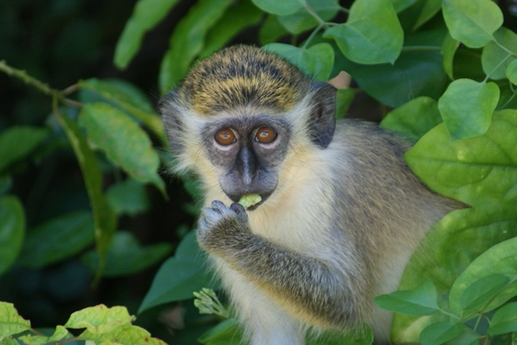  mono | 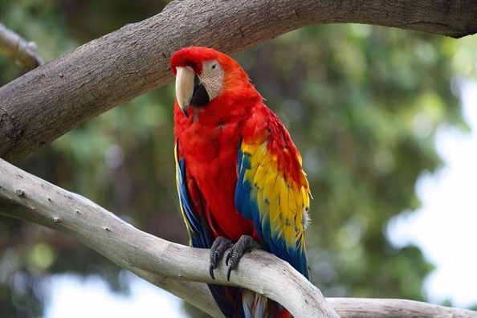  perico
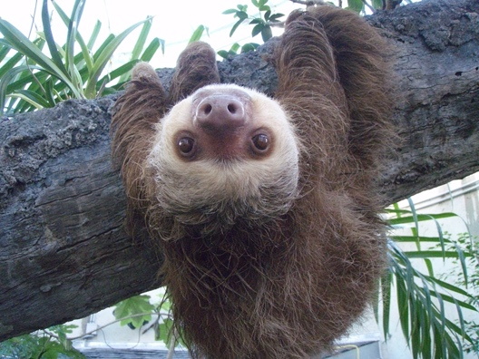  perezoso | 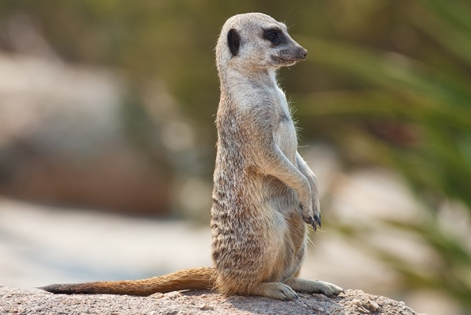  suricata
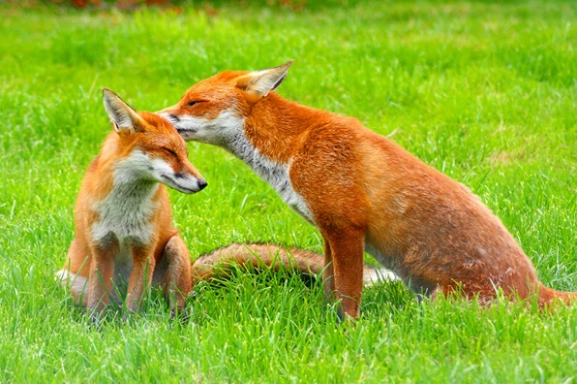  zorro | 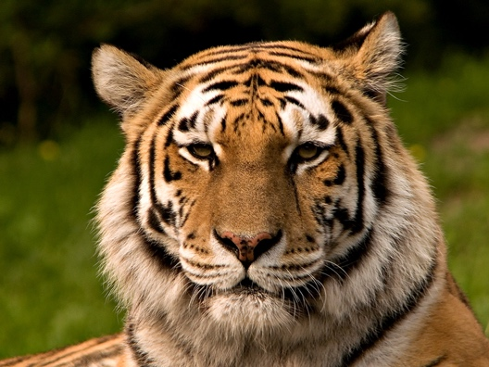  tigre
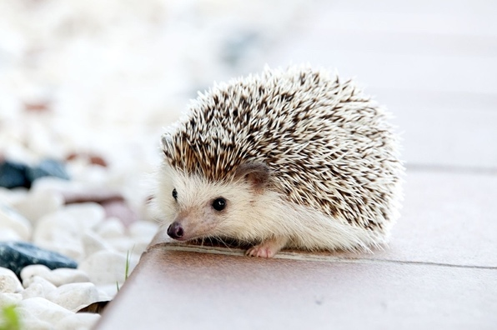  erizo | 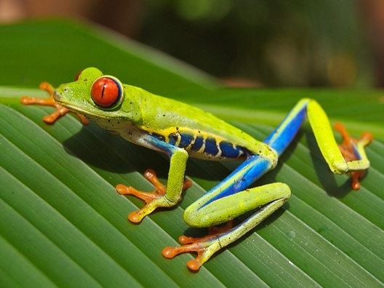  rana de árbol
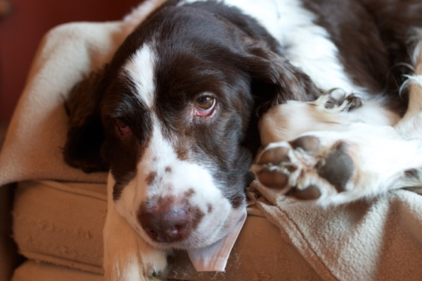  perro | 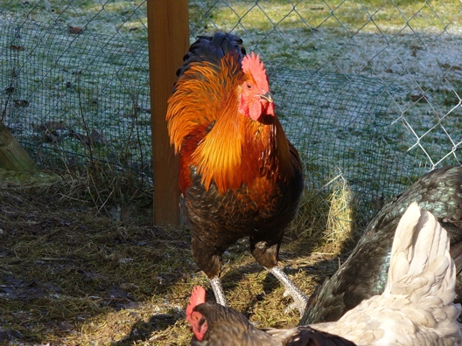  gallo
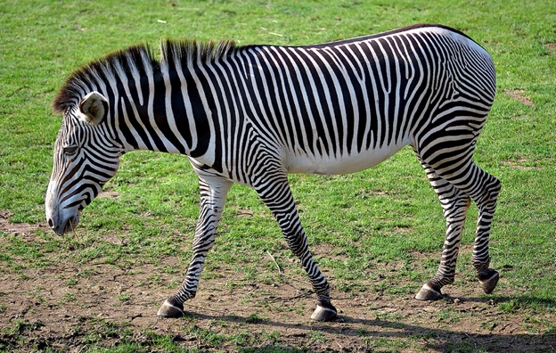  cebra | 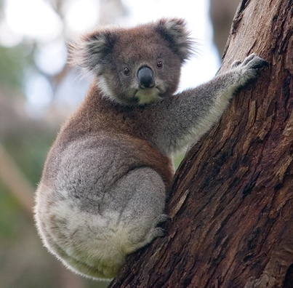  koala
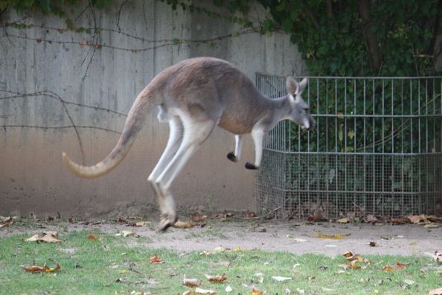  canguro | 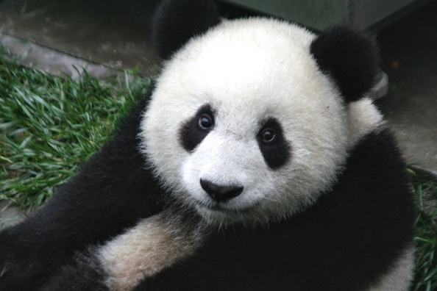  panda
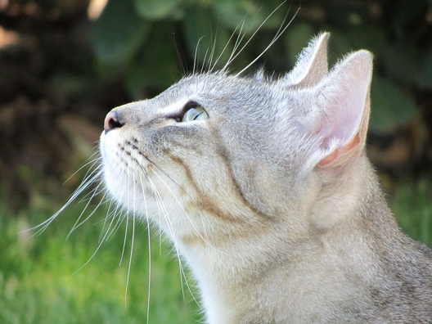  gato | 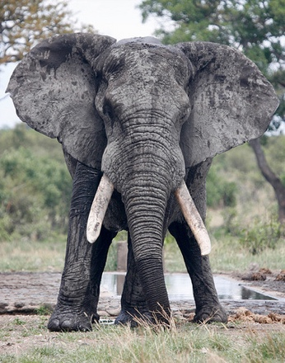  elefante
Insert more photos if you need extra cards!

Kotenko, Y. (2020). Goldf [Photograph]. Wikimedia Commons. https://commons.wikimedia.org/wiki/File:Goldf.jpg

BirdPhotos.com. (2010). Eastern Grey Squirrel [Photograph]. Wikimedia Commons. https://commons.wikimedia.org/wiki/File:Eastern_Grey_Squirrel.jpg

Wulfstan. (2006). Just one lion [Photograph]. Wikimedia Commons. https://commons.wikimedia.org/wiki/File:Just_one_lion.jpg

Cambelo, S. (2006). Giraffe [Photograph]. Wikimedia Commons. https://commons.wikimedia.org/wiki/File:Giraffe.JPG

Jcharvat. (2018). Accelerate (4) [Photograph]. Wikimedia Commons. https://commons.wikimedia.org/wiki/File:Accelerate_(4).jpg

Bulach, W. (2015). 00 2187 Höckerschwan – Breisach [Photograph]. Wikimedia Commons. https://commons.wikimedia.org/wiki/File:00_2187_H%C3%B6ckerschwan_-_Breisach.jpg

Gordan, D and E. Robertson. (2009). Raccoon, female after washing up [Photograph]. Wikimedia Commons. https://commons.wikimedia.org/wiki/File:Raccoon,_female_after_washing_up.jpg

Law, K. (2008). Flickr - law keven - The "Bald" and the beautiful.... [Photograph]. Wikimedia Commons. https://commons.wikimedia.org/wiki/File:Flickr_-_law_keven_-_The_%22Bald%22_and_the_beautiful.....jpg

Haynes, B. (2008). Chlorocebus pygerythrus, Barbados [Photograph]. Wikimedia Commons. https://commons.wikimedia.org/wiki/File:Chlorocebus_pygerythrus,_Barbados.jpg

Contributor50. (2015). Parrot [Photograph]. Wikimedia Commons. https://commons.wikimedia.org/wiki/File:Parrot.jpg

Ontley. (2008). Two toed sloth [Photograph]. Wikimedia Commons. https://commons.wikimedia.org/wiki/File:Two_toed_sloth.JPG
(2009). Meerkat feb 09 [Photograph]. Wikimedia Commons. https://commons.wikimedia.org/wiki/File:Meerkat_feb_09.jpg

Francesca Cesa Bianchi, Milano. (2011). " 11 - ITALY – cat [Photograph]. Wikimedia Commons. https://commons.wikimedia.org/wiki/File:%22_11_-_ITALY_-_cat.JPG

Bassil, S. (2009). Elephant [Photograph]. Wikimedia Commons. https://commons.wikimedia.org/wiki/File:Elephant.jpg

Giraud, P. (2006). Namibie Etosha Girafe 02 [Photograph]. Wikimedia Commons. https://commons.wikimedia.org/wiki/File:Namibie_Etosha_Girafe_02.jpg

Balboa, C. J. (2007). Red eyed tree frog edit2 [Photograph]. Wikimedia Commons. https://commons.wikimedia.org/wiki/File:Red_eyed_tree_frog_edit2.jpg

