noun picture cards
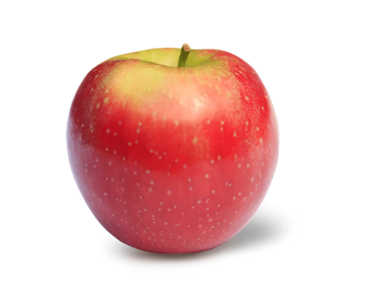  apple | 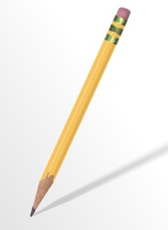  pencil
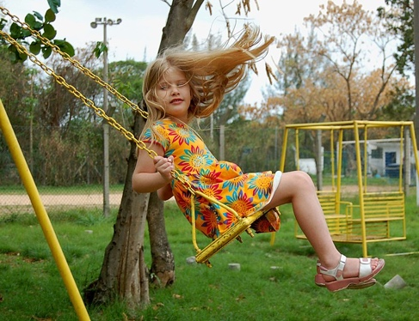  girl | 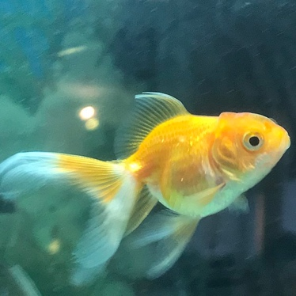  fish
man | 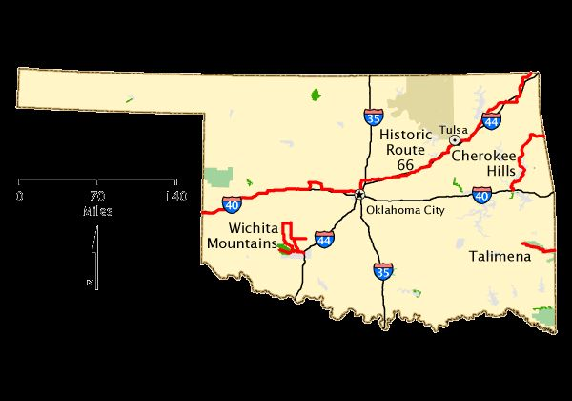  Oklahoma
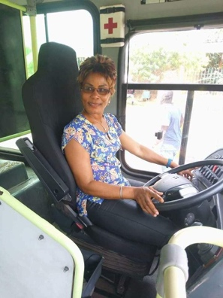  bus driver | 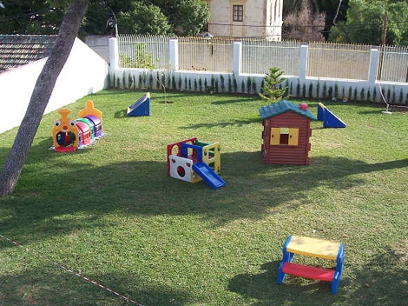  backyard
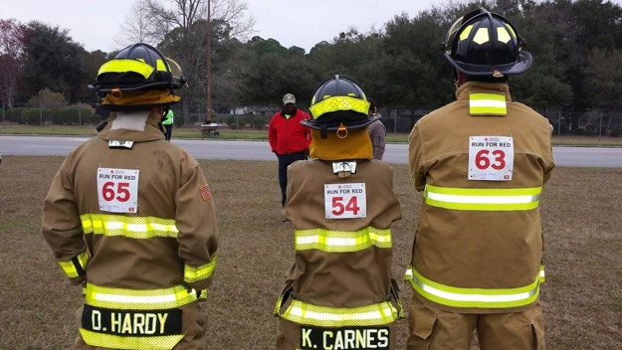  firefighter | 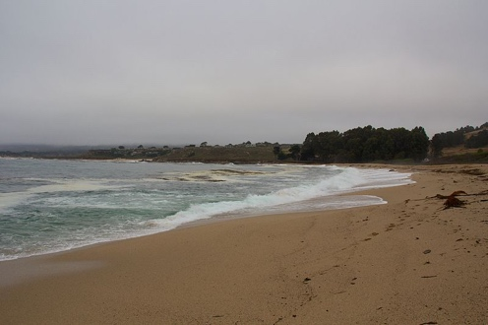  beach
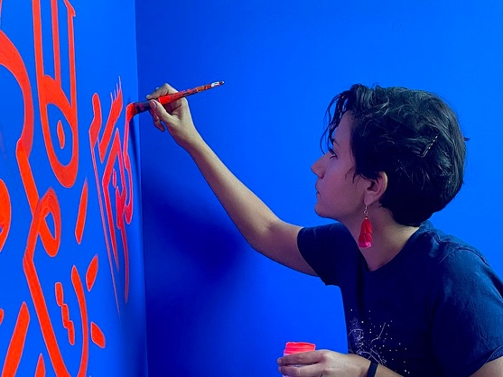  artist | 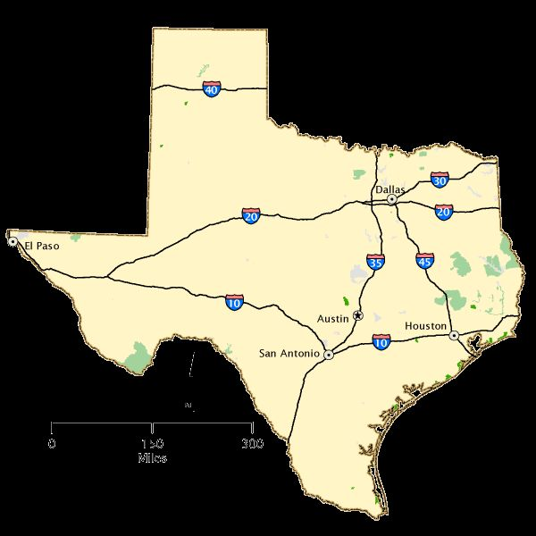  Texas
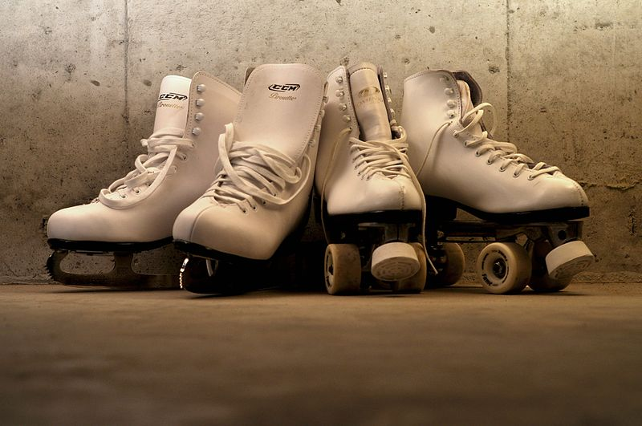  skates | 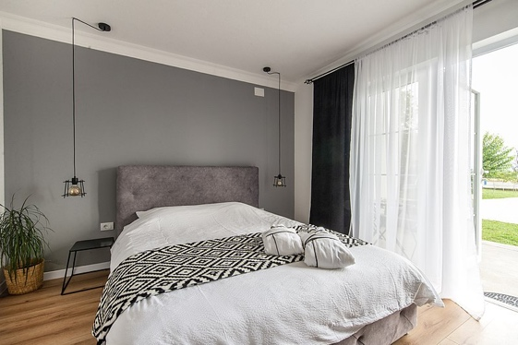  bed
baby | 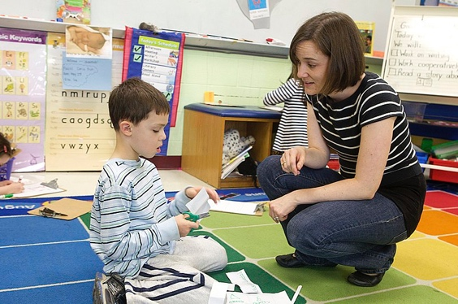  teacher
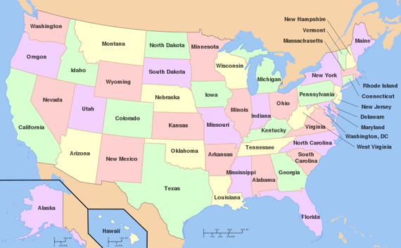  United States | 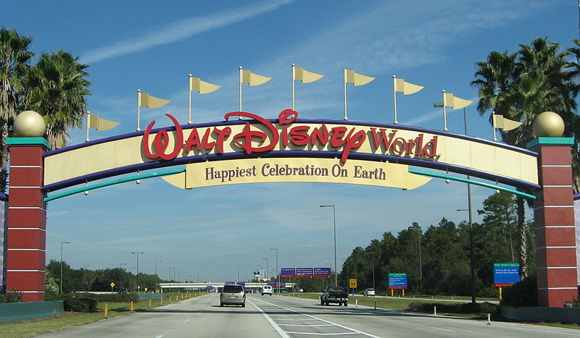  Disney World
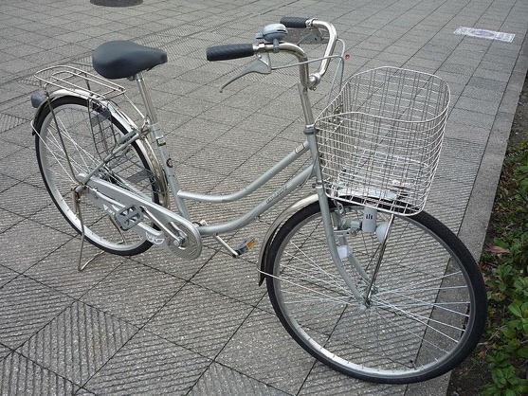  bike | 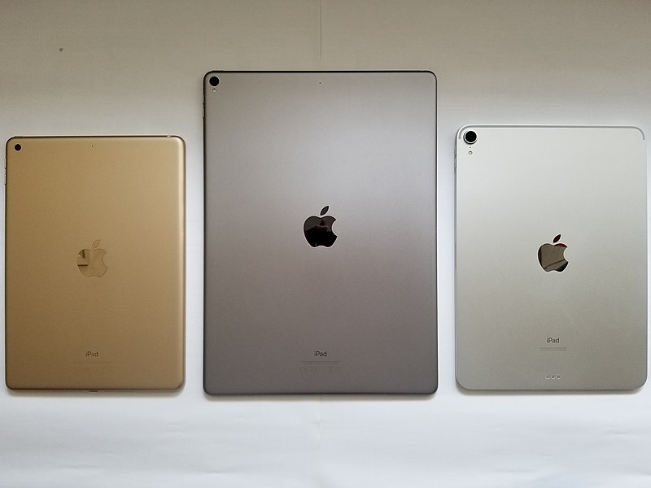  iPad
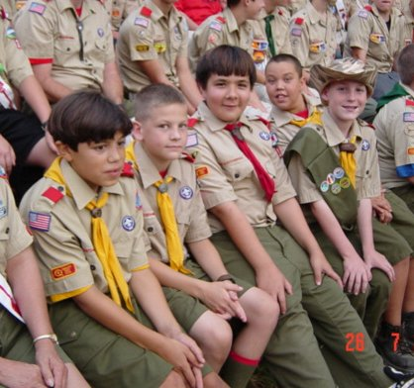  boys | 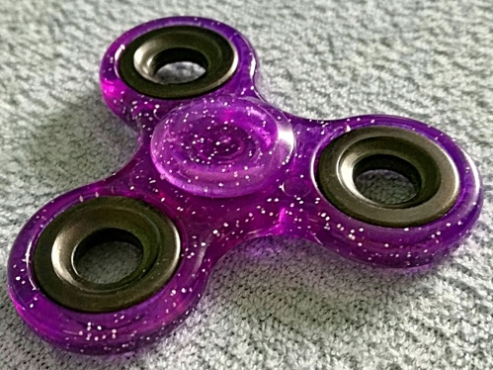  toy
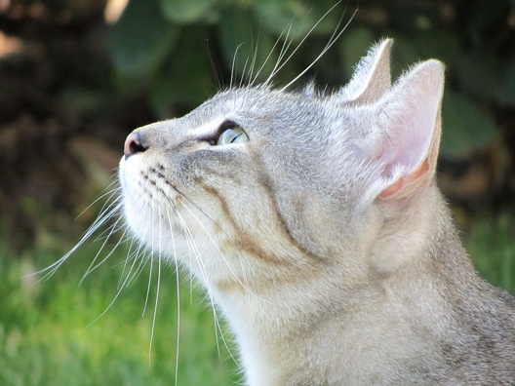  cat | 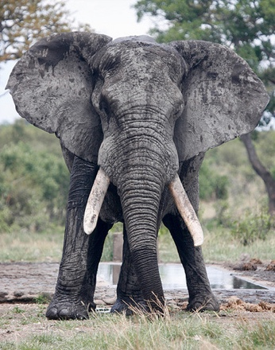  elephant
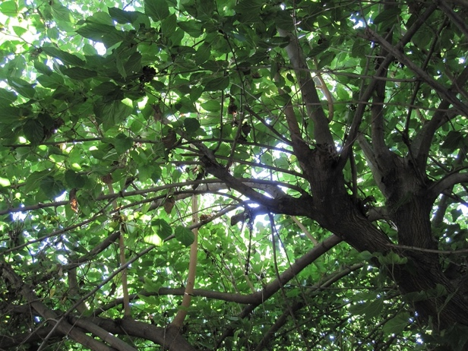  tree | 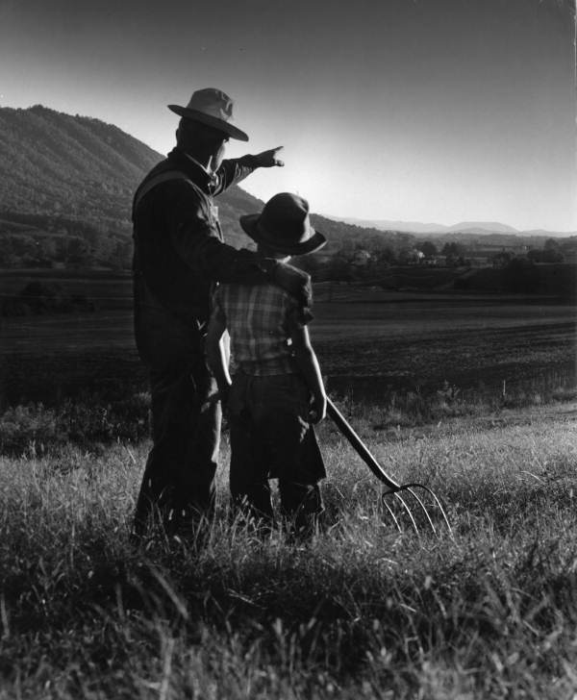  farmer
Insert more photos if you need extra cards!

KidThatOofs. (2021). Appke [Photograph]. Wikimedia Commons. https://commons.wikimedia.org/wiki/File:Appke.webp

Carlos, L. (2006). Little girl on swing [Photograph]. Wikimedia Commons. https://commons.wikimedia.org/wiki/File:Little_girl_on_swing.jpg

Singleton, A. (2021). Alex-Singleton [Photograph]. Wikimedia Commons. https://commons.wikimedia.org/wiki/File:Alex-Singleton.jpg

Singoloua225. (2020). Une femme Conductrice de Bus a la SOTRA [Photograph]. Wikimedia Commons. https://commons.wikimedia.org/wiki/File:Une_femme_Conductrice_de_Bus_a_la_SOTRA_(2).jpg

Hsoucy. (2013). 514th firefighters 92nd [Photograph]. Wikimedia Commons. https://commons.wikimedia.org/wiki/File:514th_firefighters_92nd.jpg

Cultureandart. (2020). Alia Ali, photo by Gillian Holzer. [Photograph]. Wikimedia Commons. https://commons.wikimedia.org/wiki/File:Alia_Ali,_photo_by_Gillian_Holzer._2020.jpg

Lee, J. (2010). Iceskates and rollerskates 4556686064 2a24e3edfo z [Photograph]. Wikimedia Commons. https://commons.wikimedia.org/wiki/File:Iceskates_and_rollerskates_4556686064_2a24e3edf0_z.jpg

Sagu, A. (2016). Hello html m1173fe2d [Photograph]. Wikimedia Commons. https://commons.wikimedia.org/wiki/File:Hello_html_m1173fe2d.jpg

Kotenko, Y. (2020). Goldf [Photograph]. Wikimedia Commons. https://commons.wikimedia.org/wiki/File:Goldf.jpg

(2013). National Scenic Byways Program Maps- Oklahoma – NARA – 68884790 [Photograph]. Wikimedia Commons. https://commons.wikimedia.org/wiki/File:National_Scenic_Byways_Program_Maps-_Oklahoma_-_NARA_-_68884790_(page_1).jpg

Soyjorgeceuta. (2008). Instalaciones Victoria Elena [Photograph]. Wikimedia Commons. https://commons.wikimedia.org/wiki/File:Instalaciones_Victoria_Elena.jpg

Peel, M. (2012). View from Highway 1, California 25 [Photograph]. Wikimedia Commons. https://commons.wikimedia.org/wiki/File:View_from_Highway_1,_California_25.jpg

(2013). National Scenic Byways Program Maps- Texas – NARA – 68884809 [Photograph]. Wikimedia Commons. https://commons.wikimedia.org/wiki/File:National_Scenic_Byways_Program_Maps-_Texas_-_NARA_-_68884809.jpg

Stojkovic. (2021). Bedroom hotel interior with open door window [Photograph]. Wikimedia Commons. https://commons.wikimedia.org/wiki/File:Bedroom_hotel_interior_with_open_door_window._(51536308276).jpg

Noorwifenisha. (2014). My 2014-02-05 19-11 [Photograph]. Wikimedia Commons. https://commons.wikimedia.org/wiki/File:My_2014-02-05_19-11.jpg

US Department of Education. (2012). 05092012 – Oyster class visit Teacher Appreciation 237 [Photograph]. Wikimedia Commons. https://commons.wikimedia.org/wiki/File:05092012_-_Oyster_class_visit_Teacher_Appreciation_237.jpg

Andrew c. (2005). Mao of USA with state names [Photograph]. Wikimedia Commons. https://commons.wikimedia.org/wiki/File:Map_of_USA_with_state_names.svg

McGovern, G. (2005). Disney World – Entrance sign – by inkiboo [Photograph]. Wikimedia Commons. https://commons.wikimedia.org/wiki/File:Disney_World_-_Entrance_sign_-_by_inkiboo.jpg

Imoni. (2008). Japanese CityCycle LadiesType [Photograph]. Wikimedia Commons. https://commons.wikimedia.org/wiki/File:Japanese_CityCycle_LadiesType.jpg

(2018). IPad and iPad Pro [Photograph]. Wikimedia Commons. https://commons.wikimedia.org/wiki/File:IPad_and_iPad_Pro.jpg

Rlevse. (2002). American Boy Scouts sitting around a campfire ring at a week long summer camp [Photograph]. Wikimedia Commons. https://commons.wikimedia.org/wiki/File:American_Boy_Scouts_sitting_around_a_campfire_ring_at_a_week_long_summer_camp.png

MichalPL. (2017). Fidget spinner [Photograph]. Wikimedia Commons. https://commons.wikimedia.org/wiki/File:Fidget_spinner.jpg

Francesca Cesa Bianchi, Milano. (2011). " 11 - ITALY – cat [Photograph]. Wikimedia Commons. https://commons.wikimedia.org/wiki/File:%22_11_-_ITALY_-_cat.JPG

Bassil, S. (2009). Elephant [Photograph]. Wikimedia Commons. https://commons.wikimedia.org/wiki/File:Elephant.jpg

Leneau, R. (2010). panoramio (934) [Photograph]. Wikimedia Commons. https://commons.wikimedia.org/wiki/File:-_panoramio_(934).jpg

State Library and Archives of Florida. (1955). "It's Gonna Be Yours Someday, Son." [Photograph]. Wikimedia Commons. https://commons.wikimedia.org/wiki/File:%22It%27s_Gonna_Be_Yours_Someday,_Son.%22_(8969033357).jpg

