Citation: Adapted from NSTA publications: Life science Formative Assessments – Page Keeley

Name Hour Date

Living Nut?
Two friends went to a grocery store to purchase peanuts. Emily bought peanuts with the shells removed, and Sam bought a bag of peanuts still in the shells. Emily and Sam, along with two of their friends, argued about whether the peanuts were alive.
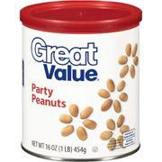
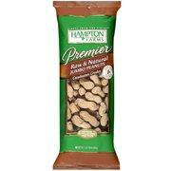
Emily Sam Here is their conversation:
Emily: Each peanut is a seed. The seeds were packed two years ago. They are dead because they did
not have food, light or energy to maintain life.
Sam: The whole peanut in the shell is a fruit. It was packed two-­‐years ago. It is alive because the hull
protects the seed inside.
Emily’s friend: The peanuts without shells are dead, but the ones with shells are alive.
Sam’s friend: I don’t think the peanuts without shells or the peanuts with shells are alive until they are
planted in the soil.

Which person do you agree with the most? Explain your thinking.

Characteristics of Life/Cell Theory: It’s Alive or Is It?

