
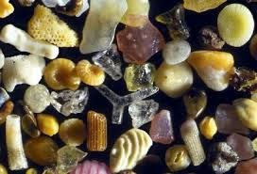
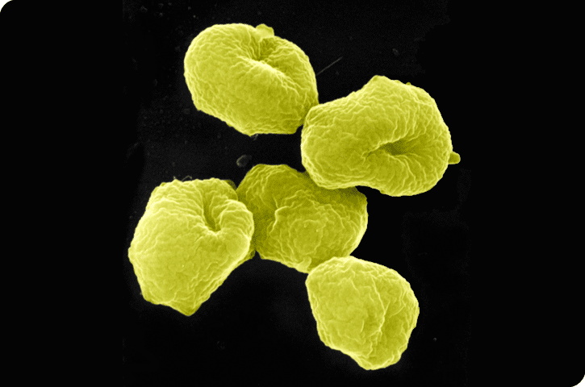

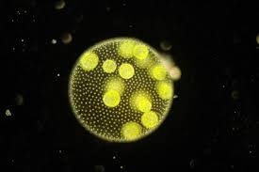
Unknown Organism A  Appears to Move toward food  Appears to be Single celled  No new organisms after 3 days  No Waste Products in medium found  No known hereditary structure | Unknown Organism B  Appears to Move toward food  Appears to be Single celled  Organism population doubles every day  Circular Genetic structure  Waste products in medium found
Unknown Organism C  “Puff up” when threatened  Decays starts after 1 day  Waste products found in medium  Thousands of new organisms found each day  Apparent cycle from infant-juvenile-adult phase | Unknown Organism D  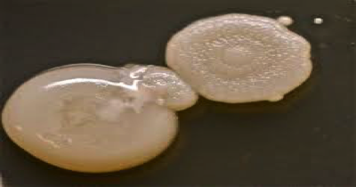  No reaction when threatened  Decay starts after 1 day  No evidence of reproduction  Waste products in medium found  No life cycle apparent
Unknown Organism E  Stationary  Appears to be Single celled  No appearance of reproduction (no new organisms) after 3 days  No hereditary material found | Unknown Organism F  Need host to move through envrionment  Appears to be Single celled  Contains hereditary material  More organisms appear every day  Adapt to their hosts

