T.A.C.O.S.
Use the acronym T.A.C.O.S. to analyze the cartoon. Follow the instructions in the table below.
T: Time and Place - Estimate the time period and region where the cartoon takes place.
A: Action - Describe what is happening in the cartoon.
C: Caption - If there is a caption, write it down.
O: Objects/People - List any people or objects shown, including symbols and use of color.
S: Summary - Explain the meaning of the cartoon in one sentence.

T: Time and Place
A: Action
C: Caption
O: Objects/People
S: Summary
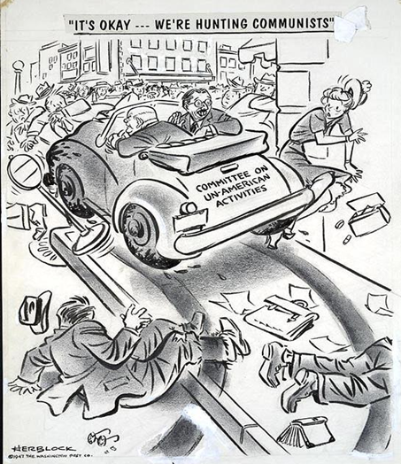
Block, H. (1947, October 31). It's okay.…[W]e're hunting communists. Library of Congress. Library of Congress Prints and Photographs Division. Retrieved April 13, 2022, from https://www.loc.gov/pictures/item/00652190/

