empareja las tarjetas: biomímesis
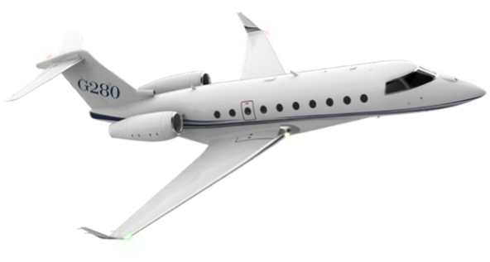  Avión | 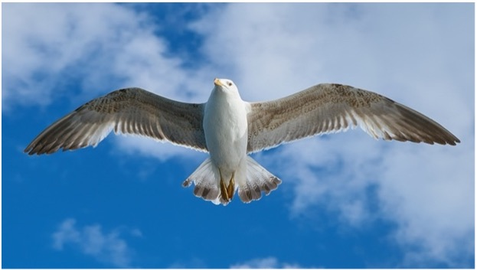  Alas
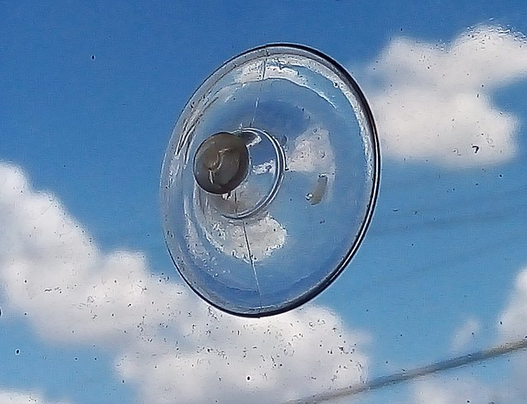  Ventosa | 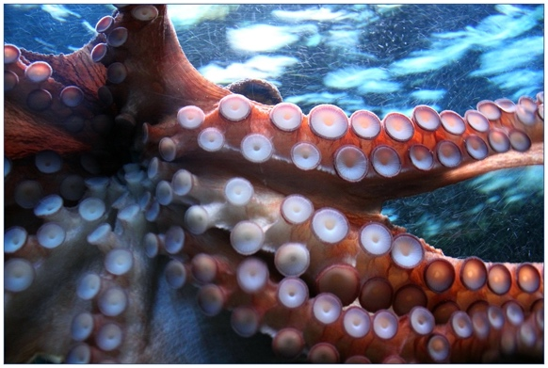Tentáculos de pulpo
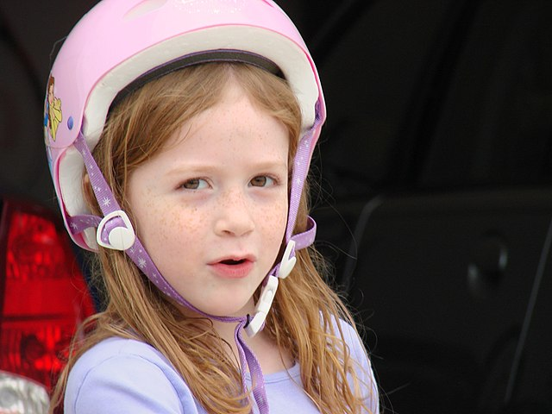  Casco | 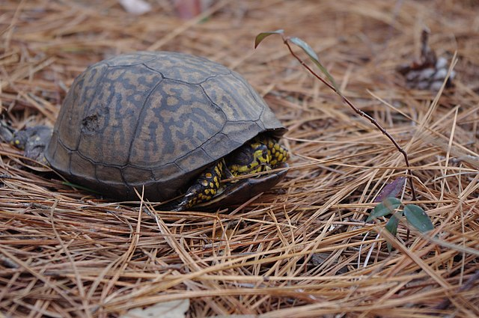Caparazón de tortuga
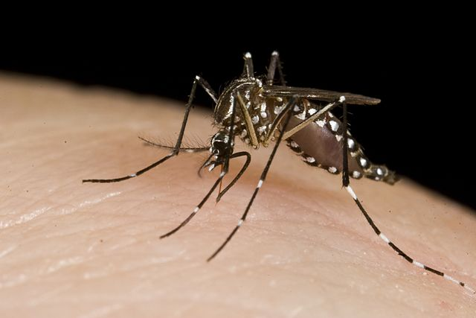Aguijón de zancudo | Aguja
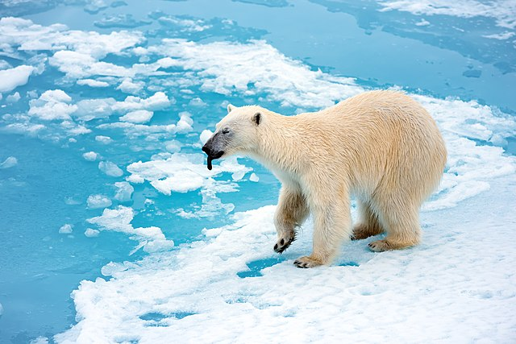Oso polar | Abrigo
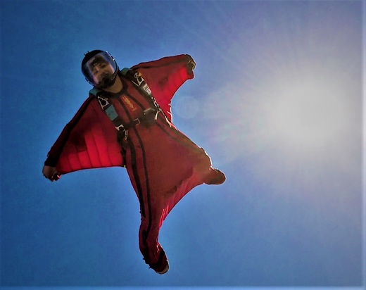  Traje aéreo | 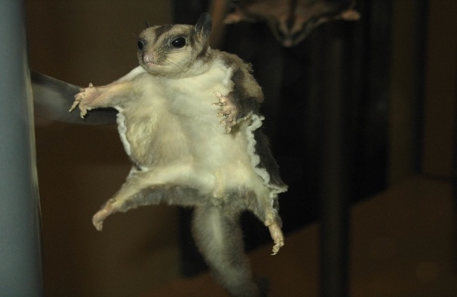  Ardilla voladora
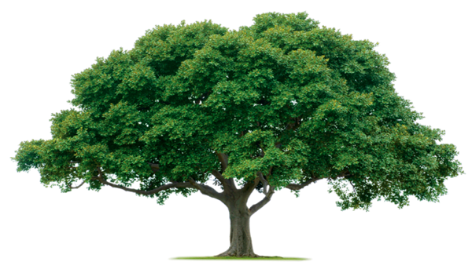  Árbol | 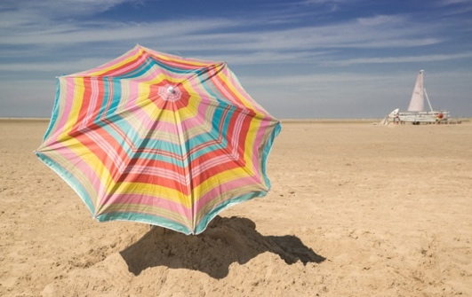  Parasol
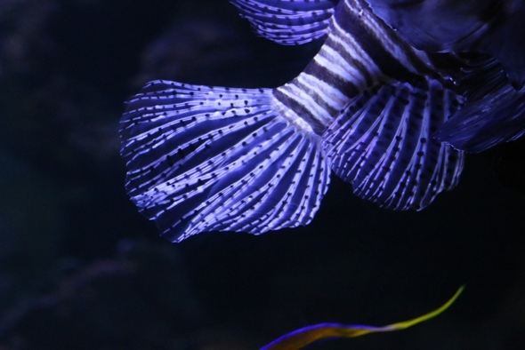  Aleta de pez | 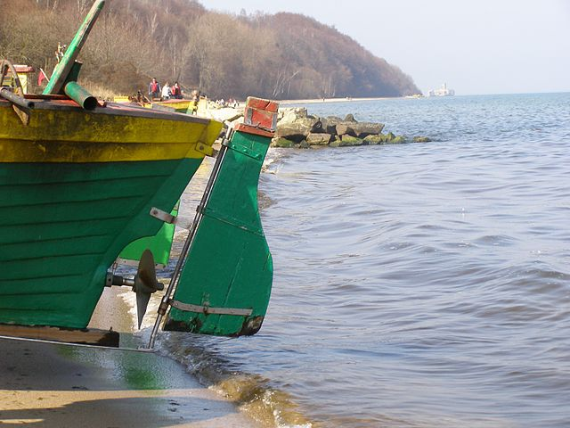  Timón de barco
cloudmajor54 (2016). Business Jet Gulfstream G280 Gulfstream G650 Gulfstream G500/G550 Family Aircraft [Clip art]. IMGBIN.
https://imgbin.com/png/gG2pJHwj/business-jet-gulfstream-g280-gulfstream-g650-gulfstream-g500-g550-family-aircraft-png
Pixabay. (2016). White and Grey Bird Flying Freely at Blue Cloudy Sky [Clip art]. Pixabay. https://www.pexels.com/photo/white-and-grey-bird-flying-freely-at-blue-cloudy-sky-122439/
Couch-scratching-cats. (2021). Suction cup 2. Wikimedia Commons. https://commons.wikimedia.org/wiki/File:Suction_cup_2.jpg
cocoparisienne. (2014). Pixabay. https://pixabay.com/photos/octopus-suction-cup-suction-cups-250101/
Brooks, J. (2007). Little girl in pink helmet [Clip art]. Wikimedia Commons. https://commons.wikimedia.org/wiki/File:Little_girl_in_pink_helmet.jpg
Virginia State Parks staff. (2011). Turtle (5817263612). Wikimedia Commons. https://commons.wikimedia.org/wiki/File:Turtle_(5817263612).jpg
Department of Foreign Affairs and Trade. (2013). Mosquitoes (10703811283. Wikimedia Commons. https://commons.wikimedia.org/wiki/File:Mosquitoes_(10703811283).jpg
frolicsomepl. (2016). Pixabay. https://pixabay.com/photos/syringe-glove-medical-blood-tests-1291129/
Michel, C. (2015). Polar Bear with its tongue sticking out. Wikimedia Commons. https://commons.wikimedia.org/wiki/File:Polar_Bear_with_its_tongue_sticking_out.jpg
AdinaVoicu. (2016). Pixabay. https://pixabay.com/photos/face-snow-white-fairy-winter-1161300/
Princi19skydiver. (2010). Wing suit flying by shital mahajan. Wikimedia Commons. https://commons.wikimedia.org/wiki/File:Wing_suit_flying_by_shital_mahajan.png
nikoretro. (2005). Flying Squirrel, Smithsonian Museum of Natural History, Washington D.C. [Clip art]. Flickr. https://www.flickr.com/photos/bellatrix6/106030446
Green leafed tree, Tree planting Lawn-Tek, LLC Pruning Arborist, Jungle Tree s, leaf,company png [Clip art]. PNGEGG. https://www.pngegg.com/en/png-bmayc
Skitter photo. (2016). Pexels. https://www.pexels.com/ru-ru/photo/691480/
emminum. (2020). Pixabay. https://pixabay.com/photos/fish-aquarium-blue-violet-water-5076267/
Otrebski, A. (2009). Gdynia Oksywie lodzie 3. Wikimedia Commons. https://commons.wikimedia.org/wiki/File:Gdynia_Oksywie_lodzie_3.jpg

