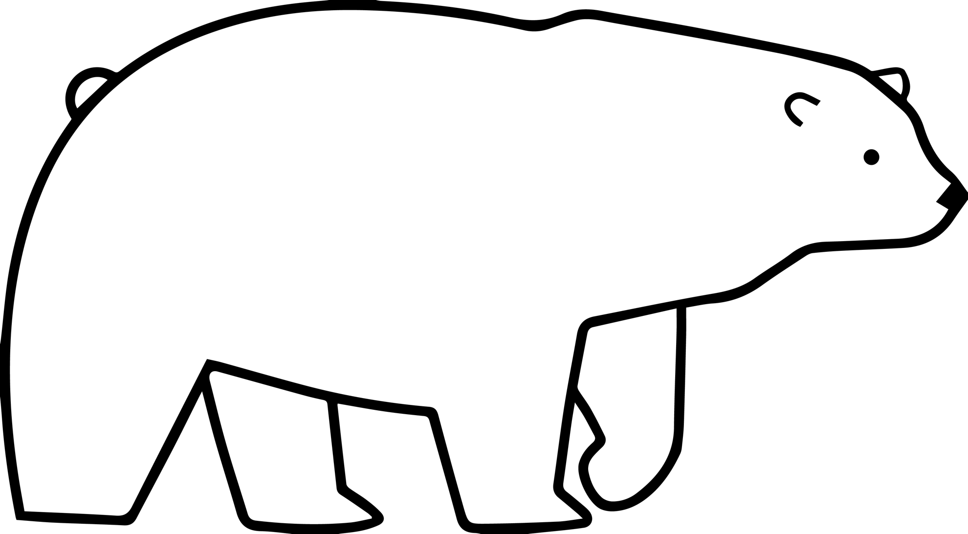
polar bear cutout

Polar bear Polar regions of Earth Giant panda Arctic fox, polar bear, white, mammal [Clip art]. PNGEGG. https://www.pngegg.com/en/png-cvatz

